

September 2018
This publication was produced at the request of the United States Agency for International Development. It was prepared by Dan Killian, Jacob Patterson-Stein, and Dima Toukan of Management Systems International, a Tetra Tech company.

Evaluation Baseline report
cities implementing transparent, innovative, and effective solutions (cities)

CITIES Evaluation Baseline report

Submitted September 2018
USAID/Jordan Monitoring and Evaluation Support Project (MESP)
Contracted Under AID-278-C-13-00009

Cover Photo: A tourist development in Ma’an Governorate
Photo Credit: Jacob Patterson-Stein



Management Systems International
Corporate Offices
200 12th Street, South
Arlington, VA 22202 USA

DISCLAIMER
The authors’ views expressed in this publication do not necessarily reflect the views of the United States Agency for International Development or the United States Government.

CONTENTS
Acronyms 6
Executive Summary 7
Introduction 10
Background 11
Cities Implementation 12
Evaluation Questions 13
CITIES Development Hypotheses, Theory of Change, and Indicators 14
General Population Survey 17
Implementation Fidelity 20
Baseline Data Collection 21
Qualitative Data Collection 21
Quantitative Data Collection 22
Evaluation Limitations 23
Key Findings by Evaluation Question/Thematic Area 23
Evaluation Question 1: Effectiveness 23
Evaluation Question 2: Sustainability 36
Evaluation Question 3: Synergy 36
Summary of Baseline Evaluation Question Findings and Conclusions 39
Internal Validity of MICA Scores 40
Assessing Baseline Equivalence 46
Public Perception 57
Conclusion 58
Annexes 59
Annex 1: Notes on Implementation Fidelity 59
Annex 2: Investigating Scorer Agreement 70
Annex 3: MESP Rater Agreement, by Municipality 82
Annex 4: Investigating Baseline Equivalence 96
Annex 5: 98
Annex 6: Analyzing Institutional Capacity 99
Annex 7: Listing of Selected Treatment and Comparison Municipalities 102
Annex 8: Qualitative Data Collection Guides 103
Annex 8: Selected Bibliography 108

TABLES
Table 1 CITIES evaluation questions 13
Table 2 CITIES Evaluation hypotheses for measuring effectiveness 16
Table 3 Evaluation indicators 18
Table 4: Implementation Fidelity Plan 20
Table 6: Total MICA Score Reliability Statistics 44
Table 7 Overall MICA scores by treatment, selection status 45
Table 8: Average MICA Services Scores by Item and Assignment 47
Table 9: Standardized Mean Balance by MICA Item and Municipality Statistics 48
Table 10: GESI Item Balance Statistics 54
Table 11: Comparison Municipalities with GESI Items Present 54
Table 12: Number of Ratings per Comparison Municipality 59
Table 13: Select MICA items with Scoring Divergence 61
Table 14: Overall MICA Score Reliability Statistics 63
Table 15: MICA Service Score Reliability Statistics 63
Table 16: MICA Service Score Reliability Statistics 64
Table 17: Select MICA items with Scoring Divergence and Final Scoring 66
Table 18: Detailed MICA Services Items Balance Statistics 84
Table 19: MICA Items Under Municipal Control 88

FIGURES
Figure 1 Local government structure 12
Figure 2 Jordan's Governance Structure and CITIES activities 13
Figure 3: Simplified CITIES Theory of Change Diagram 14
Figure 4: Evaluation Theory of Change 15
Figure 5: MICA Item 1.1 Score Count by Assignment 25
Figure 6: MICA Item 4.6 Score Distribution by Assignment 26
Figure 7: Item 7.2 MICA Scores by Assignment 27
Figure 8: MICA Item 3.3 Scores by Assignment 29
Figure 9: MICA Item 3.2 LDU Planning Scores by Assignment 30
Figure 10: MICA Item 8.1 Score Distribution by Assignment 32
Figure 11: Budget Expenditure Across Assignment Groups 33
Figure 6: Distribution of MICA Services Item Scores by Assignment Group 41
Figure 7: Total MICA Error by Comparison Municipality 44
Figure 9: Item 5.1 Score Distribution by Assignment 49
Figure 10: Item 7.2 Score Distribution by Assignment 50
Figure 11: Total MICA Scores by Assignment 51
Figure 12: Average Service Scores by Region 53
Figure 13: Distribution of MICA Scores by GESI Presence and Assignment 55
Figure 14: Distribution of MICA Scores by Enumerator 60
Figure 15: Distribution of Initial and Final MICA Scores 67
Figure 16: Change in MICA Services Scores for Jizah 68
Figure 17: Changes in MICA GESI Scores for Mazar Jadeda 69
Figure 18 Agreement Error by Item - Ain Albasha 70
Figure 19 Agreement Error by Item - Al Seru 71
Figure 20 Agreement Error by Item - Alauion 72
Figure 21 Agreement Error by Item - Alsharah 73
Figure 22 Agreement Error by Item - Alyarmook Aljadedah 74
Figure 23 Agreement Error by Item - Bab Amman 75
Figure 24 Agreement Error by Item - Iel Jadedah 76
Figure 25 Agreement Error by Item - Jizah 77
Figure 26 Agreement Error by Item - Manshiat Bane 78
Figure 27 Agreement Error by Item - Mazar Jadeda 79
Figure 28 Agreement Error by Item - Mo'ath Abn Jabal 80
Figure 29 Agreement Error by Item - Shafa 81
Figure 30 Agreement Error by Item - Tabaqat Fahl 82
Figure 31 Agreement Error by Item - Talal Aljadedah 83

Acronyms
ADS | Automated Directives System
CEP | Community Engagement Project
CITIES | Cities Implementing Transparent, Innovative, and Effective Solutions
DEC | Development Experience Clearinghouse
d-i-d | Difference in differences
FY | Fiscal Year
GoJ | Government of Jordan
IE | Impact evaluation
MEL | Monitoring, Evaluation, Learning
MoI | Ministry of Interior
MoMA | Ministry of Municipal Affairs
MoPIC | Ministry of Planning and International Cooperation
PSM | Propensity Score Matching
SOW | Statement of Work
USAID | U.S. Agency for International Development

Executive Summary
USAID/Jordan has requested technical support from its institutional contractor, the Monitoring and Evaluation Support Project (MESP), in designing a prospective evaluation and learning agenda of its municipal governance initiative, Cities Implementing Transparent, Innovative, and Effective Solutions (CITIES). By strengthening municipal institutional capacity, improving public service delivery, and strengthening community resilience and cohesion, it is expected that citizens will ultimately judge their local municipality to be more responsive to their needs and more effective in executing their core functions.

As detailed in the Evaluation Design Report, the evaluation utilizes a mixed methods approach to compare institutional-level measures between 15 treatment and 15 comparison municipalities (as measured by the CITIES Municipal Institutional Capacity Assessment (MICA) tool), small-scale surveys of direct beneficiaries of municipal service improvements, qualitative inquiry to understand the context-specific factors behind municipal institutional capacity development, and a large-scale household survey to assess public perception of municipal responsiveness and effectiveness.

This Interim Baseline Report a) summarizes qualitative inquiry in a selection of municipalities on the current state of municipal governance and decentralization, b) assesses the internal validity of MICA measures in comparison municipalities, such that they may be considered comparable to CITIES’ MICA measurements in treatment municipalities, and c) in comparing treatment and comparison MICA measures, assesses whether there is sufficient pre-treatment equivalence across treatment and comparison municipalities to enable robust inference on CITIES impact at the institutional municipal level. This interim baseline report will be further updated to incorporate baseline measures on citizen perception of municipal responsiveness and effectiveness, as measured by a large-scale household survey.

The qualitative inquiry sought to assess the current state of municipal governance and decentralization in light of the CITIES evaluation questions of effectiveness, synergies, sustainability, and learning. Findings are limited with respect to CITIES given that implementation is ongoing and still early in the hypothesized causal chain of outcomes. Nevertheless, the qualitative inquiry did highlight some broad findings:

Lack of flexibility and performance-based management prevents municipalities from improving their labor force

Serious capacity constraints in the municipal workforce will impede activity sustainability

There are honest and good faith efforts at coordination, but room to improve
Baseline data suggests that although there has been some initial coordination between CITIES and other donor activities, there is still room for CITIES, other USAID programs, and other donors to develop synergies and determine how best to complement each other’s objectives.

Some stakeholders desire more targeted and practical training
According to a government official, CITIES is attracting some criticism related to the project’s capacity building efforts within the context of decentralization. Criticism is centered on the lack of practical knowledge CITIES trainers have, the time allotted for training, and what is perceived as weak follow up to the training.

---

In order to establish a baseline of institutional-level output and outcome measures, the evaluation team applied the CITIES Municipal Institutional Capacity Assessment in 15 comparison municipalities. This was a valuable ground-truthing exercise for the evaluation team, and one that highlighted the risks and limitations of attempting to use a general assessment tool as a robust measurement for impact evaluation. The primary questions posed by this baseline measurement exercise were the following:

- Did the MESP team of MICA raters in comparison municipalities produce measurements comparable to the ratings of CITIES MICA raters in treatment municipalities, such that treatment and comparison MICA scores could be usefully compared?

- Assuming that treatment and comparison MICA scores could be compared, did the selection of comparison municipalities achieve baseline equivalency, such that the baseline measures could be usefully compared against endline measures to produce sufficiently valid impact estimates?

The evaluation team’s tentative conclusions on these questions is a qualified yes, but as always the devil is in the details. The following findings highlight a more nuanced approach to exploring what sources of rater disagreement or imbalance across treatment and comparison pose validity threats to the evaluation.

Relevant findings from this exercise include the following:

There is a moderate degree of agreement on comparison MICA scores across three separate raters.
Percent agreement scores at the municipality level range from 56 to 71 percent, while agreement statistics treating the MICA scoring as ordinal data range from .7 to .9.

Comparison MICA measures are generally considered internally valid, but some degree of inherent subjectivity of scoring remains
The final

There is baseline equivalence in aggregate MICA scores across treatment and comparison, but there is a much greater degree of variability at each of the MICA’s 40 individual items.

With the benefit of baseline scores for treatment and comparison municipalities, a reappraisal of the initial selection of 15 treatment municipalities did not offer any advantage compared to looking at all 23 class B-D CITIES municipalities.

- The relationships between municipal characteristics and MICA scores generally hold after including scores from the 15 comparison municipalities.

- Valid and defensible impact estimates based on institutional capacity scores must rely on a combination of inferential analysis of MICA scores and thick description of what actually changes in municipal capacity.

Citizen engagement and service provision improvement involve complex political, financial, and social systems. The qualitative and quantitative findings provide a strong overall baseline for assessing changes overtime and responding to the evaluation questions.

Introduction
For much of its history, USAID has relied upon local governance and community development programming as a primary tool to foster democratic norms and institutions. Complementary to this effort has been longstanding support of and advocacy at the central level for political and fiscal decentralization. While community development and political and administrative decentralization has a long history amidst a general consensus that such programming is effective at delivering resources to the local level while building democratic capacity through participatory planning and budgeting processes, only recently has a body of evidence started to coalesce around the specific outcomes of such programming and their magnitudes.

This evaluation will contribute to the emerging body of evidence in order to help USAID better tailor subsequent democracy and governance investments in Jordan and elsewhere. The findings from this evaluation and the learning agenda will help USAID, the Government of Jordan, and the broader donor and governance community better understand the impact of decentralization efforts at the municipal institution level and for the citizens who ultimately benefit from efforts to make government more effective, equitable, and responsive.

This document explores the pre-treatment data collected for the CITIES evaluation and assesses the severity of validity threats to impact evaluation measures posed by pre-treatment differences across treatment and comparison municipalities. First, it describes the Jordanian governance context and the main CITIES activity components, which have been designed to address key decentralization and local governance efforts specific to Jordan. The document then lays out the evaluation questions, theory of change, analytical approach, and key indicators for the learning agenda. The report then presents descriptive statistics and summary of qualitative information to identify any substantive pre-treatment differences that may threaten the validity of impact measurements at endline. Finally, a discussion session will investigate any substantive differences and make final assessments as to whether the validity of the evaluation design still holds.

Background
Strengthened democratic accountability is critical to Jordan’s stability and future prosperity. Over the past 10 years, Jordan has pursued several structural reforms to enhance the conditions for liberalization and more inclusive growth. Decentralization is an integral part of the reform agenda, undertaken to encourage a greater proportion of citizens to engage politically and to mitigate the stressors that are affecting them on a daily basis. Adverse regional developments, in particular the Syria and Iraq crises, continue to affect Jordan in the form of increased socio-economic pressures due to the vast inflow of refugees.

There is a long tradition of official municipal organization in Jordan, yet developing relevant, responsive, and representative local institutions remains an ongoing challenge. Municipalities as a modern governance institution were developed in 1955 and have been subject to several reform efforts (Ababsa 2003). In 2002, the Ministry of Municipal Affairs (MoMA) consolidated the number of municipalities across the Kingdom to address financial insolvency issues, with the total number of municipalities falling from 328 to 99. There are now 100 municipalities, which receive funding from the national government based on their population, and within which there is a municipal council voted into office through local elections. Municipalities collectively cover an estimated 83 percent of Jordan’s population. This local administrative structure overlaps with other institutions that exist at the sub-national-level, such as governorates, and Ministry offices and initiatives, such as Local Development Units, which are responsible for socioeconomic development in municipalities and governorates.

In 2015, Jordan passed both a Decentralization Law and a Municipalities Law as part of an effort to integrate municipalities into a general governance framework and increase accountability among local democratic institutions. Amman has been the locus of control and remains the primary service provider across Jordan. Recent local elections that took place in August 2017 under the new legal framework provide a window of opportunity to strengthen local governance and engage communities in their own development. The elections brought elected local councils, mayors, municipal councils and governorate councils under a new system of governance that is expected to strengthen accountability and transparency, improve service delivery and increase community engagement. It remains to be seen if these recent legislative measures, and the increased enfranchisement at the municipal level lead to improved local governance and increased citizen engagement.

Figure 1 Local government structure
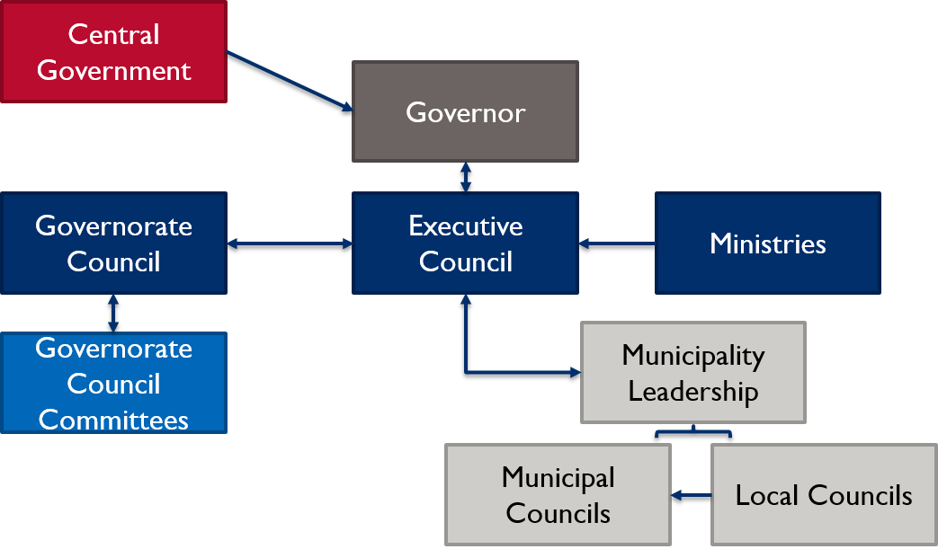

Cities Implementation
USAID commissioned Cities Implementing Transparent, Innovative, and Effective Solutions (CITIES), a five-year activity that Chemonics International started implementing in October 2016, to further assist the Government of Jordan (GoJ) in its efforts to improve local service delivery and governance, citizen engagement, and accountability at the municipality level. CITIES will be implemented in 33 municipalities across all 12 governorates in Jordan.

CITIES implementation is based around four components that cut across its overarching decentralization facilitation goal:
- Improved Service Delivery: Illustrative activities include the Development of Service Delivery Improvement Plans (SDIP); assistance with solid waste management (SWM); conducting municipal institutional capacity assessments (MICA); and additional activities that align with MOMA priorities.
- Increased Effectiveness of Local Government Operations: Illustrative activities include analysis on legal and regulatory frameworks; review of human resources, financial, organizational, and budgetary management in municipalities.
- Increased Responsiveness to Community Priorities: Illustrative activities include support for the Ministry of Political and Parliamentary Affairs; and assessment of public outreach tools.
- Enhanced Capacity to Promote Community Cohesion and Resilience: Illustrative activities include youth engagement, grant support and local development capacity building.

By strengthening municipal institutional capacity, improving public service delivery, and strengthening community resilience and cohesion, it is expected that citizens will ultimately judge their local municipality to be more responsive to their needs and more effective in executing their core functions. As shown in the figure below, most of CITIES activities are focused at the municipality level of government, but implementation for component 2 activities does include interventions at higher-levels, as well. The results of CITIES are expected to contribute to USAID’s development objective of stronger democratic accountability and a more stable, prosperous Jordan.

Figure 2 Jordan's Governance Structure and CITIES activities
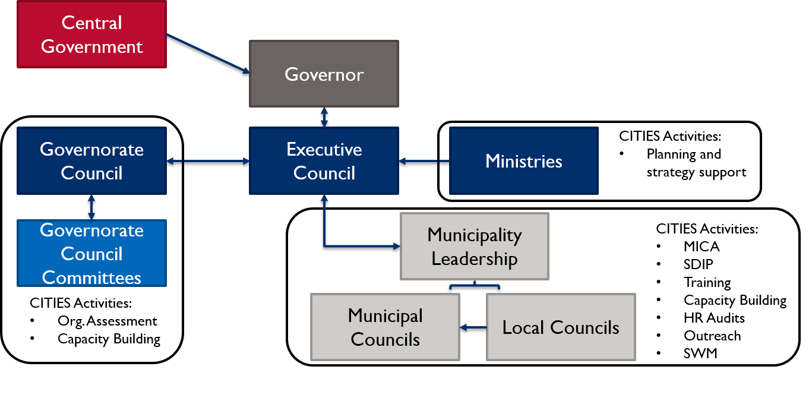

Evaluation Questions
The evaluation team has organized its work according to broad performance evaluation questions that examine activity effectiveness, sustainability, synergies, and learning. Impact measurement aim to test specific hypotheses under activity effectiveness. Qualitative/mixed methods inquiry will address broad themes of sustainability and synergy. Finally, a set of learning agenda questions will formalize what can be learned analytically through triangulation of data sources and secondary data analysis. Additional lines of inquiry may be added as the evaluation team learns more about implementation, and CITIES adapts to local municipality needs. The evaluation questions are summarized below.
Table 1 CITIES evaluation questions
Theme | Question(s) | Approach
Effectiveness | - What is the overall effectiveness of CITIES for achieving its goals of enhancing democratic governance, improving trust and confidence in elected officials, and strengthening stability?  1a. Did the activity achieve its intended outcomes?  1b. Are there certain areas/activities and components  that have been more effective than other  areas/activities and components? | Effectiveness is measured by 10 indicators across six hypotheses. See the indicator list for additional detail.
Sustainability | - Which interventions under CITIES are most likely to be sustained over time? Why and how? To what extent are CITIES capacity building efforts being sustained by municipalities and other targeted bodies of decentralization? | Qualitative inquiry, triangulation of data sources, expert observation and judgment
Synergies | - How well has CITIES developed synergies (coordination and collaboration) with other USAID activities that focus on similar objectives, for example, decentralization and working with Municipalities? Are donors operating in the decentralization and local governance space achieving synergies through coordination or knowledge sharing? | Qualitative inquiry, triangulation of data sources, expert observation and judgment
Learning | - Based on the performance of CITIES, both in terms of effectiveness and sustainability, what are some key lessons learned, by component and sub-activity? | Summary reflection across all evaluation activities and data. Learning agenda questions for specific inquiries about the mechanics of implementation and outcomes.

The primary goals of this baseline report is to explore the internal validity and baseline equivalence of the approximately 10 indicators mapping to seven hypotheses explicating the CITIES theory of change. Given the data that were available, this report is limited to institutional level measures covering Hypotheses 1-3 (see below). As public perception measures are captured through other USAID survey activities, such as the General Population Survey, the evaluation team will update its analysis to cover Hypotheses 4-7. The complementary qualitative inquiry that accompanied the institutional level data collection provide valuable context for the broader performance evaluation questions where possible. The role of this baseline report is not to provide answers to the evaluation questions, but to generate findings for comparison with later data collection rounds. The broader performance evaluation questions will be addressed in full in the endline evaluation report.

CITIES Development Hypotheses, Theory of Change, and Indicators
According to the CITIES Monitoring, Evaluation, and Learning (MEL) plan, if municipal government effectiveness and service delivery is increased, and if municipalities are better able to address the priorities of their community members while promoting community resilience, then democratic governance will be enhanced; trust and confidence in elected officials will be improved; and stability will be strengthened. A simplified theory of change (with arrows denoting the ‘how’ rather than ‘so what’ question) is as follows:
Figure 3: Simplified CITIES Theory of Change Diagram
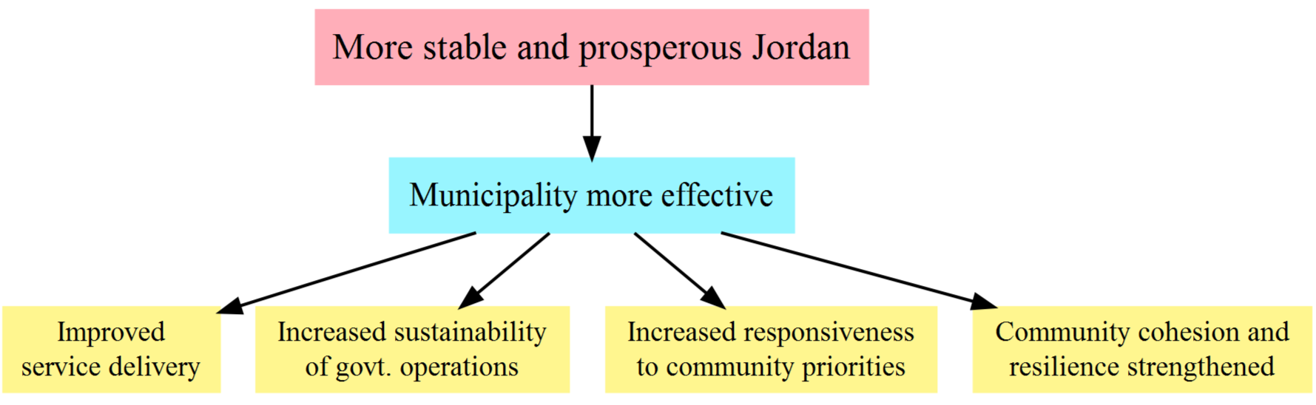

In order to more fully delineate the primary pathways by which the CITIES intervention could meet its objectives, the evaluation team expanded the results framework into a more detailed logic model to help guide the evaluation. The figure below follows the various programmatic streams under CITIES and relates these through seven hypotheses to key outcomes and overall goal.

In this extended logic model, boxes in yellow represent programmatic inputs, light green boxes represent intermediate outcomes, light blue boxes represent activity outcomes, and purple boxes represent mission-level outcomes. All boxes feed into the overall USAID mission goal of a stable and prosperous Jordan. Note that the highest-level impact indicator in the CITIES MEL plan is municipal government effectiveness, while the CITIES evaluation includes the higher-level impact measures of confidence and stability. For accountability purposes, CITIES performance targeting applies only to its sub-purpose outcomes of service delivery, institutional capacity, responsiveness, and cohesion, and its activity level impact measure of municipal government effectiveness.

Figure 4: Evaluation Theory of Change
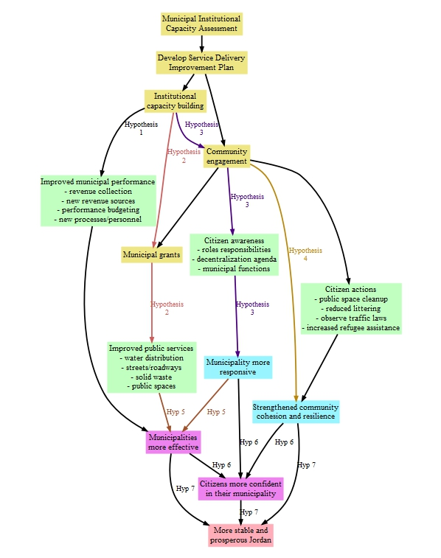

For measurement and learning purposes, the overall CITIES development hypothesis and theory of change is broken into seven constituent hypotheses based on how programmatic inputs and activity outcomes may interact to produce desired results. This also enables the evaluation team to better assess the different aspects of activity implementation and their respective contributions to observed outcomes. However, while the validity and directionality of each hypothesis will be explicitly tested, and the evaluation learning agenda will examine how the failure of one hypothesis may affect downstream hypotheses, the figure above cannot pretend to fully capture the realities of activity implementation. Rather, this extended logic model is designed to identify hypotheses that contribute to mission learning about what works and what doesn’t, but also recognizes that actual interactions from implementation will likely remain too complex to be fully diagrammed. These constituent hypotheses referenced in the figure above are presented in the table below.
Table 2 CITIES Evaluation hypotheses for measuring effectiveness
Evaluation question | Hypothesis
1. Effectiveness | Hypothesis 1: If CITIES provides institutional capacity building, then municipal operations will improve.
1. Effectiveness | Hypothesis 2: If CITIES provides institutional capacity building, combined with incentive grants and improved public service delivery, then this will lead to an improvement in the quality of public services.
1. Effectiveness  2. Sustainability | Hypothesis 3: If CITIES provides institutional capacity building, combined with proactive outreach by municipalities, then this will increase public perception that municipalities are responsive to citizen needs.
1. Effectiveness | Hypothesis 4: If CITIES supports increased attention to marginalized groups, such as youth, gender, nationality, and disability, then this will strengthen a sense of community cohesion and resilience.
1. Effectiveness  3. Synergies | Hypothesis 5: If CITIES provides institutional capacity building, combined with proactive outreach and increased / improved public service delivery, then this will increase public perception that municipalities are effective.
1. Effectiveness  2. Sustainability  3. Synergies | Hypothesis 6: More effective public service delivery, responsiveness to citizen needs, and strengthened community cohesion and resilience will increase citizen confidence in their municipality.
1. Effectiveness  2. Sustainability  3. Synergies | Hypothesis 7: More effective public service delivery, confidence in local leadership and performance, and strengthened community cohesion and resilience will lead to a more stable and prosperous Jordan.

General Population Survey
One of the key data sources for this evaluation is data from a large-scale survey that USAID/Jordan has commissioned to collect mission project and activity performance data. The survey measures cover six mission performance indicators across multiple sectors, including CITIES-related service delivery and citizen engagement measures. The general population survey data is a separate, but critical piece to the overall CITIES evaluation. USAID has commissioned MESP to conduct the first round of the general population survey from May 27th to September 4th, 2018. The evaluation team will incorporate the general population data into its baseline analysis once a final dataset becomes available to develop a descriptive assessment of differences across assignment groups.

The evaluation team will draw from this general population survey to estimate household-level changes in both CITIES and non-CITIES municipalities to test hypotheses on citizen engagement and government responsiveness and effectiveness. At endline, the evaluation will measure these hypotheses through a set of 10 indicators. Each of these have been mapped to the evaluation questions (presented here by their themes for brevity), the data source, disaggregation approach, and analysis method. The indicators are as follows:
Table 3 Evaluation indicators
Hypothesis | Indicators | Data Source | Disaggregation
Hypothesis 1: Institutional capacity building will improve municipal operations. | - MICA Services Score  - MICA GESI Score  - Municipality Revenue  - Budget allocation to salaries | - MICA assessment data  - Available municipality administrative data  - KIIs | Municipality, district, governorate, region
Hypothesis 2: Institutional capacity building, combined with incentive grants, will improve the quality of public services. | - Availability of services  - Perceived quality/availability of services | - Beneficiary survey  - Population survey  - KIIs  - FGDs | Service, municipality, district, governorate, region, gender, age, education
Hypothesis 3: Institutional capacity building, combined with proactive outreach by municipalities, will increase public perception that municipalities are responsive to citizen needs. | Perceived municipal responsiveness | - MICA assessment data  - Beneficiary survey  - Population survey  - FGDs  - KIIs | Municipality, district, governorate, region, gender, age, education
Hypothesis 4: Increased attention to marginalized groups such as youth, gender, nationality, and disability will strengthen a sense of community cohesion and resilience. | Perceived municipal effectiveness | - Beneficiary survey  - Population survey  - FGDs  - KIIs | Municipality, district, governorate, region, gender, age, education
Hypothesis 5: Institutional capacity building, combined with proactive outreach and increased / improved public service delivery, will increase public perception that municipalities are effective. | Perceived ability to address common problems | - Beneficiary survey  - Population survey  - FGDs  - KIIs  - Activity and municipality documents | Municipality, district, governorate, region, gender, age, education
Hypothesis 6: Improved public service delivery, increased public perception of municipal responsiveness and effectiveness, and a stronger sense of community cohesion and resilience will lead to an increase in public confidence in municipal / local governance. | - Confidence in local government  - Trust in local government | - Beneficiary survey  - Population survey  - FGDs  - KIIs  - Other activity documents | Municipality, district, governorate, region, gender, age, education
Hypothesis 7: More effective public service delivery, confidence in local leadership and performance, and strengthened community cohesion and resilience will lead to a more stable and prosperous Jordan. | - Quality of life  - Composite measures | - Beneficiary survey  - Population survey  - FGDs  - KIIs  - Other activity documents | Municipality, district, governorate, region, gender, age, education

Implementation Fidelity
Ensuring that the basic assumptions about implementation hold is critical to the internal validity of any evaluation design. The evaluation team has undertaken regular implementation fidelity checks to ensure that any potential risks to the validity of the design are discovered quickly and any changes in implementation, from actual activities and scope to the general timeline of CITIES, are discussed early enough to address in a methodologically sound manner.

The risks of ignoring implementation fidelity range from potentially misunderstanding aspects of activities to increasing error in estimates and reducing the effect size that endline analysis detects. To avoid these issues, the evaluation team has requested access to the regular reporting of CITIES (e.g. quarterly and annual reports). The evaluation team continues to work with USAID and CITIES for check-ins with the CITIES staff to address any potential challenges or changes based on review of the quarterly reports and follow-up on developments in the municipalities. Throughout baseline data collection and moving forward, evaluation team worked with CITIES and USAID to schedule visits to treatment group municipalities to meet with municipal staff, such as the head of finance, executive director, mayor, head of human resources, and other relevant leaders, to see how implementation on the ground compares to planned and reported activities.

As result of this coordination with the CITIES team, there were several updates to implementation that were not planned at the time of the evaluation design proposal. As part of its outreach efforts, CITIES implemented a nationwide public awareness campaign. From March through mid-June 2018, CITIES worked in all 99 municipalities to share information on decentralization with key stakeholders. This included outreach to local community members, local councils, municipal councils, and mayors to address the decentralization and municipalities laws. These activities may have implications for the evaluation in that they may affect certain MICA items and qualitative responses during future data collection rounds since citizens may be more aware of the role of their local government within the context of decentralization. One concern that was raised was whether this would undermine the validity of comparing treatment and control municipalities. Given that both treatment and comparison groups received the outreach on decentralize, the evaluation team would expect that, on average, equivalency would be maintained since targeting was universal. In its inferential analysis, the evaluation team may need to investigate the relationship between these activities, covariates, and the outcomes of interest.

The evaluation team will continue to monitor CITIES implementation to determine what, if any, changes may need to occur for future analyses. The table below shows illustrative activities, the parties involved, and the frequency for implementation fidelity.
Table 4: Implementation Fidelity Plan
Activity | Description | Status
Status Updates | Formal discussion of implementation and evaluation progress, highlight changes, discuss potential next steps or updates. | Sessions conducted in Feb and Aug 2018
Implementation Tracking | Work with MEL team to develop tracking inputs. This will be a one-off meeting initially and then incorporated into the quarterly status updates. | In progress
Document Distribution | Sharing of implementation documentation, such as municipality reports and work plans. | In progress
MICA synthesis | Shared review of MICA scores between implementation and comparison areas to ensure consistent implementation of the tool and to walk-through updates or changes enacted by CITIES | Conducted Aug 2018
MEL Data check | Review of municipal rosters, Component 2 HR audits, Component 1 MICA data, other MEL data. Share data from surveys, activity monitoring, municipality tracking, and other activities; the evaluation team will then input this data as part of their regular tracking for analysis | In progress. CITIES baseline data shared in Feb 2018, municipal roster data shared in Aug 2018
Fidelity Interviews | Brief KIIs with municipality administration and leaders to understand implementation adherence, delivery, and differentiation. | To be completed as part of midline evaluation (~ Oct 2019)

The goal of implementation fidelity is not to evaluate CITIES implementation through some additional approach or make planned versus actual judgments, but rather to ensure that if and when changes to implementation occur, the evaluation team can adequately and accurately account for them in their analysis and design. Any qualitative fidelity interviews with municipality staff will follow a semi-structured format based on a general interview template to be developed based on review of the CITIES work plans. The quarterly check-in calls with CITIES will be unstructured and allow both the evaluation team and CITIES staff to openly discuss potential challenges and progress on both sides.

Annex 1 contains summary meeting notes from the two rounds of implementation fidelity conducted to date, covering FY18-Q2 and FY18-Q3.

Evaluation Design
As described in the evaluation design proposal, there are two key design features of this evaluation:
- Matching process for the construction of a comparison group
- Qualitative data collection and analysis

This section provides a brief overview of these three design features.

Matching for Comparison Group Construction
In the absence of randomizing the assignment to treatment, grouped data by beneficiaries and non-beneficiaries is not directly comparable due to observable or unobservable differences between groups in addition to treatment status. One wishes to know how the treatment effects beneficiaries, but cannot be sure if any observed group differences are driven by treatment or some other observable or unobservable difference between groups.

A common tactic is to use observable characteristics to attempt to adjust for these differences and thereby generate “as-if” random assignment allowing a direct comparison of the outcomes between the two groups as the estimate for activity impact. Under this approach, researchers create pairs between each implementation unit and a comparison unit on the exact same observed characteristics; however, this can quickly become onerous and difficult if the number of observable characteristics required to find one-to-one matches is large. One alternative method of applying this tactic is to select a sub-sample of your data beforehand using Propensity Score Matching (PSM). Under propensity score matching, a select number of observable characteristics are used to generate a predicted probability of belonging to the treatment group. This predicted probability (the propensity score) is then used to match treated and comparison units based on the theorem that if they match on the score generated from observable characteristics, they essentially match on the specific values of the observable characteristics as well.

CITIES is being implemented in 33 municipalities, including all 10 of Jordan’s Class A municipalities. This leaves 23 municipalities available to match. Time and cost constraints limited the potential pool of comparison municipalities to 15, and matching was done on the following observable characteristics:

- Poverty rate
- WB municipal grants (ESSRP)
- Refugee population
- North region
- Community Engagement Project
- Class C
- Log population
- Class B
- South region
- Central region

The matching analysis described in the design proposal suggests that on these observable metrics, there is statistical equivalence between 15 CITIES municipalities and 15 comparison municipalities. As discussed later in this report, it is important to re-visit the assumption of equivalence on the outcome of interest at baseline to ensure this similarity holds and to determine what adjustments may be needed at endline. The design report provides a more detailed summary of the matching process.

As detailed in the design report, the basic measurement to estimate outcomes between the two assignment groups will follow a difference-in-differences (d-i-d) approach, in which a sample of both treated and untreated units (in this case, municipalities) are examined before (baseline) and after (endline) treatment. Examining the first differences in outcomes across both groups (trends) rather than at single points in time (levels) has the important effect of removing any unobserved sources of bias in the data that are common to both groups and remain constant over time. The difference between the trend lines of each group (the second difference) then generates an estimate of the overall treatment effect.

Qualitative Performance Evaluation Analysis
To better understand the implementation context beyond quantitative metrics, this evaluation also features a significant qualitative portion. The evaluation team will analyze transcribed data from the FGDs and KIIs using content analysis techniques, in which text will be coded according to key themes of interest across the interviewees and discussion participants. The team will summarize responses related to each theme and include quotations from respondents to illustrate key findings. This will include highlighting “outlier” responses and experiences, such that the range of responses will be captured in the summary write-up. The team will also make planned/actual comparisons in answering evaluation question 1. The evaluation team will make comparisons between activity descriptions, work plans, targets, and periodic performance data to inform the examination of CITIES’s performance relative to overall perception of the activities. Throughout the analysis phase, the team will identify where male/female and youth/adult responses and experiences appear to be parallel and where they differ, for example with respect to civic engagement, outreach efforts, understanding of municipality’s roles in services.

Baseline Data Collection

Qualitative Data Collection
As part of the CITIES IE, qualitative data was collected in both treatment and comparison municipalities. In addition to supplementing quantitative data and addressing evaluation questions, qualitative tracking was needed to analyze the technical, regulatory, and relational dimensions of the various municipal functions mandated in the Municipalities Law. Tracking decentralization reforms and collecting contextual data was also important to understand the municipalities and CITIES’ ability to improve these functions.

The evaluation team conducted 20 individual KIIs drawn from: GoJ line ministries; local government (heads of governorate councils and executive council members); municipal councils and staff; local councils, and donors who are implementing projects in the same programmatic space as CITIES. Interviewees were selected based on their affiliation and familiarity with the CITIES’ focus areas and ability to address questions related to the project’s interventions and inform learning.

Respondents included a cross-section of officials at the national, municipal, and local levels. KIIs with central and local government representatives, municipal officials and donors included the following:

- Mayors of Zarqa, Manshiyyet Bani Hassan, Mazar Al-Shamali and Al-Khaldiyyah municipalities;
- Municipal council members from Zarqa and Al-Jeeza municipalities;
- Local council members from Deir Alla and Al-Jeeza municipalities;
- Heads of the governorate councils of Zarqa and Al-Tafileh governorates;
- Members of the executive councils of Irbid and Madaba;
- Six government officials from from national ministries;
- Local CBOs in Al-Jeeza and Al-Tafileh municipalities;
- Donors including the Federation of Canadian Municipalities (FCM), the Organization of Economic Cooperation and Development (OECD), World Bank, the Spanish Agency for International Development Cooperation (AECID) and the French Development Agency (AFD).

The instruments for qualitative data collection are presented in Annex 8. The guides were designed to preserve the potential for a relatively free-flowing conversation, while creating a standardized format to facilitate a reliable and comparative analysis of data pertaining to the evaluation questions for triangulation of information. While the questions in the guides were based on the study’s overarching objectives, they were tailored depending on the identity of the informants.

Quantitative Data Collection
The Municipal Institutional Capacity Assessment (MICA) is CITIES’s primary tool for determining a municipality’s service delivery capacity and a key quantitative input for the evaluation. The evaluation team used CITIES MICA tool with the aim of collecting equivalent quantitative data in each of the 15 comparison municipalities (Annex 2 provides more information on this process). CITIES provided MICA scores for each of their municipalities to serve as the treatment group.

The evaluation team used the CITIES MICA tool to score each comparison municipality using an ODK form. The evaluation team used the same form to re-enter MICA scores from CITIES’s municipalities, as well, to create a data set that contains the full universe of all MICA scores, including those municipalities that were not strong matches.

Chemonics, the CITIES implementing partner, developed the MICA as part of an activity in Afghanistan. CITIES has adapted the tool for the Jordanian context and described it as a way to “start a conversation” around its implementation approach in each of its municipalities. The Assessment, according to CITIES staff, is only a first step to build a picture of where services can be improved. After scoring the municipality, CITIES staff facilitates the development of the Service Delivery Improvement Plan (SDIP), which is a demand-sided process that helps community members identify priority interventions for CITIES to support. These may or may not correspond with the needs identified through MICA.

Change in the MICA scores is the empirical measure used to document changes at the municipal institutional level. MICA scoring items will also guide some of the qualitative inquiry to understand how specifically CITIES achieved a given outcome. Given the importance of MICA scoring for both implementation and estimation of CITIES’s impact, assessment of the MICA scores themselves is warranted to ensure reliable, minimally biased estimates.

The final set of scores produced internally within the evaluation team scoring of the 15 comparison municipalities was subjected to review by the CITIES Component 1 lead to ensure reliable and consistent scoring. As discussed in Internal Validity of MICA Scores section, the evaluation team conducted an analysis of its own scoring across multiple MICA raters to develop a final set of comparison municipality scores. Upon arriving at final scores in comparison municipalities, the evaluation team conducted a final review of scores and their justification with the CITIES Component 1 lead. This led to a few modifications of comparison scores in order to harmonize the interpretation of scoring criteria across the CITIES and evaluation teams. This scoring was labeled as ‘Alternate’ and maintained as a separate set of outcome values for the purposes of conducting sensitivity analysis. While the alternate scoring would be the preferred choice among either, ideally any CITIES treatment effect should persist across both. The values and figures in this document report the “alternate” scoring that was determined in coordination with CITIES.

Evaluation Limitations
As outlined in the evaluation design proposal, there are several key limitations to the approach of this evaluation.
- Unobservable factors and data scope: the quantitative portion of this evaluation relies on the MICA tool to determine changes in municipality management and service provision. This tool was designed to help CITIES target its implementation not to fully capture municipality performance. There may also be factors that affect MICA scores that are not part of CITIES’s implementation. For example, social connections may affect item-level changes on the MICA, but would not be captured. The evaluation team’s qualitative data collection aims to fill the gap, but still relies on respondents being aware of or forthcoming about otherwise unobservable or indirect factors. In addition, the effect of any given MICA item on citizen perception is unclear. Aggregate scores are the main outcome of this evaluation, but it remains to be seen through qualitative data how item-level and aggregate MICA scores relate to perceptions and experiences.
- MICA Scoring: The MICA tool was designed as a rapid assessment tool not a data collection instrument. In its deployment of the tool, CITIES staff were not collecting “baseline” data, but informing an implementation approach. The MICA items were not rigorously pre-tested in the field prior to launching as would be expected for standard data collection. From a survey methods perspective, the MICA presents many limitations. For one, there is quite a bit of subjectivity in how items are scored. Although scores should, in theory, be verifiable, the experience of both CITIES and the evaluation team suggests that there may be variation based on when and with whom the MICA is conducted. This kind of sensitivity in measurement can present uncertainty around any analysis. To mitigate this challenge, the evaluation team will aim to be transparent in its approach and to present results based on various configurations to assess reliability.
- Internal validity: one challenge of using the MICA tool across both the implementation and evaluation teams is that each team may interpret the MICA items differently. If these differences are significant it could threaten the internal validity of the evaluation. To mitigate this risk, the evaluation team has held multiple trainings with CITIES and reviewed its scores with the CITIES MICA team. However, given that there is some room for subjectivity within the MICA tool itself, the evaluation team has also undertaken its own reliability tests to ensure that the evaluation team is consistent in how it has applied the tool. The internal validity of the data will be critical to monitor through the evaluation’s data collection rounds.
- Recency and recall biases. The evaluation team will utilize administrative and implementation data, such as MICA scores, for its estimation of CITIES impact. However, a large portion of understanding how decentralization is progressing involves asking people about their perceptions of how decentralization is progressing. This creates several challenges. Notably recency bias, where in people remember whatever has happened most recently, whether good or bad, rather than what has occurred over a certain period of time. Recency bias can be an issue even when questions are asked about, “the past 12 months.” Similarly, recall bias relates to the fact that people do not always remember what activities have taken place or the details of their involvement. For example, people may not recall that municipal leaders held outreach events or introduced new street cleaning activities if they did not occur in the proximate past. The use of multiple data sources, as well as multiple data collection periods, will help mitigate some of the effects of these biases. The use of well tested survey instruments can also help improve responses and diminish the potential risk these biases pose.
- External validity. The nature of the CITIES activity imposes limitations on the external validity of the evaluation (i.e., the extent to which the evaluation findings can be expected to predict the impacts of a program like CITIES undertaken in a different country or in Jordan at some point in the future). First, as noted in the background section, Jordan has undergone multiple institutional reform efforts and it is likely that changes to the local governance context will continue to evolve. The results from this IE may not hold in a future context or even at a different governing-level. Secondly, any results from an IE come with critical caveats that often get forgotten in the shadow of key findings. The evaluation team will strive to make the limits and exceptions of their analysis clear. Causal attribution can be highly sensitive to underlying assumptions and analytical specification. The extrapolation of the IE results to a broader understanding of decentralization efforts may not be valid and should be informed by detailed understanding of this report.
- Changing implementation context: The evaluation team has worked closely with CITIES to track implementation and understand the implications for this evaluation. In some cases, this has meant noting when activities are applied across both assignment groups; in others, it will mean additional qualitative inquiry during future data collection rounds to see how perceptions of need have changed over time and if this has led or lagged implementation activities or broader changes in Jordan. CITIES implementation approach is responsive to local needs, which is valuable for beneficiaries as it likely increases the relevance of activities. If interventions are provided that, for example, do not affect directly affect MICA scores it may be the case that no impact is found when positive changes did in fact occur; as noted above, the MICA may not measure all of CITIES activities. Strong communication between implementation and evaluation teams and implementation fidelity tracking will help mitigate this limitation, but it still may be the case that changes in CITIES approach occur that are not controlled or accounted for through the evaluation team’s analysis.
- Failure to capture a true baseline. In a few municipalities, CITIES initiated activities prior to the MICA measurements in comparison municipalities. For all CITIES municipalities, the public perception survey was conducted after CITIES initiated its work but prior to execution of grants that would be most likely to affect public perception. The evaluation team must be alert to the possibility of substantive differences between treatment and comparison municipalities being caused by the onset of CITIES activities. This most typically will have the effect of underestimating any treatment effects as there will be some effect of programming that is captured as a baseline difference rather than a treatment effect.
- Other donor activity. The evaluation team estimates that there are currently 28 implementing partners operating across 48 activities in the democracy and governance space. The evaluation will be able to control for the biggest actors such as CEP, ESSRP/MSSRP, but will not be able to track all donor activity that may also effect CITIES outcomes. If untracked donor activity realizes substantive outcomes, it will distort the CITIES impact estimates in ways that depend on the distribution of that donor activity. For example, if there are untracked outcomes realized in comparison municipalities (the most likely scenario), it will have the effect of a) underestimating the CITIES treatment effect under the assumption of comparing CITIES to no intervention, or b) will shift the impact estimate to be how much CITIES is to the alternative of other donor programming. The safest interpretation under this threat is to assume that the comparison municipalities have some level of other donor programming relevant to CITIES outcomes.

MICA scoring process and SCORE unification
The main quantitative portion of this evaluation relies on the use of the Municipal Institutional Capacity Assessment (MICA) tool. The tool, which scores municipalities from 0 to 5 across 23 items related to municipal services and 0 to 1 on 17 items related to Gender and Social Inclusion (GESI), was designed to guide implementation decisions. The evaluation team is using the MICA as a data collection tool to measure changes between treatment and comparison groups in overall MICA scores.

The evaluation team worked with CITIES to mimic their overall MICA implementation approach. The general MICA scoring process works as follows:
- MICA review: Education session on the MICA, including an item-by-item review and discussion of different scoring scenarios.
- Implementation: Meetings with municipality leadership, including mayors, council leaders, and other relevant staff, to conduct MICA. This step may require multiple visits depending on the availability of information and staff.
- Score review: the scorer reviews all notes taken during implementation and initial scores given. The scorer may discuss scores with a technical lead or peer, as well as make follow-up calls to the municipality to corroborate or clarify information. Final scores are submitted. A technical lead conducts a final review and any changes or clarifications are made before scores are finalized.

For the evaluation team, fourth and fifth steps were added:
- Synthesize scores: as detailed in this report, the evaluation team used multiple scorers for each comparison municipality. After review of scoring differences, the scorers discuss and align their scores, making any additional municipality follow-ups as needed. This results in a preliminary final score for each item in each municipality.
- Confirm scores: to ensure alignment in implementation with CITIES use of the MICA tool, the evaluation team reviews all their scores and notes with the CITIES Component 1 lead. A final set of scores are developed based on this step to ensure that both the evaluation team and CITIES have comparable scoring approaches.

This process results in three sets of scores that are combined into a single dataset for accessible analysis:
- CITIES generated scores
- Synthesized evaluation team scores
- Final confirmed scores

Key Findings by Evaluation Question/Thematic Area

Evaluation Question 1: Effectiveness
Baseline data suggest that the overall effectiveness of CITIES for achieving its goals will be subject to influence from within and outside municipalities. These factors include limits on the ability to raise own revenue and systemic constraints to staffing and capacity building. Endline data will provide more insight into whether the activity achieved its intended outcomes and what activities or components were more or less effective. Among the factors that will affect the project’s ability to meet its objectives are elements outside the municipalities span of control and that form their macro-environment. These play out in a largely dysfunctional financial system that allows a large share of salary costs in municipal budgets—48 percent and 45 percent of budget expenditure in the comparison and treatment municipalities, respectively, went toward salaries—and limits the ability to raise internal revenue. There are also challenges with existing bureaucratic patterns within the central government, limited autonomy to hire and fire staff, rising administrative costs associated with additional tiers of local government without commensurate government allocations, and partial de-concentration that devolves certain authorities without affording an adequate level of flexibility for municipalities to perform their roles.

Findings related to EQ1 fall into the following thematic categories relevant for understanding the municipality context and factors that may affect CITIES overall effectiveness:
- Municipal Services and Control
- Community Engagement within Municipalities
- Role of Local Councils
- Role of Governorate Councils
- Perceptions of Decentralization

Municipal Services and Control
According to municipal staff, the municipal sector remains mired in challenges with both external and internal factors affecting its ability to provide quality services to constituents. Weak financial stability, few citizen feedback mechanisms, unclear and unfunded service provision mandates, and other issues detailed below were all found to affect municipal services and control.

The dearth of resources and overall weak financial situation is among the municipal sector’s main challenges. Weak tax collection and the limited ability to raise other internal revenues; the lack of control over government appropriations as well as a significant portion of revenue diverted to salaries, electricity and sometimes to extra-jurisdictional costs the central government will not bear, limits the range of activities and services municipalities can engage in. “We can only provide waste management services,” a municipal council member commented.

Another challenge is information sharing and feedback for service improvement. Item-level quantitative analysis of the MICA tool shows that most of the comparison municipalities, for example, do not have proper citizen complaint response mechanisms even if there were the budget to provide services. MICA item 1.1 assesses citizen services with scores ranging from 0 to 5. A score of 0 implies that, “The municipality has no formal mechanism for responding to citizen requests for information about services” while a score of three is characterized by a complaint mechanism for collecting citizen requests, “operational Citizen Service Desk (or other type of service center),” the ability to receive fees for licensure and permitting, and “an accurate document tracking system; and has a complaints mechanism.”
Figure 5: MICA Item 1.1 Citizen Services Score Count by Assignment

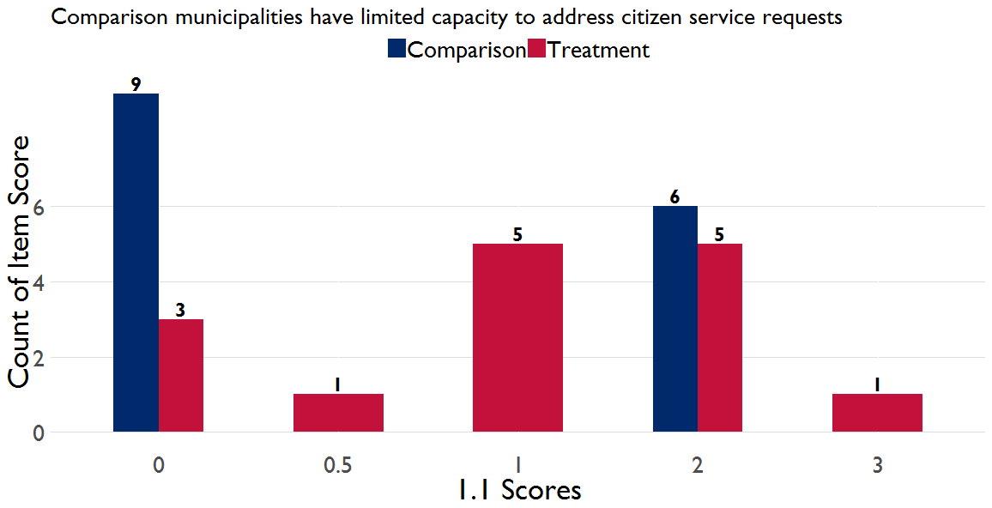
The comparison municipalities MICA item 1.1. scores were skewed between 0 and 2, while five treatment municipalities received a score of 1 and six received a score of 2, suggesting that many of the CITIES municipalities have some person or mechanism to address citizen requests or complaints. However, the context is more complex than the above figure may suggest.

During qualitative interviews, several executive directors said their municipalities are providing services beyond their territorial jurisdictions because for years the government has not expanded the borders of the municipalities’ regulated areas. “The biggest challenge we face is that the expansion of the regulated areas was last done in 1995. Fifty percent of the municipality is outside the regulated area. Even though we are not allowed to service these areas, we do,” the head of an LDU said. This jurisdictional issue was raised during MICA data collection, as well, further complicating how to properly score items related to service provision.

Municipalities are also often required to service main roads the Ministry of Public Works or the Electricity Company are mandated to cover. “Many ministries such as transportation, public works and water are not doing their job especially MoMA. When they do not fulfill their responsibilities, our own performance is affected,” an executive director said. A mayor subsequently commented on the effect this has on citizens’ perceptions of the municipality: “Amman Jerash street is a problem. People think we are responsible for the street when we are not. The Ministry of Public Works is not responsive. People tell us the health center does not have medicines. This is really not our job.”

The MICA tool captures data on items that are outside of the span of control for municipalities. This allows for some triangulation between the key informants who reported citizen expectations for services for which the municipalities are not responsible and third-party municipal assessment. MICA item 4.6, for example, covers waste water management. A score of zero suggests that municipalities do not have a sewage network, with scores one through three given based on the percentage of buildings connected to the sewage system. A score of four is given if there is a sewage system and the ability to address complaints related to the system; while a score of five is given if the sewage system is connect to a water treatment plant with effluent that can be re-used. Each of these scores, from the presence of a sewage system to a treatment plan, deal with a public good over which there is limited local control or input.

As shown in the figure below, the assignment groups were almost identical for item 4.6, with scores heavily skewed toward zero. Both the treatment and comparison groups had a single municipality that received a score of two—Sahab and Manshiat Bane Hasan, respectively—but aside from these, MICA data collection confirms the perceptions among KII respondents that municipalities cannot deliver certain key services on their own despite citizen expectations.

Figure 6: MICA Item 4.6 Score Distribution by Assignment
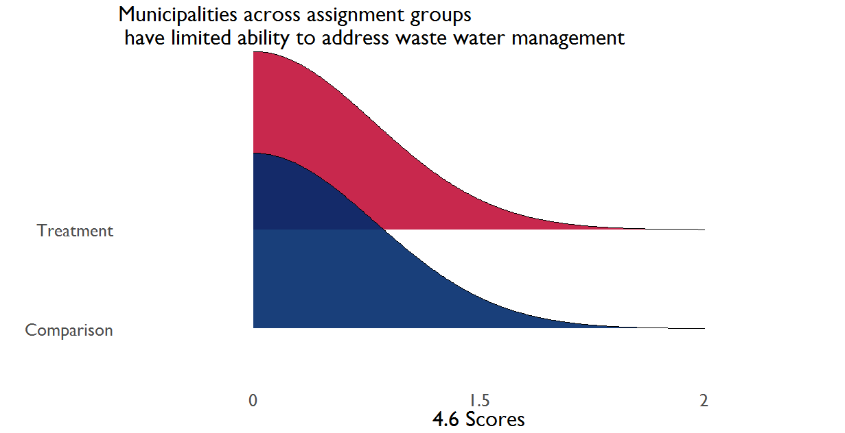

The lack of autonomy to make decisions on key services also limits municipal performance. An executive director said that municipalities do not have independent authority to make investment decisions. Another LDU head said that his unit was able to attract an investor and work out the parameters of a lucrative investment project, which the ministry later refused for reasons he does not understand and cannot contest. Another executive director said: “Most of the land is agricultural. Agriculture law prohibits use of land for other purposes. When we get investment opportunities, we don’t have land for them.”

Limitations to autonomous municipal action extend to the ability to hire and fire staff. Municipal respondents said they have little say about the qualifications or selection process of new employees. “I ask for one, civil service sends me one, I have to choose that person whether qualified or not. I don’t get options,” one mayor said. The executive director of another municipality said: “MoMA determines qualifications for various positions. If we ask for a university graduate surveyor, they might say no. Tawjihi is enough. The health inspector in the municipality does not even have Tawjihi.” Commenting on the inability to manage unwanted staff, a municipal council member commented: “We have around 4600 employees. Many of them were appointed to appease someone. I believe half of them are at home receiving their salaries while doing nothing. This is a problem that has been going on for years.”

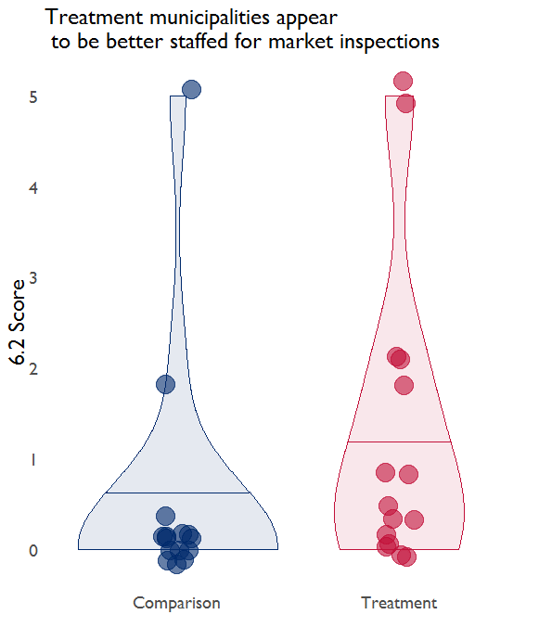
Quantitative data show that staffing challenges differed depending on the sector or focus area. For example, MICA item 7.2 addresses whether or not qualified staff are available to respond to calamities. Six treatment municipalities received a score of zero, i.e. there are no qualified staff available for calamity management, and only one treatment municipality received a score of three, suggesting there is a calamity plan, but staff do not receive training on it. In contrast, item 6.2, which addresses whether the municipality has staff available to conduct inspections of slaughterhouses to protect public health, shows that 12 comparison municipalities did not have any staff to fill this role. As shown in the figure to the right, most of the comparison municipalities received a score of zero for item 6.2, with the average item level score of 0.5 compared to 1.3 for treatment municipalities. Other MICA items, such as 5.1 (market inspections), also directly address staff qualifications. For MICA item 5.1, 12 comparison municipalities received a score of three, implying the municipality carries out regular market inspections and defines which goods can and cannot be traded. In contrast, only four treatment municipalities received a score of three for this item, with ten of the treatment municipalities receiving scores below three.
Figure 10: Item 7.2 MICA Scores by Assignment

Most municipal respondents highlighted the staff’s overall weak capacity and the need for technical support. Respondents reported the lack of technical staff to perform municipal tasks and the weak incentives to perform. Staff are regularly subjected to internal secondments that leave them holding several municipal positions at the same time. Category A municipal staff who are university graduates and tend to relatively be more motivated do not exceed 5% of the number of overall municipal staff. More problematic is that this “municipal leadership” cannot under the current system and circumstances hire and fire staff members. There are social and legal constraints that limit the ability of the higher echelon of staff to address this problem. One mayor in the north commented:

“I’ll be honest with you and tell you that I rely on 2 employees. The rest are not doing much; yes, they do receive all sorts of trainings but without use. All municipal employees have a very lax work ethic. They want to come late, they don’t want to work.”

The municipalities’ functional capacity to provide quality services is circumscribed by the ability to recruit and retain municipal staff. It is also limited by the municipalities’ ability to assign staff to specific positions and to determine their qualifications and job descriptions. Regardless of specific needs determined by the municipality, the central government makes final decisions as to the number and positions of new municipal staff. “We asked for a surveyor. MOMA changed the job position to a civil engineer. I already have 3 engineers. What I need is a surveyor. We know best what the municipality needs, but MoMA insists on interfering,” one mayor commented.

Three respondents commented on what they saw is an overemphasis of CITIES on capacity building. One mayor commented that the training component is more pronounced than the services support component. “What we need is that both components receive the same attention. Training should not trump other needs,” he said.

This analysis highlights how staffing capacity can be uneven. Within municipalities, the lack of clear delineation of tasks and responsibilities, conflicting and unclear chains of command, in addition to weak staff capacity especially among the lower tier of municipal staff is especially debilitating and hinders the provision of quality services to the public. Interviewed mayors saw the institutional development component of the CITIES project as being particularly beneficial. Some respondents lauded the technical nature of the training delivered by CITIES. One municipal council member said that the training provided to LDUs is very effective. In Zarqa, the mayor requested CITIES to provide specialized training to municipal units, and CITIES was responsive. At the same time, a local council member from the north expressed his reservations about the project and what he saw is its unnecessary focus on social cohesion. “We have tangible needs and they say they are restricted in what they can do. They have a work plan and need to stick to it.”

The theme of staffing, expectations, and ability to address service requests were all common themes within the context of assessing the overall effectiveness of CITIES for achieving its goals of enhancing democratic governance, improving trust and confidence in elected officials, and strengthening stability. The summary provided here highlights the challenges of municipal services and control at baseline. As discussed, the effectiveness of service provision can vary across treatment and comparison groups and within municipalities. Additional data collection rounds will allow the evaluation team to assess what areas or activities may address the staff, perception, and citizen service constraints.

Community Engagement within Municipalities
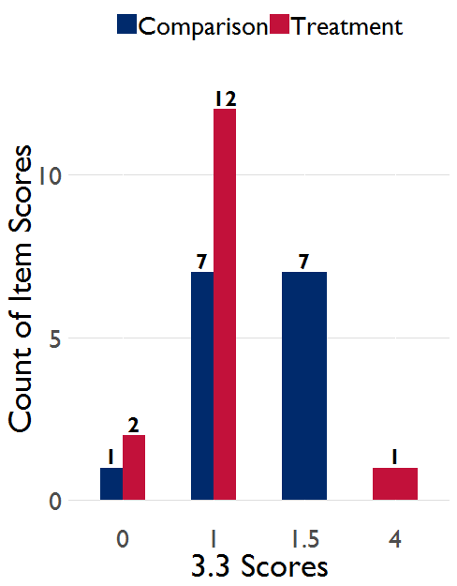
Municipal respondents reported that community engagement is mostly facilitated through the close personal relationships local and municipal council members have with community members. MICA data show that only two municipalities in each assignment group are not conducting citizen, community and business engagement to identify needs. Qualitative data collection revealed that council members rely on inspection rounds they undertake in their communities, Facebook pages, and direct contact with citizens who approach them when the need arises. For those municipalities with different districts, citizens engage directly with municipal staff at the main municipality building or with local council members at municipal buildings within the districts that make up the municipality. In the MICA tool, item 3.3 records whether or not a municipality conducts citizen engagement to understand local needs. A score of one for item 3.3 suggests occasionally engagement, while a score of four is defined by a municipality that “concretely addresses at least one citizen and/or community need.” As the figure to the left shows, there is at least a minimum level of engagement within the evaluation’s sample across both assignment groups.
Figure 11: MICA Item 3.3 Scores by Assignment

The needs guides that were prepared in almost all municipalities the evaluation team visited cover both municipal services as well as capital projects to be processed at the governorate level. The needs guide effectively covers services and projects that concern municipalities as well as those that could be supported if endorsed by the governorate council. An executive director said that the municipality includes both sets of needs in the guide but that the municipal services are only included to inform the executive councils of those needs. The filtering process, according to him, is undertaken by the executive council. Another respondent said the filtering process is undertaken by the LDU at the governorate level.

Without tangible results, municipal respondents worry that community engagement will backfire. The dearth of resources and the lack of investment projects were mentioned repeatedly as a cause of concern for continuous engagement. Local council members are worried about having to collect needs without the mandate to deliver services or implement projects. The 355 new local councils from 82 municipalities have been voted in. With no resources to deliver services, one mayor stressed that regular community engagement by the councils might backfire if funding does not materialize to cover the identified needs.

Most of the municipalities the team visited have already engaged their communities to develop their municipality-specific needs guide. The government mandates that municipalities through their LDUs engage community/tribal leaders, youth, and civil society to identify priority needs. Without other forms of systematic engagement, most interviewed municipalities held three meetings to determine needs. A CBO head in Tafileh said that the process to prepare the needs guide did not engender significant participation. In one of the meetings, sixty community members attended of which only ten were women.

The MICA data indicates that 14 of 15 comparison municipalities have LDUs that have trained staff on it, while four of the treatment municipalities did not. Municipalities receive a score of one for MICA item 3.2 if they have an LDU, but have not produced a local development plan, but higher scores—if the LDU has led to a local development plan (score of 2), developed a plan in consultation with the local community (score of 3), started implementation of a project as a result of LDU planning (score of 4), or been able to trace an improvement in services and revenue to the LDU plan (score of 5)—are contingent on engagement and socialization of the LDU and its planning. As shown in the figure below, no municipality received a score of four or five, and three municipalities in the comparison group scored a three, while two treatment municipalities scored a three and one treatment municipality scored a 3.5.

Figure 9: MICA Item 3.2 LDU Planning Scores by Assignment
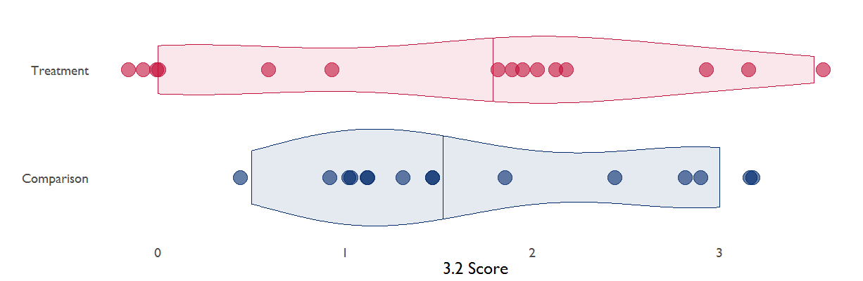

While participation is important for ensuring that citizens provide inputs into local governance, accountability is necessary so that public officials explain and justify their decisions to the people. To hold officials accountable, however, citizens must be aware of what officials are doing. Decisions taken during municipal or local council meetings are recorded following meetings but these records according to three respondents are not available to the public. One CBO representative commented that the problem is the lack of transparency associated with municipal and local councils work. “They could have done something but the community is unaware of their achievements, if any, because their action plans are not made public.”

In the same vein, the 2015 Municipalities Law requires the engagement of civil society in the development of the municipality needs guide. The two interviewed CBOs said that municipalities do not initiate engagement with civil society. CBOs proactively invite municipal staff to participate in their events or occasionally engage municipal council members in discussions about community needs. Both organizations do not lobby municipal representatives to be responsive or monitor their performance. Moreover, CBO representatives do not see their organizations functioning as a watchdog over local government. Their role, as they see it is to address needs in the community through training, charity or other basic support initiatives. One of the interviewed NGO representatives said civil society outreach efforts to engage municipal staff is ineffective because the mayor does not value the role of civil society.

It should be noted that the municipal organizational structure has not been reconciled with the 2015 Municipalities Law. While the law mandates that municipalities should engage civil society, there are still no municipal units or departments to take on this role in a sustainable fashion.

Role of Local Councils
The law mandates local councils to engage citizens, determine their priorities and channel them upwards so the needs can be processed, filtered, and funded. The new structure is meant to enable municipalities to be more responsive to citizens’ priorities and better placed to address them. Council members said the law does not clearly chart their role or responsibilities. Respondents complained of an unclear mandate and a lack of local budget allocation, which limits their autonomy and ability to act. Local council members said they have little authority to make decisions or effect change. One council member said, “I do not have the power to make one machine move.” Another council member used a similar analogy by saying: “We don’t even have the authority to open a fridge. I thought our role would be different…We are a liability on the municipal council, the mayor, and citizens.”

Local council members said their role is unclear. According to them, this lack of clarity in the delineation of responsibilities creates overlap and redundancy with municipal units and council. For example, one executive director said, “The law did not clearly delineate the mandate and power of the districts’ directors and local council members. The position of district director is not stipulated in the law so there is clear overlap with local councils.” In another municipality the executive director complained of continuous friction between local council members and district directors.

In all but one of the comparison municipalities, there was no mayoral reporting to municipal councils, and 10 of the treatment municipalities faced a similar situation. The local council members’ confusion voiced in the above quotes is widespread and seen in the figure below, which shows the distribution of MICA item 8.1 scores. This MICA item measures the planning and reporting between the mayor and local council. A score of zero implies no regular reporting, while a score of two, which four CITIES municipalities received, suggests that the mayor reports to the council “half yearly,” i.e. every six months, while a score of three is similar to a score of two, but given if the reporting allows for comparison to earlier reports. In the case of one comparison municipality, Ain Albasha, the executive director reported that he twice prepared reports about municipality achievements and needs, which he then submitted to the mayor, who in turn shared the reports with the municipal council, but this was not a regular occurrence.

Figure 10: MICA Item 8.1 Score Distribution by Assignment
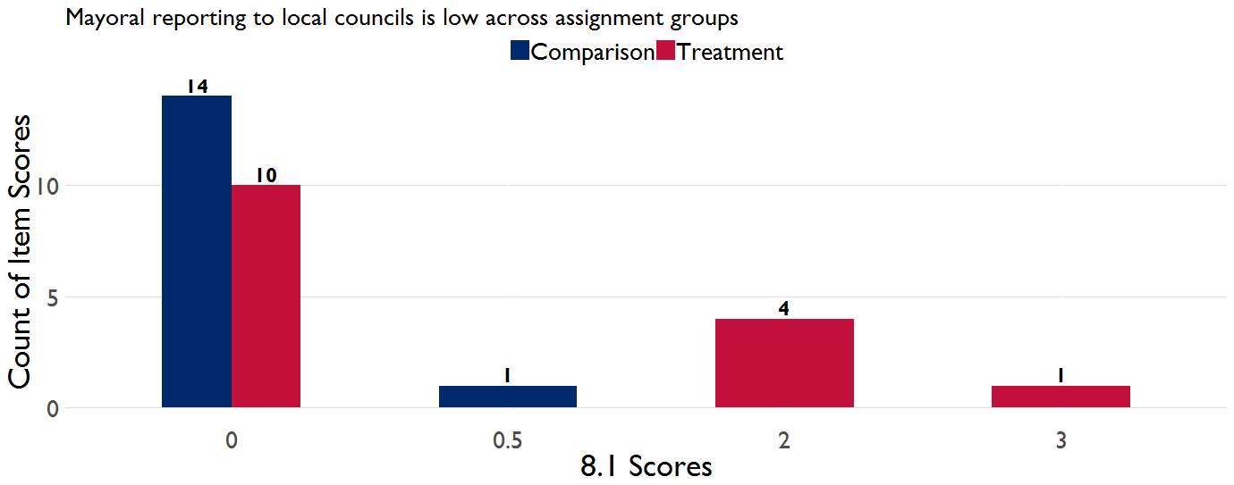

Commenting on community members’ expectations from local councils, one council member said: “Community members are two kinds: Either they have very high expectations for us or they are smart enough to realize that we have no power and therefore ignore us.” Local council members complained of having no designated offices, staff or a separate budget and of not having the power to follow up on the decisions they make in the councils.

Mayors and executive directors also complained that despite municipality’s increased financial responsibilities related to the creation of new local councils, governmental allocations have not witnessed a commensurate increase. Most municipal staff perceive local councils as a “liability” imposed on municipalities without a clear assignment of role, staff or budgetary allocations. An executive director said: “Local councils are supposed to drive local development but they do not. Instead their decisions are about what to pay members for meetings, or moving one employee from one municipal unit to another. They are not doing any strategic work.” Another municipal council member said: “The local councils are draining the little resources we have…We had to rent out venues and furniture without having seen any increase in our budgets.”

Among the other factors compounding the municipal sector’s dire financial situation is that municipalities have to now bear the expenses associated with the newly created local councils. Sometimes these are covered through budget items essential for service provision. “Our budget was not increased after local councils were elected. We took money from other budget items like projects and procurement to be able to pay the members of the local councils,” a mayor commented.

The figure below shows the budget expenditure for treatment and comparison municipalities. The log value is presented to minimize the distance between large gaps in the data, but the overall picture is one of treatment municipalities with slightly lower overall budget expenditures relative to comparison municipalities. The treatment group had an average budget expenditure of 1,449,556 JOD while the comparison group’s average reported budget expenditure was 46,167,800. The large gap between the two assignment groups is largely a result of Husha Aljadedah in the comparison group, which reported a budget expenditure of 599,334,134 JOD.
Figure 11: Budget Expenditure Across Assignment Groups
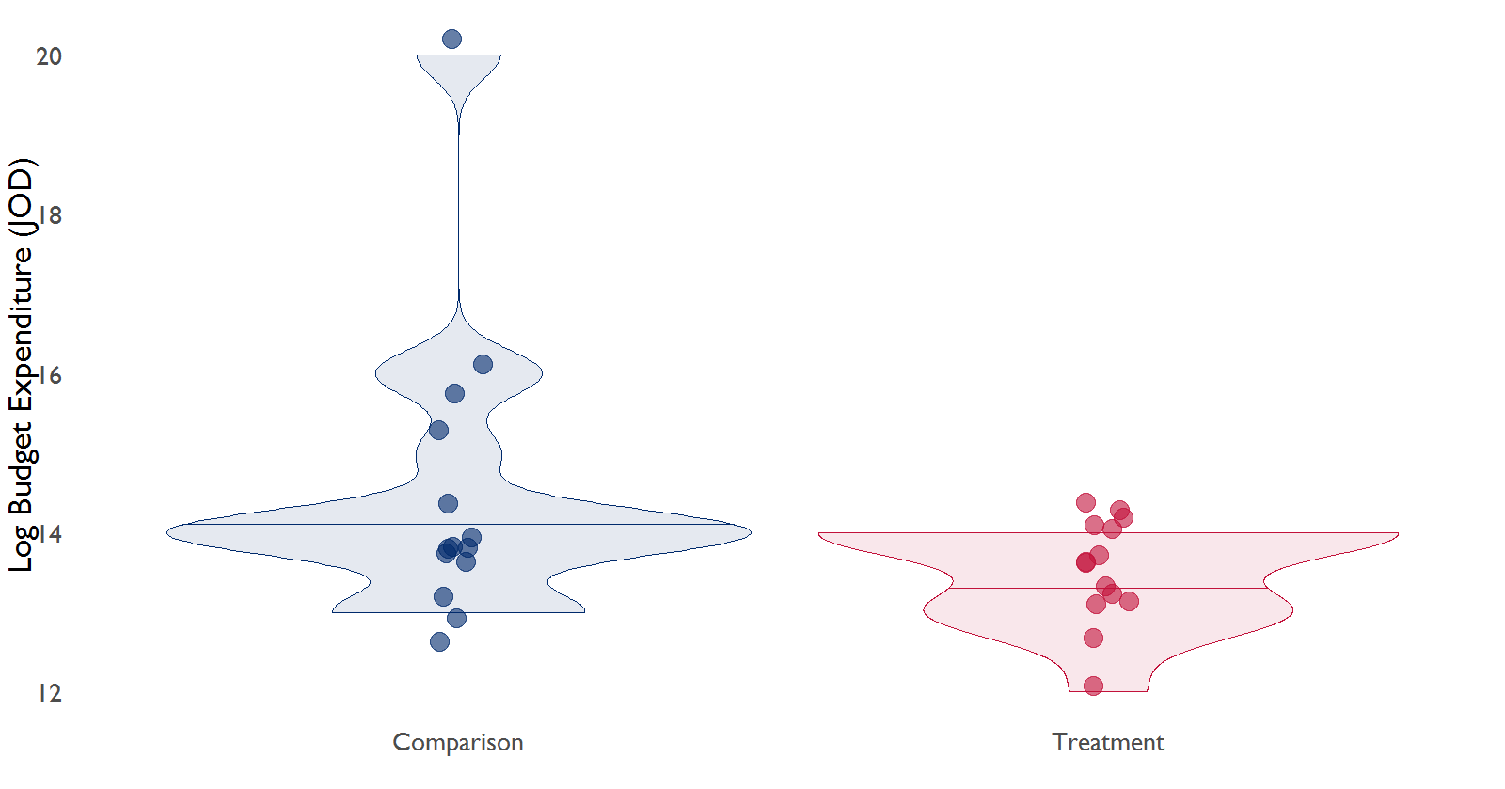

Role of Governorate Councils
Governorate council members agreed that decentralization is a welcome and timely reform initiative that will ensure the “equitable distribution of the benefits of development.” At the same time, council members stressed the limited ability of the councils to effect change, their meager resources and the centralization of all efforts related to overseeing the implementation of decentralization. For example, the head of a governorate council said that the process the executive council undertakes to filter through municipal needs and determine capital projects is still within the control of central ministries. According to him, this undercuts the ability of governorate council members to perform their job. He emphasized that power needs to be devolved from the ministries to the directorates. The evaluation team’s respondents also reported that communication with ministries is weak. Many said that devolving power to the directorates would ensure a closer working relation with the governorate councils.

Governorate council members noted that the development of strategic plans by governorate LDUs should have preceded the development of the needs guides. This would have better facilitated the reconciling of priorities and needs and helped prioritize projects that align with the plans. Council members also noted that regulations clarifying the grounds on which to reject or endorse projects is lacking. “There are demands made by citizens we do not know how to channel. We do not know if these demands should be covered through the needs guide or the government. For example, what do we do about the need for a police station?” one governorate council member said. As alluded to earlier, the needs guide lumps together those services and projects to be provided by municipalities as well as through the governorate council. As one executive director said, all projects are included in the needs guide whether the projects will be covered by the municipality or at the governorate level.” Governorate council members expressed their concern that if community demands captured by the needs guides are not met, the public will blame the councils.

The 2018 governorate budgets were approved without the input of governorate councils. The few governorate council staff that exist often are employees of MoI. Their time is divided between their original positions and their newly assigned responsibilities serving the governorate councils. All respondents emphasized the need for additional regulations to clarify legal provisions that have not served to carve out clear responsibilities and roles for the various councils.

Municipal sector respondents described unsystematic interactions with governorate council members. Respondents reported different forms of engagement by governorate council members in the development of the needs guides, with only a few municipalities reporting close involvement. Municipal respondents also reported limited or no linkages between municipal and governorate level LDUs. All but one executive director has attended an executive council meeting despite a legal mandate to do so.

One head of a governorate council stressed that decentralization requires that government officials believe in the need to meaningfully transition power to local government. While it would not be surprising for governorate council members to run into bureaucratic resistance to decentralization by central ministries and their representatives in the executive councils, the head of the governorate council noted instead the continued application of laws that are contradictory to decentralization’s legal framework. According to the same respondent, directorate heads insist these laws are still applicable and binding.

According to three government officials, the implementation of decentralization has exposed gaps in related legislation that need to be addressed. Laws need to be revised and new regulations have to be developed. One reason for that is the opaque mandates of the various layers of local government structures that affect their ability to perform. One respondent said that the revision of laws is central to this process and must be followed by a focused effort to activate municipalities’ developmental role. According to her, municipalities are still focused on the delivery of conventional services when they should be pursuing development opportunities to uplift their municipalities. The engagement of the private sector is key to this new role as well as the need to build LDUs’ capacity to lead on development opportunities.

One government official emphasized the need for a strategy for spatial planning as a form of national urban planning to enable governorate council members to make governorate-level decisions and prioritize projects in each governorate. The same government official said that municipalities must prioritize projects that propel local development and provide employment opportunities.

Perceptions of Decentralization
Respondents reported that the new system has ensured the election of representatives to new tiers of local government. It has also assigned new responsibilities to what most respondents saw as inexperienced actors. By the admission of municipal respondents, existing challenges include the new council members weak capacity, lack of experience in public service and the heightened expectations of community members who expect decentralization to yield short-term wins. One CBO member noted that many citizens believe government appropriations to governorates have increased as a result of the recent decentralization process, and therefore expect significant changes.

According to most respondents, the new decentralized system is fraught with challenges. While they agree that elected representatives standing for the new administrative layers are closer to the people and can better understand and engage community members, they insist that decentralization has not yet produced tangible changes and will need time to take root. “Decisions are still made by the ministries,” one mayor commented. Respondents also emphasized that ambiguity of the law and the overlap in mandates. “We don’t know if the governorate council members belong to the decentralized system or the centralized system,” another mayor commented.

With resource allocations for both governorates and municipalities unchanged, five municipal respondents negatively assessed recent changes saying the situation is regressing with decentralization serving to worsen the ability of local governance structure to address communal challenges and needs.

Another challenge relates to the lack of engagement between the layers. According to all respondents, municipal LDUs are generally weak and collaborate little with their counterparts at the governorate level. Governorate council members also reported the lack of engagement with executive councils.

According to a government official, CITIES is attracting some criticism related to the project’s capacity building efforts within the context of decentralization. Criticism is centered on the lack of practical knowledge CITIES trainers have, the time allotted for training, and what is perceived as weak follow up to the training. During an interview at MoMA, the government representative said that trainers lack the practical knowledge to respond to questions about the implementation of decentralization. The respondent added that one-day workshops are seen as inadequate to build capacity. “These are complicated issues. One cannot cover the areas they are trying to cover in one day. It is just not enough. How can people digest all this content in one day?” the ministry official said. The same official expressed concern about what he regarded as CITIES focus on capacity building and training:

“So many orgs are training. CITIES is training the same people that MoI, the Electoral Commission and CEP have trained before. How can this be effective? How does one measure the impact of all this?”

The government official went on to comment on the lack of follow up to the training to assess if trainees are applying the acquired learning. Training, according to respondents, should be focused on the practical application of the legal infrastructure. Respondents noted that training must be applicable in the context from which the various council members hail. “The training we are being offered tends to be general when it needs to be focused and highly technical,” another central ministry official said. The head of one of the governorate councils added that while training is necessary, it is also useful to share experiences with those who have gone through decentralization so that council members can understand how the system is supposed to function.

Government officials at MoMA expressed other concerns about the CITIES project. One official stated that CITIES did not provide a work plan even though the ministry had requested it several times. Another official said the Minister is requesting a review of the training content CITIES is using to train local, municipal, and governorate council members. He added that the implementation of the project has generally been slow.

Summary of Effectiveness Findings
The quantitative and qualitative data collection conducted through implementation of the MICA tool and in-depth interviews with municipality stakeholders provide a snapshot of a local context in which the following observations can be made:
- The capacity to assess and provide local services is limited overall due to staffing and resource constraints in both assignment groups;
- Community engagement is recognized as an important activity, but is only slowly being operationalized across both treatment and comparison groups;
- There is almost no reporting happening between mayors and the local councils in the comparison group, and the role of local councils is unclear across both assignment groups;
- The governorate council is still determining its role and relationship with the central ministries and municipalities, with respondents noting the need for policy guidance to implement the decentralization law;
- There remains confusion around decentralization, with respondents reporting mixed perceptions of CITIES’s support for capacity building around decentralization.

How effective CITIES is at addressing these factors will become more apparent during subsequent rounds of data collection. As observed by several respondents, follow-up on training and a capacity building may be critical for effectively promoting service provision, needs assessment, and citizen engagement, as well as the various efforts to promote decentralization and local capacity.

Evaluation Question 2: Sustainability
More time will be needed to determine the sustainability of specific CITIES interventions, but a clear theme was the need for more agile decision making in determining the labor force and serious capacity constraints to sustain intervention benefits. The evaluation team found that there are large gaps in labor capacity and the capacity to fulfill labor needs, which then affects the capacity for service provision. Qualitative baseline data also suggest that there is quite a bit of overlap between CITIES approach—e.g. training—and that of other donor programs. The CITIES institutional development intervention was reportedly useful, but the focus of some of CITIES efforts, such as social cohesion, were met with initial criticism among respondents.

Integrate slides 41 and 42 from presentation

Evaluation Question 3: Synergy
Baseline data suggests that although there has been some initial coordination between CITIES and other donor activities, there is still room for CITIES, other USAID programs, and other donors to develop synergies and determine how best to complement each other’s objectives. The multiplicity of donors working to support municipalities and decentralization requires the subordination of projects to a joint approach to maximize the impact of programming. Speaking to various donors about the nature of their support and how it fits with government’s efforts, donors agreed on the existence of an overall national vision for change but emphasized that a clear roadmap for how to bring this change about is still lacking.

To address challenges in local capacity, various organizations and projects are or will soon be implementing direct and indirect capacity building interventions to support local, municipal, executive and governorate council members including CITIES, LENS, IRI, NDI, Danish Aid, FCM (JMSP), ITDC (SMASRIJ), JICA (WMP), AECID (DCP), GIZ (PRM), OECD, VNG and AFD, among others. According to Jordanian officials an institutional framework for capacity building has been developed by MoPIC, and the ministry is trying to harmonize efforts to support capacity building.

The government is in the process of setting up a local governance-training institute to build the capacity of council members and municipal staff. A special committee was set up to oversee the institute’s establishment and curricula and harmonize donors’ related efforts. It includes representatives from MoMA, the municipal sector and MoPIC. The progress of the project, as a MoMA official admitted, is slow. Only a few meetings to discuss plans have taken place. According to WB respondents, the World Bank’s new project supporting municipalities also contains a capacity development plan. The plan has not been harmonized with the government’s plans to establish the institute. “We cannot freeze what we want to do until the government’s own plan is implemented,” the WB respondent said.

The Jordanian government established various committees in support of decentralization including the ones for legislation, resource management, and finances. The committees are all working under the umbrella of an Inter-Ministerial Committee.

MoPIC is responsible for the overall coordination efforts between donors. According to government officials, MoPIC’s coordination efforts are focused on the national and policy levels without combing through the details of specific projects. On the other hand, MoMA provides donors working in the decentralization space with guidance, coordination, and facilitation support. According to donors, what partly hampers effective coordination is different MoMA staff overseeing donor projects with little horizontal coordination between them. Compounding this situation according to a government official is that projects can reach municipalities without first passing through MoMA. According to the same official, municipalities are not under any obligation to publicize donor programming in their communities and government officials cannot force them to divulge information about such programming.

According to a government official, USAID Community Engagement Project (CEP) worked with the Ministry of Interior (MoI) to develop a guide to lead a community-focused process to identify needs. MoMA officials complained that CEP should have been working with them first. As a result, CEP worked with MoMA to develop another guide for a similar process. The result is two similar guides, one geared towards the governorate level and the other focused on the municipal level.

Interviewed government officials agreed that coordination efforts are unsystematic. This is due to the lack of an overall framework that connects, according to one official at MoMA, disparate components of programming. “When it comes to decentralization, we only have laws. There isn’t a framework for our work. Efforts are not systematic. We are trying to coordinate and connect disjointed interventions.” According to the official, the drive for decentralization should have started with the development of an overall policy delineating the government’s vision for the initiative followed by the introduction of laws and subordinate legislation then strategies to carry out the envisaged change. This long-term vision “would have prevented the chaos we see today…We are trying to rectify the situation and learn from our mistakes” the official said. The EU is currently working on a strategy for decentralization. According to respondents, this will require another two years to be completed. The strategy is part of the Decentralization and Local Development Support Programme (DLDSP), an initiative funded by the EU and implemented by the UNDP to support the GoJ guide the decentralization and local development process and develop the relevant institutional and organizational settings for its implementation. The DLDSP is supporting the Inter-Ministerial Committee (IMC) to lead the process and make the required modifications at both the governorate and municipality levels to ensure alignment with the newly modified mandates introduced by the legal framework. A key component of this work is to support the GoJ to develop its vision and policy to reform local administration and to formulate a National Strategy and Programme for Decentralization.

An executive director in a municipality in the north emphasized the weak coordination efforts. He said that when it comes to donors, the biggest problem municipalities face is the lack of coordination between them. He added: “they come in and insist on focusing on the same area even if the need is already being met by another donor.”

All interviewed donors agreed that CITIES is trying to coordinate efforts. However, the WB believes that the government should be taking the lead on this front. According to WB respondents, coordination is difficult when a “simple matrix on what everyone is doing” is lacking. Commenting on this effort, one donor representative said: “CITIES is trying to coordinate. It is not enough. They held their last meeting last April I think. We exchanged ideas but that’s it. We go there to learn what others are doing but not really to coordinate.”

MOPIC has in fact requested UNDP to map all the support being provided at the municipal and governorate levels to assess donors’ interventions relevant to needs, identify gaps and avoid duplication. This resulted in a matrix of interventions by development partners in support of the implementation of the new legal framework and more precisely the sub-national system at the governorate and municipal levels. The final matrix identified 28 implementing agencies operating through 48 projects that translated into 208 separate interventions at both the central and local levels and in the following areas:

- Policy, Legislation and Regulation
- Functional Assignment
- Institutional and Organizational Structures
- Inter-Governmental (Institutional)
- Systems, Procedures and Manuals
- Capacity Development
- Local Public Finance

Interviews with the WB revealed that CITIES has been coordinating with the new MSSRP project. The WB will be using CITIES’ manuals and training material and the project’s consultants to train and roll out in non-CITIES municipalities. According to WB respondents, the two projects diverge on the issue of ensuring accountability for the needs guide process. The WB sees the need for closer monitoring of community engagement to ensure participation is meaningful while CITIES wants the process to unfold more organically. World Bank representatives said that CITIES manuals would be reviewed. If they are not sufficiently rigorous they will be supplemented in non-CITIES municipalities. CITIES is also coordinating with the WB on the Technical Assistance of Municipal Financial Capacity project to ensure there is no duplication.

In addition, there is an OECD project focused on participatory budgeting and development planning. Respondents said they have met with CITIES several times and are closely coordinating the two projects. The two respondents agreed that decentralization would improve the quality of services if the system is functional and allows needs to translate upwards to be better reflected in budgeting. Otherwise and because of citizens’ high expectations the system might backfire. There remains a big issue of trust in the links between the administrative layers. Engagement must be inclusive and meaningful. Respondents said more effort has to go into understanding how grassroots priorities are filtered as they move up to subsequent local government levels; this, according to respondents, boils down to the quality of regulation.

AECID, AFD and VNG’s respondents also confirmed they are coordinating with CITIES. AECID is focusing on the three municipalities of Mafraq, Sarhan and Ramtha and is working to improve financial management. AFD’s project is expected to start end of 2019 and focus on the governorate centers of Salt, Ajloun, Madaba, Irbid and Jerash, while VNG and in addition to its capacity building support is partly focusing on Mafraq working in the three municipalities of Balama, Al-Sarhan and Umm Al-Jimal to develop green public spaces.

Summary of Baseline Evaluation Question Findings and Conclusions
Municipalities suffer from significant structural burdens that impair the provision of quality services to citizens. The most pronounced challenges are those related to municipalities limited financial resources and revenue streams, the encroachment of the central government on their autonomy and independence and their overall weak institutional capacity.

To propel the democratic transition forward the government has created municipal and local government layers and devolved power to the publicly elected bodies. The overall objective of the new structure and overall decentralization process is to improve the level of services provided to citizens and to promote citizen participation in the decision-making process at both the governorate and municipal levels. The two objectives are inextricably tied to each other, as engagement in decision-making will bolster accountability and ensure public services are in tune with public needs.

Various factors could stall the transition and donors’ efforts to improve municipal performance. In addition to the dire situation municipalities are in, coordination mechanisms between local government structures and municipalities are weak; the current structure does not delineate a clear mandate for the various layers including the local, municipal, executive and governorate councils. The municipal organizational structure has not been reconciled with decentralization requirements. The lack of adequate resources and weak institutional capacity including that of the LDUs mean that decentralization does not guarantee economic development. It only ensures that some form of community engagement to determine priorities is taking place. Citizens’ expectations are high. This will require quick wins, before the process runs out of steam.

Sector ministries operating at the local level are not under the span of control of the governorates or municipalities and have not seen much power devolved to them. Horizontal links between directorates representing sector ministries and municipalities is also weak. Defining and operationalizing coordination mechanisms between the various local governance and municipal levels is challenging and the features of these mechanisms including for decision-making are still opaque. The implementation of the system has revealed gaps in the current legal landscape that require the revision of existing laws and the development of new regulations.

The effectiveness of the CITIES project will depend on its ability to navigate the change that can reasonably be expected within this new system. Improving the municipal sector’s institutional capacity requires an understanding of the technical, regulatory and relational dimensions of municipal functions and the ability to secure government’s support in areas within its span of control.

On the other hand, decentralization requires that the central government ensures the provision of adequate financial resources and the will to devolve power. Municipalities still regard themselves as vehicles for the provision of conventional services and need to grow their development role to attract or implement investment projects, considered key to addressing communities’ most pronounced needs.

Various donors are implementing projects to support the municipal sector and the process of decentralization. While donors continue their coordination attempts, the government’s ability to take the lead in this effort remains weak.

Internal Validity of MICA Scores
Any impact evaluation must address the issue of internal and external validity. External validity generally refers to how applicable the findings of a given study are beyond that study’s context. In the case of CITIES, there may be questions about how applicable these findings are to another MENA region country, or even to non-study municipalities. A focus on the mechanisms for impact and careful noting of contextual factors can help address external validity concerns for decision makers. Internal validity broadly refers to how well research is implemented. Threats to internal validity can arise if, for example, data collection occurs in a non-uniform way or there is contamination between assignment groups. The threat of data contamination or inability to maintain comparable respondent groups is low in the context of the MICA data—it is unlikely that a mayor from a treatment municipality would somehow respond to a comparison municipality MICA question. The MICA tool itself was applied equally across each comparison municipality. Although there were subjective differences in MICA scoring between evaluation team enumerators, each enumerator asked every question and applied the tool the same way. As noted above and in Annex 2, all within-team differences were clearly documented and resolved.

There are two main threats to the internal validity of the MICA scores:
- Enumerator bias
- Non-comparable MICA application across the CITIES and evaluation teams

The agreement statistics suggest that there is a strong potential for enumerator bias, or the bias that arises from how enumerators ask and record questions, for MICA services items. However, the evaluation team’s process for data review helps mitigate the threat of this bias. By first identifying the error, as shown above, and then reviewing, item-by-item differences, the evaluation team undertook a MICA synthesis process to align scores across raters. The end goal of this was to develop a final dataset of comparison municipality MICA scores. In some cases, MICA guidance is ambiguous or inconsistent leading to an increased role for subjective judgement in determining a score. As part of the data review process, the enumerators went over their notes for each item where there was disagreement, discussed what they observed, and determined whether to maintain or change the final score.

The CITIES team applied a similar process of scoring and review to improve data reliability. However, there is a threat to internal MICA data validity across the CITIES-evaluation teams. If CITIES applied the MICA tool in a way that is different from that of the evaluation team, or if their review process somehow biases scores, there could be a threat to the internal validity of the study since the two MICA datasets would not be comparable. By training, meeting, and consistently communicating with the CITIES team, the evaluation team sought to align its application of the MICA tool with CITIES. Both teams asked each question in the tool, questioned the relevant stakeholders based on CITIES’s guidance in applying the tool, and took diligent notes. Despite these similarities, there are likely differences in MICA application because the CITIES scoring team was assembled based on its expertise in the relevant MICA criteria. This could, in theory, result in an ex-ante difference in their MICA-related measurement skills that training may not be able to resolve.

The MICA data do suggest slightly different usage of the tool. As shown in the figure below, item-level analysis across assignment groups generally shows that the evaluation team used interim scoring more often; for example, giving the score of 0.5 58 times compared to CITIES 19. The evaluation team explored the use of half-scores with the CITIES team to understand when to best utilize these since the MICA tool has clear integer categories. Additional discussion with CITIES staff may be warranted between this round of data collection and the next implementation of the MICA in the comparison municipalities to ensure that the evaluation team is properly aligned with the MICA methodology.

Figure 12: Distribution of MICA Services Item Scores by Assignment Group

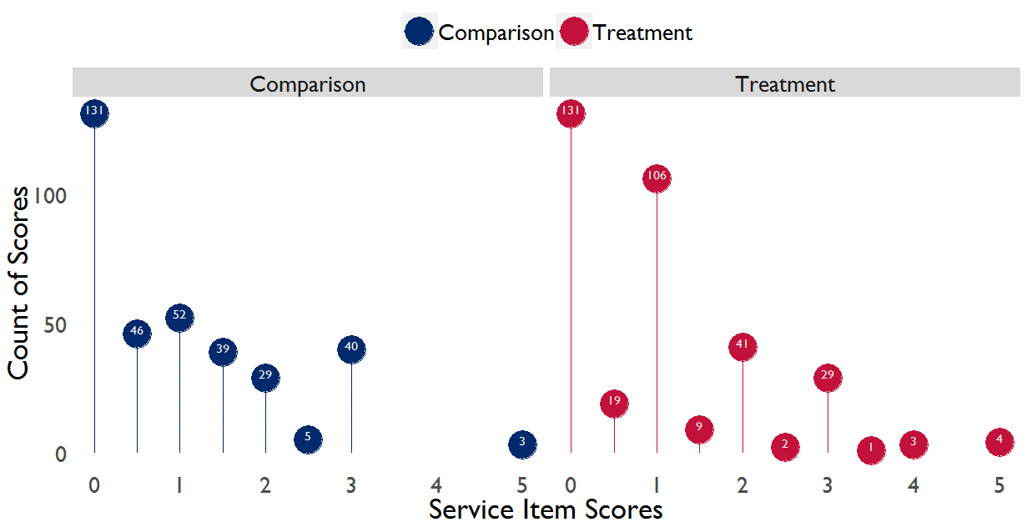

The next section addresses scoring equivalence across assignment groups, but understanding how the MICA tool and subsequent scores were functionally applied is important for understanding threats to the internal validity of the data itself. Beyond using half-scores more frequently, there is no clear evidence that the tool itself was applied in a different capacity across treatment and comparison groups. On an item level, there is some clustering around certain values, such as item 7.2, but the notes of the MICA tool suggest that this clustering, as well as the evaluation team’s use of half-scores is consistent with guidance from the CITIES team.

The threats of enumerator bias and incomparable MICA application are real, but resolvable threats to the internal validity of the MICA data. The evaluation team addressed these two threats through its own internal reliability processes and through its training and outreach with the CITIES team.

Scorer Agreement Error
There is concern about measurement consistency with any data collection effort. Two reasonable people can interpret the same question in slightly different ways, which can affect the reliability of the overall measurement endeavor. In the case of the CITIES IE, the use of the MICA as a primary data source for this IE presents two main challenges: between team reliability and within team reliability.

The evaluation team’s MICA scoring in control municipalities needed to be aligned with that of CITIES’s scoring in its treatment municipalities to ensure between-team comparability. The evaluation team and CITIES needed to have a similar understanding of each MICA item and how to apply MICA scores appropriately. To this end, the evaluation team received two training sessions with members of the CITIES team. The evaluation team also shadowed CITIES staff as they applied the MICA in six Mafraq governorate municipalities. The goal of training with and shadowing CITIES staff was to minimize the variability between each group’s scores and overcome the challenge of each team implementing the MICA tool differently.

During the training, members of the CITIES team were told that the tool could produce socially desirable answers or impressionistic responses that may not hold up to objective scrutiny. The CITIES team emphasized the importance of requesting municipal staff to produce evidence in the form of related documentation when responding to questions. The IE team followed the guidance but was still able to identify ratings within the tool that covered subjective criteria or rubrics that did not exhaustively define applicable objective criteria and therefore allowed evaluators to exercise their discretion and assign a higher or lower score depending on their opinion or particular bias.

The second challenge MICA scoring presented as part of baseline data collection was within team, or inter-rater, reliability. Even though the IE team received training on how to employ the MICA tool, there could still be variability within the IE team on how to appropriately score the same municipality on the same measures. Beyond the training and guidance that the evaluation team received from CITIES, the MICA tool itself has guidance on how to apply scores for each item. For example, on MICA measurement 2.1, Technical Trainings in Service Delivery, the MICA tool provides the guidance to apply a score of 1 if, The municipality occasionally organizes training on technical topics (e.g. maintenance infrastructure, maintenance of vehicles/equipment, SWM), at request [sic]. This seems straight forward, but there are often cases where conditions on the ground are more ambiguous, such as whether staff were actually able to provide services and their qualifications to do so. If there is a lot of variation within the IE team on what constitutes one score over another, assessment of the comparison municipalities could be biased as would comparison to CITIES’s treatment municipalities.

The table below provides a summary of agreement between evaluation team enumerators across each municipality, as well as a set of municipal-level agreement statistics (the intra-cluster correlation coefficient statistic) most appropriate for ordinal level data. This analysis was part of the overall reliability and scoring process that took place after baseline MICA data collection was completed.

Table 5: Total MICA Score Reliability Statistics
Municipality | Percent Agreement | ICC
Al Seru | 73.91 | 0.84
Alsharah | 73.91 | 0.83
Ain Albasha | 60.87 | 0.88
Alauion | 60.87 | 0.69
Talal Aljadedah | 60.87 | 0.75
Alyarmook Aljadedah | 56.52 | 0.87
Bab Amman | 56.52 | 0.84
Manshiat Bane Hasan | 56.52 | 0.73
Shafa | 52.17 | 0.78
Mo'ath Abn Jabal | 47.83 | 0.70
Tabaqat Fahl | 47.62 | 0.64
Iel Jadeda | 43.48 | 0.75
Jizah | 43.48 | 0.30
Mazar Jadeda | 43.48 | 0.80

Agreement ranges from 43 to 74 percent. A percent agreement of 100 would result if all of the enumerators had identical MICA scores for a given municipality, whereas, the 56 percent agreement for Shafa, for example, suggests that there was disagreement on almost half of the MICA items. It is important to note that percent agreement on its own may not be a fair assessment of enumerator alignment. One limit of this approach is that it simply measures whether enumerators assigned scores identically, but it does not account for the fact that scores could be similar, but not the same, among raters for a given municipality. The intra-cluster correlation coefficient (ICC) provides a measure of how similar scores are within a given municipality, or “cluster.” A higher ICC suggests a stronger relationship between scores for a given set of raters within a municipality; for example, if the ICC were 1.0 for a given municipality, all of the raters would have identical scores. Mazar Jadeda provides a good example of how the percent agreement and ICC differ. The percent agreement for Mazar Jadeda is 43.5, suggesting that raters’ scores differed for about 56.6 percent of the time, yet the ICC is 0.80, which suggests that although the raters’ scores differed, they were very closely related. The item-level scores for Mazar Jadeda differed by about 0.47 on average, with only three items differing by more than one point (i.e. the magnitude of the overall difference was low); in contrast, in Jizah, which has the same percent agreement but an ICC of 0.30, scores differed by an average of 0.52, including five items with an item-level difference larger than one.

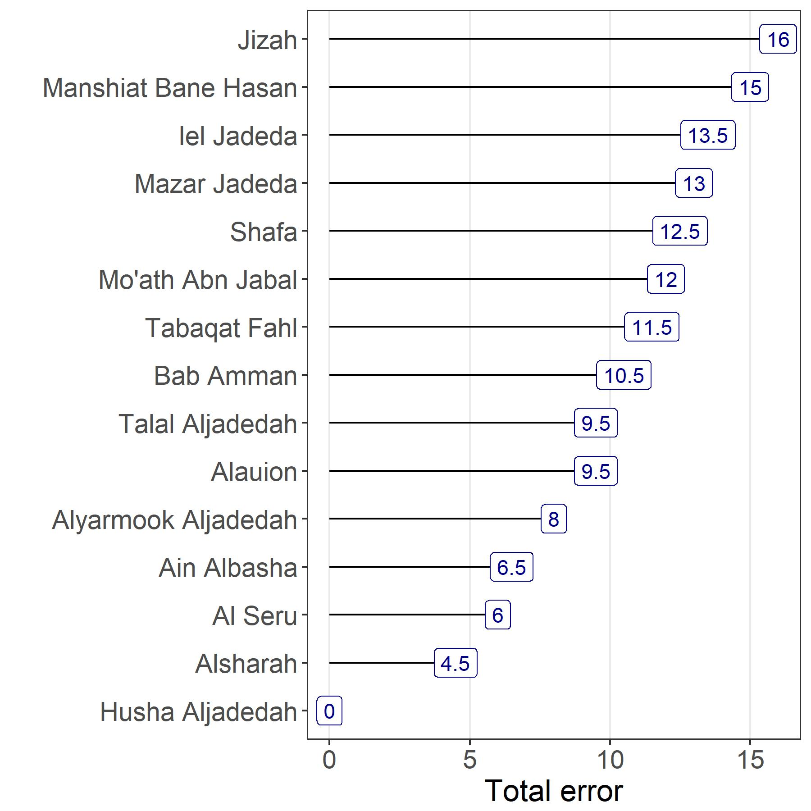
To understand error more directly and descriptively, the evaluation team manually calculated the error rate, i.e. the rate at which one or more evaluation team members scored the same item for the same municipality differently. As shown in the figure below, the error rate varied across municipalities. Annex 3 provides more detail and additional agreement statistics such as for continuous data.
Figure 16: Total MICA Error by Comparison Municipality

A review of a simple percent agreement statistic, examining a range of agreement statistics customized to various data types (categorical, ordinal, continuous), and a manual exploration of total error across raters, municipalities, and items indicates the existence of a low to moderate dissonance across MICA scorers. This dissonance varies but does indicate some cause for concern in the case of a few municipalities and a few items.

Upon internal review as well as review with the CITIES Component 1 team lead, such dissonance is considered within normal bounds and the comparison municipality scoring to be sufficiently valid as to compare against the CITIES MICA scoring.

Assessing Baseline Equivalence
If the MICA scoring in comparison municipalities is sufficiently valid as to compare against the CITIES municipal scoring, the natural next consideration is the difference across assignment groups. That is, how do the CITIES municipalities compare to a set of similar municipalities that do not receive CITIES implementation? The question is critical for maintaining validity of the evaluation design - if substantial differences across municipalities exist, the control group may not be a valid representation of the counter-factual, or additional weighting may need to be applied to improve the comparability.

As outlined in the evaluation design document, the evaluation team conducted an initial selection of comparison municipalities through an ex-ante matching process to create observably similar assignment groups on general municipal characteristics. While the initial municipality matching procedure sought to ex-ante increase the probability of balance between the treatment and comparison groups, it is important to test this assumption once data are collected to confirm the fidelity of the procedure and see what, if any, additional steps may be needed before the next stage of analysis. With scoring of the comparison municipalities concluded, it is now possible to directly assess baseline equivalency across municipal institutional measures.

Note that balance metrics are assessed against three configurations of treatment and comparison municipalities. The first configuration is all 33 CITIES municipalities against the 15 comparison municipalities. Given that this configuration includes class A municipalities that are entirely a part of the CITIES activity, it is for reference only and not a central part of the evaluation. The second configuration is the 23 CITIES municipalities that exclude class A, compared against 15 comparison municipalities. The third configuration consists of 15 treatment municipalities compared against 15 comparison municipalities.

The value of assessing equivalency across multiple configurations is that the evaluation team can better understand how sensitive scoring is to particular metrics or municipality characteristics. It may be the case that the matching of 15-15 was overly conservative based on similar data, but not the exact metrics of interest for this IE. By testing the three aforementioned configurations, the evaluation team can assess whether and by how much scores across assignment groups differ. This is important for understanding how robust the findings are and whether they may carry over to a broader implementation context.

The balance metrics that follow are organized by aggregate and item-level scores across score type (Services and GESI), and across the three configurations mentioned above. Finally, each of these set of metrics is presented across the final set of scores produced by the evaluation team, and the alternate set of scores after harmonization.

Aggregate Balance
The MICA score is predicated on the concept of an aggregate score of municipal level competency consisting of the sum of 23 services and 17 GESI scores. The CITIES evaluation, specifically Hypotheses 1-3 (municipal institutional level outcomes), takes the further step of supposing an overall capacity measure consisting of the overall mean MICA score across the entire set of treatment municipalities under study, compared to the overall mean MICA score across the entire set of comparison municipalities.

Overall balance indicates a mixed picture of achieving baseline equivalence depending on what municipalities are included in the analysis and the MICA items assessed. More detail is provided in Annex 3, but a standardized difference with an absolute value of 0.25 or less indicates particularly strong balance, while a value at or above 1.0 should raise serious concerns. The Selected Municipalities and Municipalities Excluding Class A were balanced across services items, which is valuable for the evaluation since much of the focus of the MICA tool is focused on services items and the 15-15 matched municipalities are the target groups for this evaluation. However, as seen in the table below, aggregated balance is less apparent for the GESI items and for the broader CITIES-comparison municipalities.
Table 6 Final MESP MICA scores by treatment, selection status
Category  (Treatment / Comparison) | Component | Comparison Mean | Treatment Mean | Difference | Standardized difference
All CITIES municipalities (15/33) | Services | 21.07 | 27.62 | 6.55 | 0.54
Excluding class A (15/23) | Services | 21.07 | 21.11 | 0.04 | 0.01
Selected municipalities (15/15) | Services | 21.07 | 22.57 | 1.5 | 0.18
All CITIES municipalities (15/33) | GESI | 0.53 | 1.79 | 1.25 | 0.74
Excluding class A (15/23) | GESI | 0.53 | 1.52 | 0.99 | 0.7
Selected municipalities (15/15) | GESI | 0.53 | 1.53 | 1 | 0.75

For MICA services scores summed across municipality for an overall services capacity score, and then municipal scores averaged by treatment or comparison status, there is equivalence for the specification of 23 CITIES municipalities compared against 15 comparison municipalities (standardized difference .02). For the specification of 15 CITIES municipalities and 15 comparison municipalities, the standardized difference and raw mean difference suggest statistically similar aggregate scores. For all 33 CITIES municipalities compared against the 15 comparison municipalities, the standardized difference of 0.54 is unacceptably large, and indicates substantive differences between groups. This substantive difference is at least partially observable in that class A municipalities are generally of higher functional capacity and better resourced.
Differences in aggregate services scores are visualized below.
Figure 14 Overall MICA scores by treatment, selection status
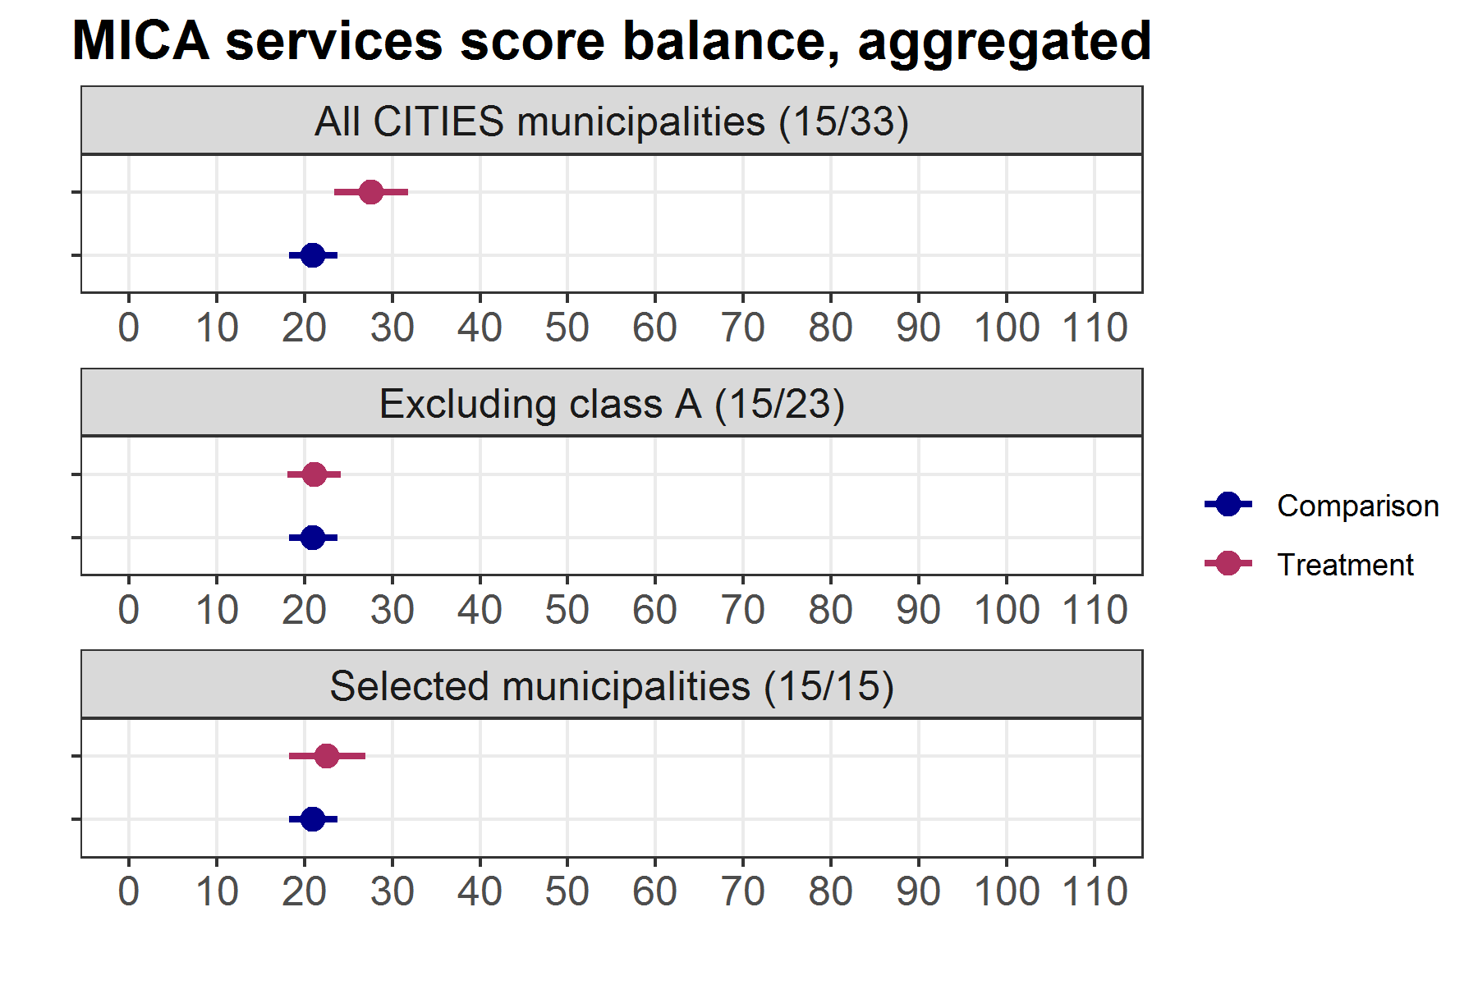

For MICA GESI scores summed across municipality for an overall GESI score, and then municipal GESI scores averaged by treatment or comparison status, balance metrics are unacceptably high. However, at least some of the poor balance properties for GESI scores may be considered to be floor effects – scores are very close to zero and objectively small differences become large relative differences. Even so, the feasibility of using GESI scores is called into question, and any estimates generated from GESI scores should be scrutinized carefully. Differences in aggregate GESI scores are summarized below.
Figure 15 Overall GESI scores by treatment, selection status
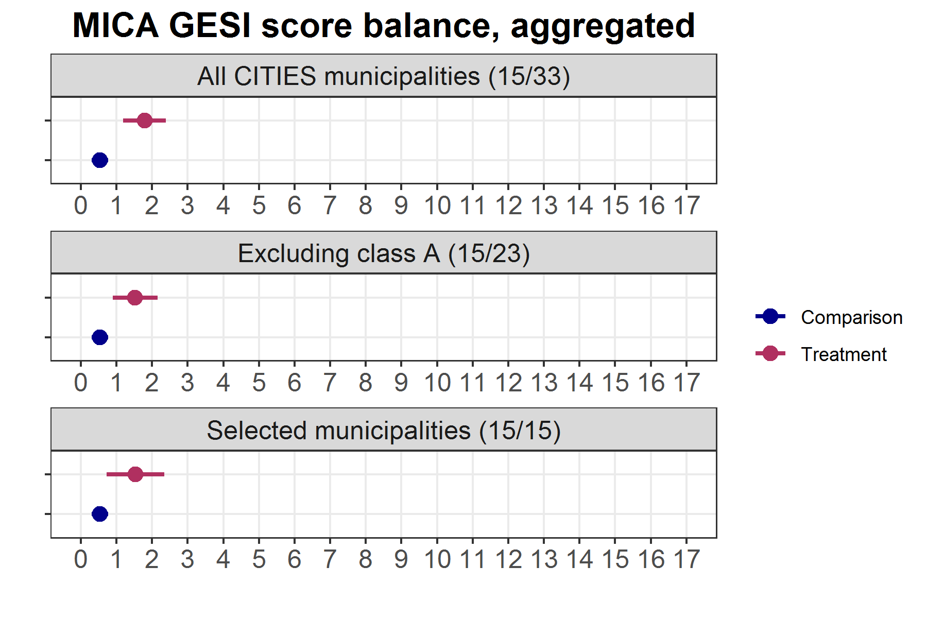
Here differences across treatment and comparison status are more apparent and could be related to outcomes.

The following table presents the same aggregated balance, but this time using the alternate scores.
Table 7 Alternate MICA scores by treatment, selection status
Category  (Treatment / Comparison) | Component | Comparison Mean | Treatment Mean | Difference | Standardized difference
All CITIES municipalities (15/33) | Services | 22.6 | 27.62 | 5.02 | 0.41
Excluding class A (15/23) | Services | 22.6 | 21.11 | -1.49 | 0.19
Selected municipalities (15/15) | Services | 22.6 | 22.57 | -0.03 | 0
All CITIES municipalities (15/33) | GESI | 0.73 | 1.79 | 1.05 | 0.61
Excluding class A (15/23) | GESI | 0.73 | 1.52 | 0.79 | 0.54
Selected municipalities (15/15) | GESI | 0.73 | 1.53 | 0.8 | 0.57

Under the alternate scores the balance metrics on the services scores improve, but there is also a substantive change. Under the final internal scores, there was equivalence in the 15/23 specification and the 15/15 specification was marginally acceptable. Under alternate scores the situation is reversed: the 15/23 specification now has a standardized difference of 0.2 while the 15/15 specification has full equivalence across treatment and comparison status.

For GESI scores the pattern is the same, and balance metrics are all improved due to a slightly higher overall GESI score in the comparison municipalities. Differences remain high however, and any impact estimates using these figures will still require scrutiny.

Item-Level Balance
Unfortunately, small sample sizes prevent examination of individual municipalities or individual MICA measures. Still, examining item-level variability and balance can offer insight into the properties of the evaluation data and highlight areas where inference may be more or less feasible.

As noted above and shown in the figure below, there were some differences between the CITIES and comparison municipalities across several MICA services items. The treatment and comparison municipalities scores differed across overall MICA services items by around 0.1 on average. MICA items related to training in service delivery (2.1), urban planning (3.1), capital projects (3.2), and maintenance of assets (4.2) were particularly similar across assignment groups. The graph below shows the average MICA services scores across the 23-matched treatment and comparison municipalities for each item. Overall, the 15 comparison municipalities scored slightly higher, on average, than the 15 CITIES municipalities.

Table 8: Average MICA Services Scores by Item and Assignment
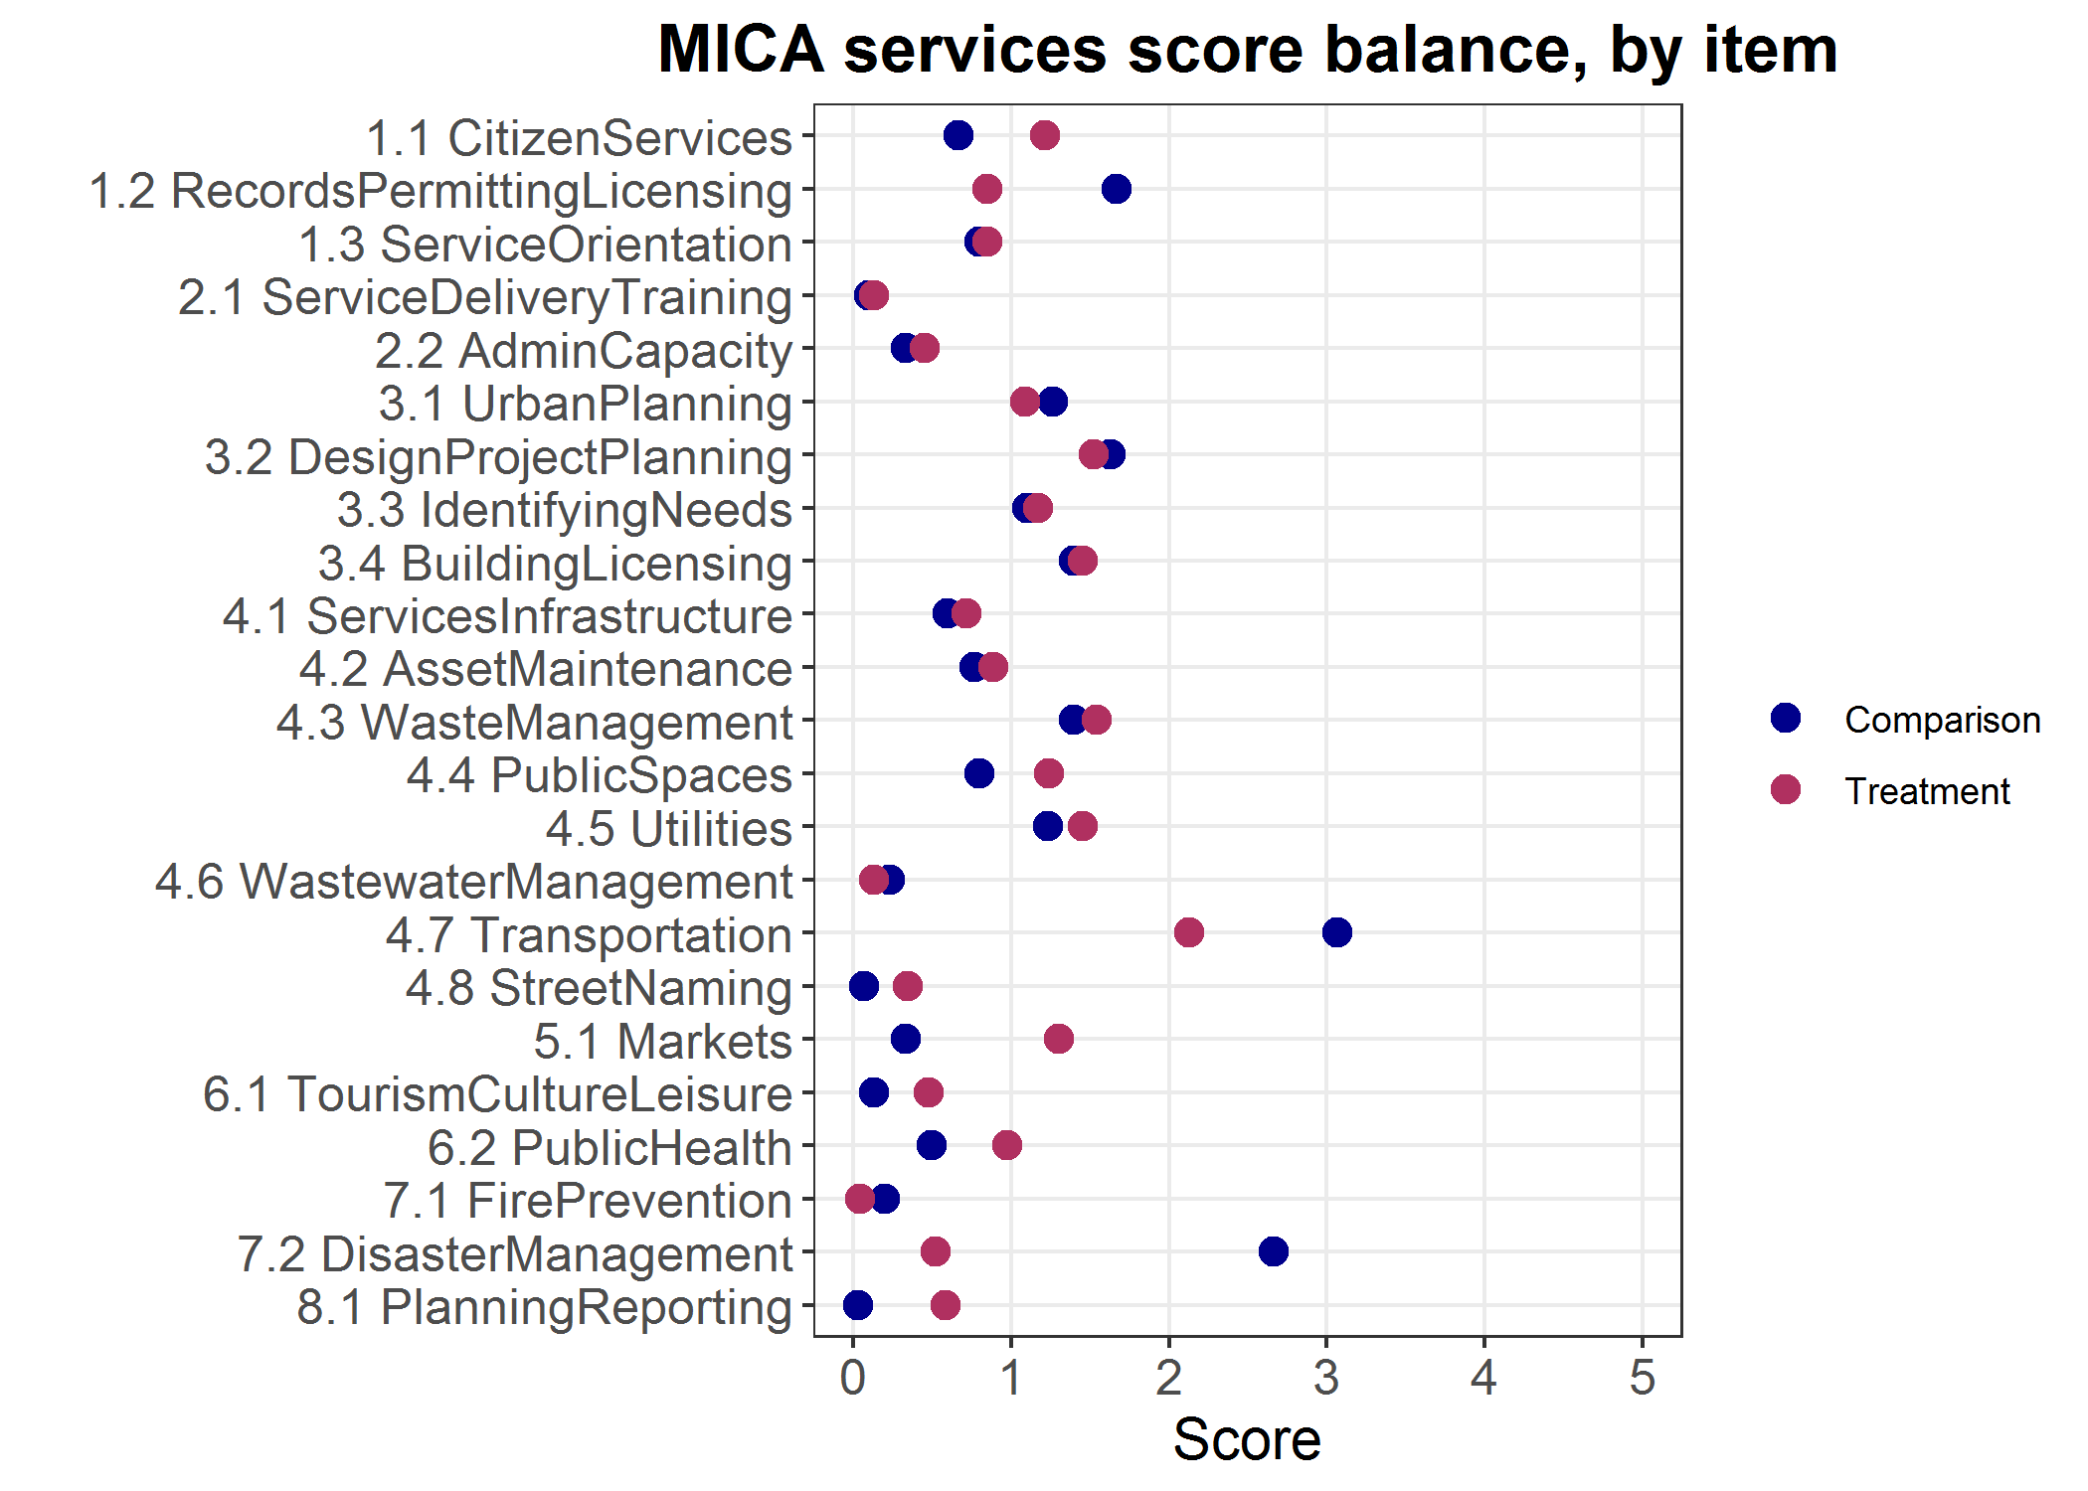
The alternate scoring shows the same general pattern, but with reduced variability across items.

While the above graphic is descriptive, there are specific statistical tests to determine baseline equivalency. Following Imbens and Rubin (2015), the evaluation team used a normalized differences approach to assess balance between assignment groups. This method calculates a statistic based on the difference between the treatment and comparison group means, divided by the square root of one-half the sum of the treatment and comparison group variances. An absolute value greater than one for this statistic raises concerns, while an absolute value of 0.25 or less indicates particularly strong balance. Normalized differences also help assess whether any potential imbalance can be addressed in the analysis phase.

The table below shows the results of the normalized differences for the 23 MICA services items across both sets of MICA scores.

Figure 19: Standardized Mean Difference of MICA services scores, Final (eval team) and Alternate (with CITIES review)
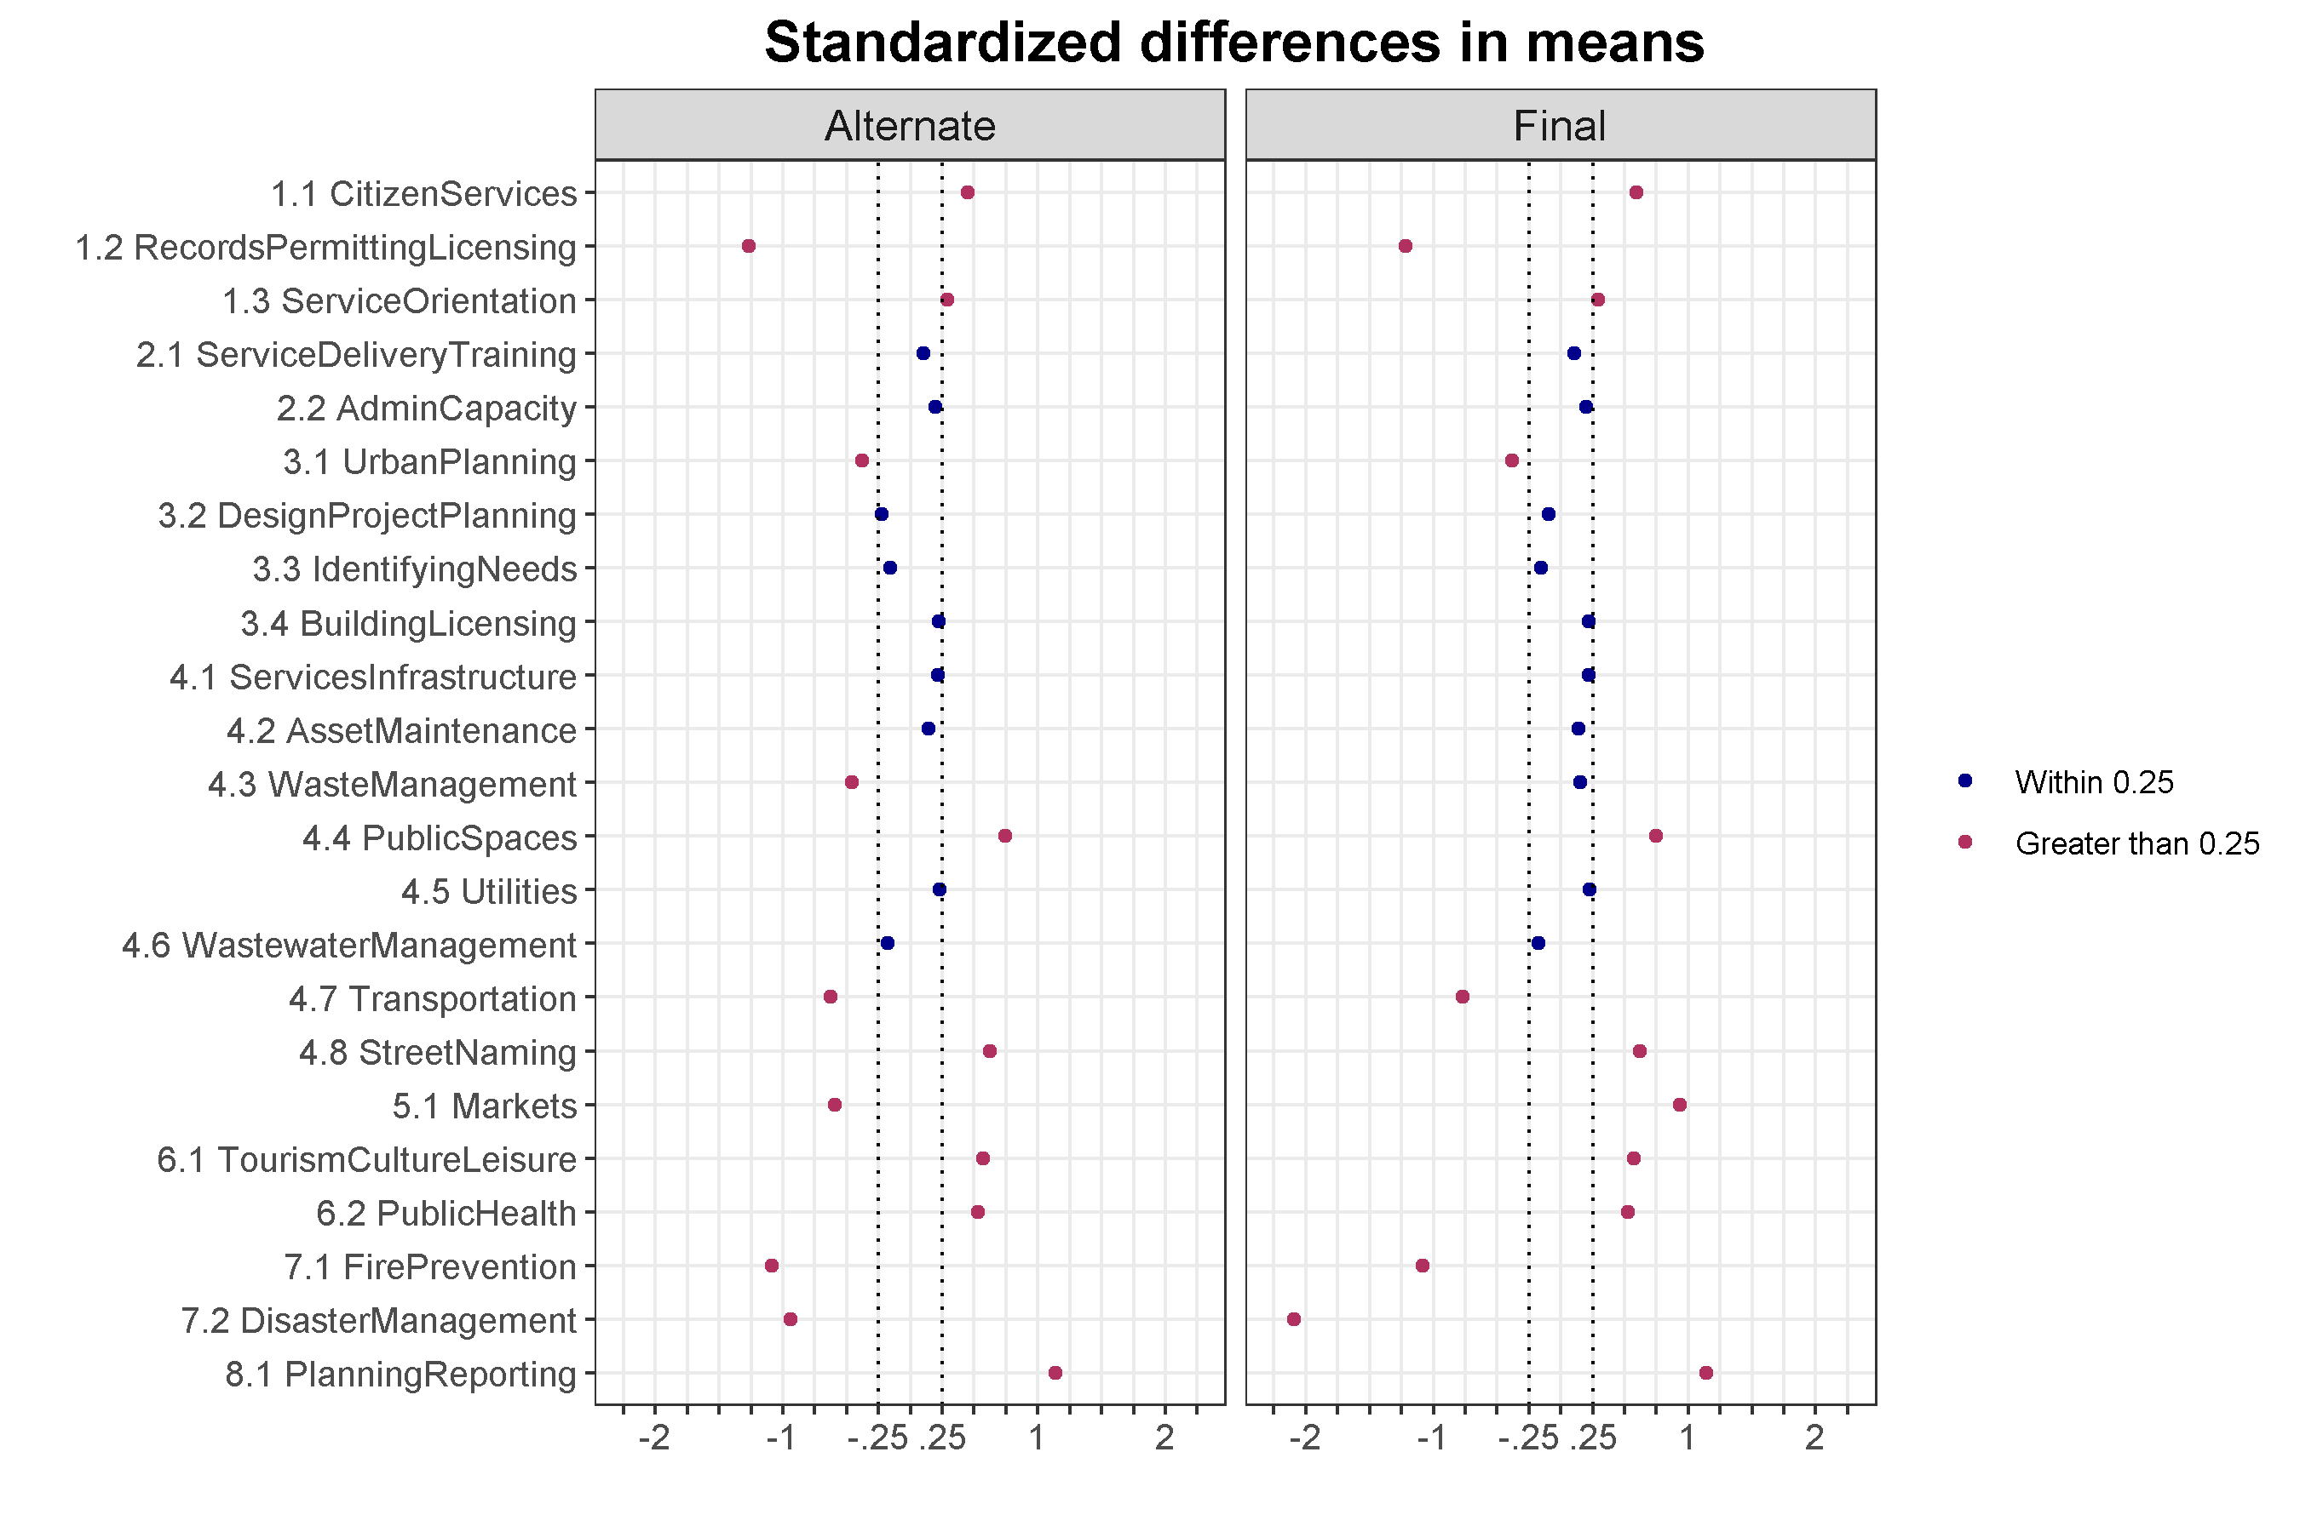
The alternate scoring actually has an additional item whose standardized mean difference lies outside the desired range of 0.25. However, the magnitude of the differences is consistently lower in the alternate scoring, contributing to better overall balance and a closer match in overall scores.

Note that sections 5-8 have larger differences across treatment and control, an issue that is only slightly mitigated in the alternate scoring. On the other hand, only one of the section 3 MICA services items had a normalized difference beyond the threshold of 0.25. This may suggest that, overall, both assignment groups are similar in their ability to plan and identify needs.

It is important to bear in mind that the overall MICA score is the outcome of interest, rather than change in any single item. So although there may be imbalance on many of the items above, the aggregate balance is a primary concern. The evaluation team will use the information in item-level variability to understand the properties of the MICA scoring and, potentially, develop appropriate weighting schemes to ensure that inferential comparison across assignment groups is balanced. See Annex 4 for the full balance table by item.

------

Despite similar scores across a few of the assessment categories, there were MICA items for which the gap was much larger or where one assignment group received a larger share of high scores. For example, CITIES’s 15 municipalities received an average score of 1.6 for services item 5.1, which covers a municipality’s capacity to inspect markets, while comparison municipalities received an average of score 2.4. This difference was largely driven by the fact that one treatment municipality, Dair Alla, received a score of 5, defined as, “The municipality actively and systematically carries out inspection of public markets, defining the goods that may be traded and goods that may not be traded there”, and four municipalities received scores of 3, which has the same definition as a score of 5, but with inspections happening only occasionally. As shown in the graph below, the distribution of scores for item 5.1 varied in its distribution between the treatment and comparison groups.
Figure 17: Item 5.1 Score Distribution by Assignment
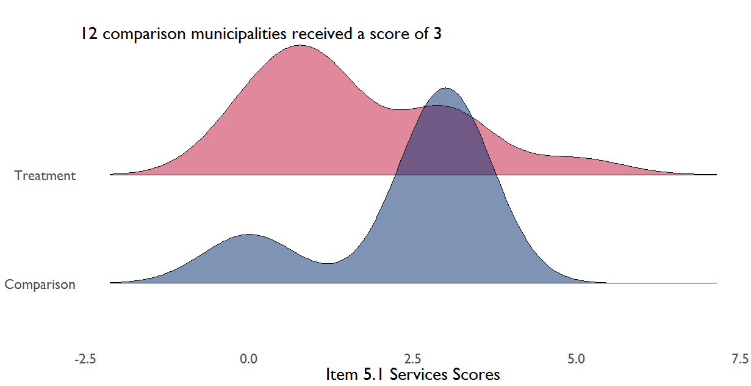
Although a third of the treatment group received a score of three or higher for item 5.1, the distribution of scores was wider compared to that of the comparison group, which only had three municipalities that did not receive a score of three. This was not the only case where the evaluation team’s scoring was significantly higher than that of CITIES. This was notable for item 7.2, which covers calamity management. The CITIES team gave six of the 15 matched municipalities a score of zero for item 7.2. In contrast, the evaluation team only gave two municipalities a score of zero and five municipalities a score of three, pushing the average item-level score for 7.2 to 1.57. Discussions with CITIES revealed that they only provided scores above 0 for 7.2 if the calamity plan was of “high quality,” a subjective criteria that may explain some of the difference between assignment groups.
Figure 18: Item 7.2 Score Distribution by Assignment
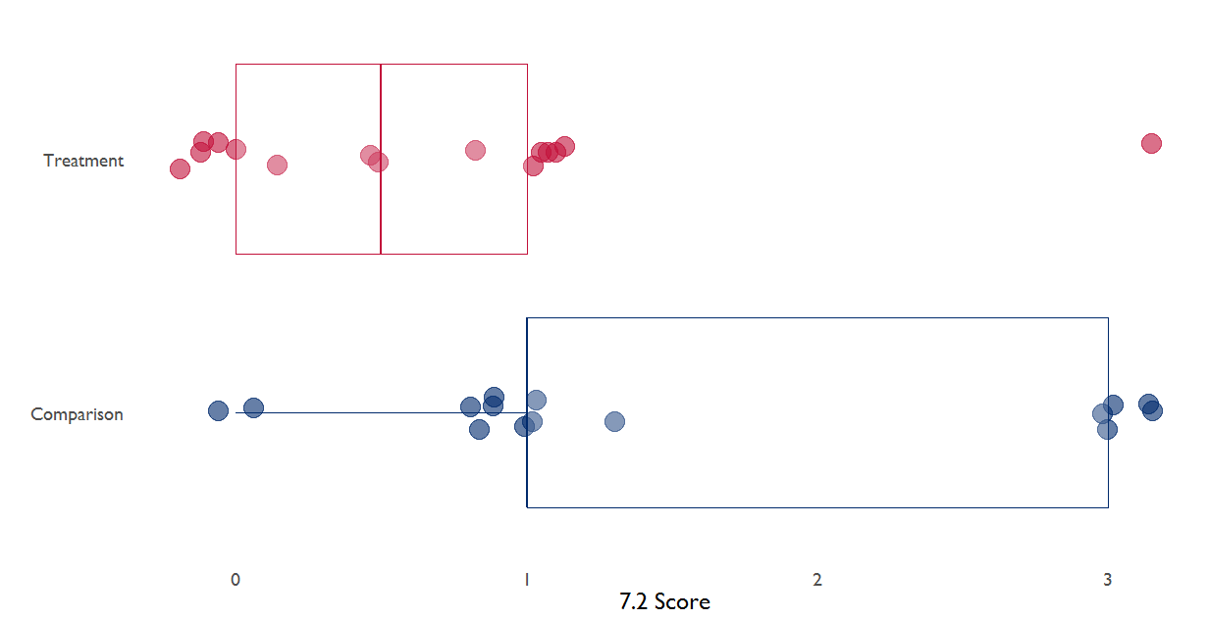
Item-level analysis across assignment groups generally shows that the evaluation team used interim scoring more often; for example, giving the score of 0.5 46 times compared to CITIES 19. The evaluation team explored the use of half-scores with the CITIES team to understand when to best utilize these since the MICA tool has clear integer categories. Additional discussion with CITIES staff may be warranted between this round of data collection and the next implementation of the MICA in the comparison municipalities to ensure that the evaluation team is properly aligned with the MICA methodology. The item analysis findings suggest that there are gaps between assignment groups on many of the assessment criteria. This is to be expected to some extent given the purposive selection of CITIES municipalities.

MICA Services Scores by Municipality and Region
Reviewing the MICA scores by municipality shows that the CITIES municipalities reached a higher total MICA services score. The highest possible services score is 115. The highest scores in the treatment and comparison groups were 41 and 30, respectively, with a median total score in the CITIES municipalities of 22 and a median score in the comparison municipalities of 24. These close median values can be seen in the figure below, which shows a large grouping of total scores between 20 and 30.
Figure 22: Total MICA Scores by Assignment

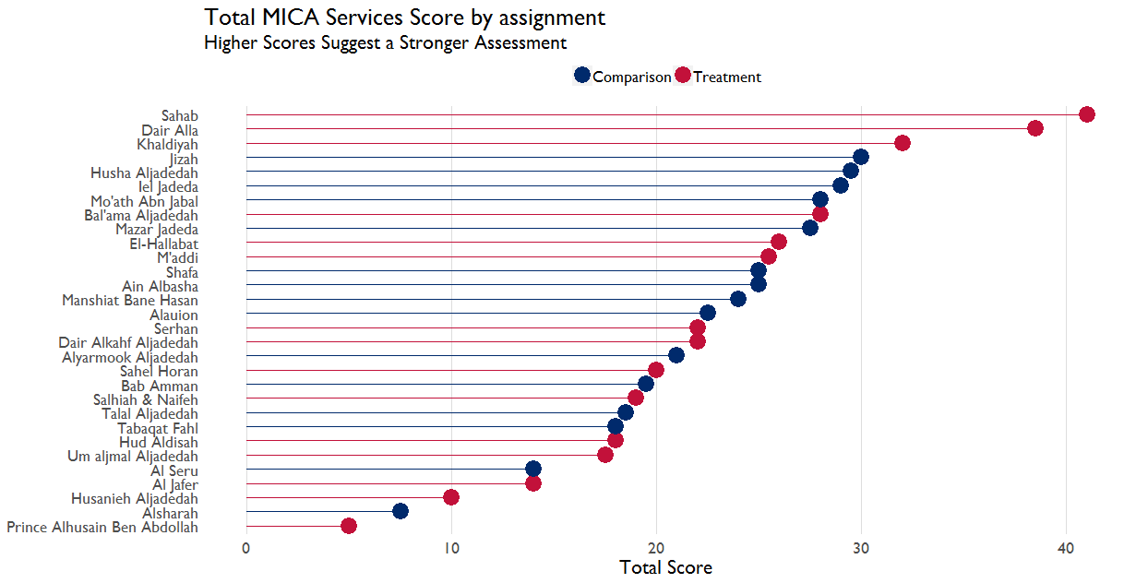

At the regional level, the item-level scores were somewhat similar in the North region, where there are eight CITIES municipalities and 10 comparison municipalities, with average item score of just under 1 across assignment groups.

 | Comparison |  |  | Treatment
Region | Mean Item Score | Item SD | Max Item Score | Mean Item Score | Item SD | Max Item Score
Central | 1.05 | 0.90 | 3.00 | 1.43 | 1.37 | 5.00
North | 0.92 | 1.12 | 5.00 | 0.90 | 0.92 | 4.00
South | 0.80 | 1.07 | 5.00 | 0.61 | 0.77 | 3.00

Notably, budget expenditure and own revenue in the central region for the comparison group was the third highest of any municipalities, treatment or comparison, at 10,748,000 JOD and 4,000,000 JOD, respectively, in Ain Albasha (budget and revenue information was not available in the other central region municipality, Jizah). Both comparison group central region municipalities had the highest number of employees within the comparison group and the second (Ain Albasha) and third (Jizah) highest number of employees overall. These are factors that are relevant for MICA scoring, e.g. availability of staff, although the exact relationship between contextual factors and MICA scores will need to be explored through additional inferential analysis using the population survey data.

The relatively low average item score, relatively high item standard deviation, and maximum score of 5 in the South region for the comparison group suggests a somewhat wider range of scoring frequency compared to the CITIES municipalities in the region. Indeed, less than half of the scores in the South region were a 0, with a score of 1 comprising 20 percent of all comparison item scores in the region, and a score of 3 given to10 percent of comparison region MICA items. In contrast, 51 percent of the CITIES items in the South region received a score of 0 and a score of 3 was only given twice across all MICA services items in the region.

Within the comparison group, the services scoring at the regional level has a similar distribution, with item-level scores generally skewed toward 0. Of the two comparison municipalities in the central region neither received a score above 3, as shown in the figure below. The distribution of item scores in the figure also shows that the North region were somewhat similarly distributed across assignment groups, albeit with a higher density of items receiving a score of 1 in the CITIES municipalities; 35 percent of CITIES items received a score of 1 compared to 13 percent of comparison items in the North.

Figure 22: Average Service Scores by Region
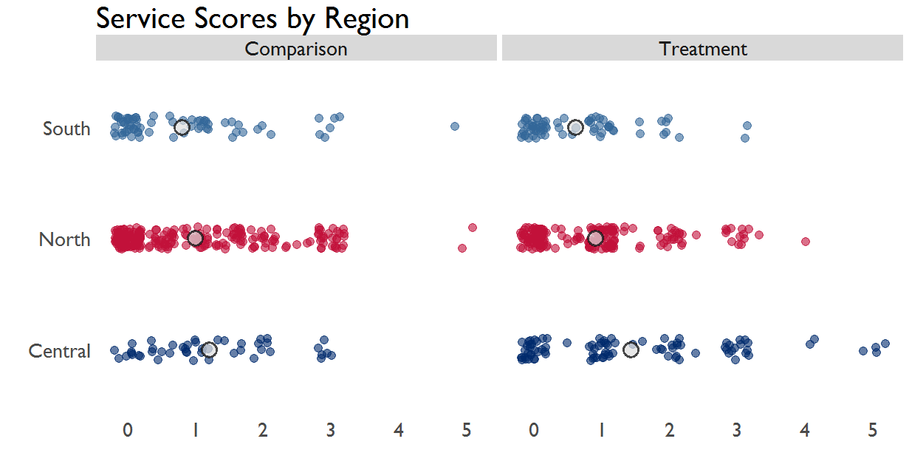

GESI Scores
Although at the aggregate level there is little equivalency on GESI items, at an item level they are paradoxically similar across the CITIES and comparison municipalities. The improved equivalence at the item level is largely a function of the GESI measures themselves. This binary, 1/0 scoring metric was designed to capture the presence of inclusive practices within municipalities. The minimum score will always be a zero and the difference between scores is limited in magnitude. As shown in the table below, the comparison municipalities did not have relevant GESI items for 14 of the assessment criteria. There was a difference in average GESI scores for nine of the 17 GESI items between the CITIES and comparison municipalities. In general, the normalized mean difference for the GESI items suggests that there are differences across assignment groups, with only one item, 3.3, falling below the absolute value threshold of 0.25 mentioned above.

Table 10: GESI Item Balance Statistics
GESI  Item | Treatment Mean | Comparison Mean | Standardized Mean Difference
1.1 Citizen Services | 0.07 | 0 | 0.07
1.3 Service Orientation | 0.07 | 0.2 | -0.13
2.1 Service Delivery Training | 0 | 0 | 0
2.2 Admin Capacity | 0.13 | 0 | 0.13
3.1 Urban Planning | 0 | 0 | 0
3.2 Design Project Planning | 0.4 | 0.13 | 0.27
3.3 Identifying Needs | 0.27 | 0.2 | 0.07
3.4 Building Licensing | 0 | 0 | 0
4.1 Services Infrastructure | 0.2 | 0 | 0.2
4.3 Waste Management | 0 | 0 | 0
4.4 Public Spaces | 0 | 0 | 0
4.7 Transportation | 0.27 | 0 | 0.27
5.1 Markets | 0 | 0.2 | -0.2
6.1 Tourism Culture Leisure | 0.07 | 0 | 0.07
6.2 Public Health | 0 | 0 | 0
7.2 Disaster Management | 0 | 0 | 0
8.1 Planning Reporting | 0.07 | 0 | 0.07

Looking at the items where comparison municipalities did receive GESI scores, the following municipalities had GESI items:
Table 11: Comparison Municipalities with GESI Items Present
Municipality | Region | Total GESI Score
Ain Albasha | Central | 1
Alauion | North | 1
Alyarmook Aljadedah | North | 1
Husha Aljadedah | North | 1
Iel Jadeda | South | 1
Jizah | Central | 1
Manshiat Bane Hasan | North | 1
Mazar Jadeda | North | 1
Talal Aljadedah | South | 3

Given the low number of comparison municipalities, it is worth disaggregating the data further to see what, if any, relationship there is between GESI item presence and service item scoring. It may be the case that a municipality’s ability to provide GESI-related services speaks to overall engagement with citizen needs. For comparison municipalities that had GESI items present, i.e. scored at least a 1 on one of the GESI dimensions, the median services score was slightly higher than that of comparison municipalities that did not have any GESI items present, with a median total services score of 25.5 to 17.5, respectively. The relationship between the GESI and services scores may warrant additional analysis and qualitative study. The top services score in the comparison municipalities had a total GESI score of 7, but the second highest services score had no GESI items. Indeed, one of the comparison municipalities that received a 1 for GESI item 1.3, which is scored based on whether or not there is a mechanism to collect complaints from GESI groups, had the penultimate lowest total score in the comparison group. As shown in the figure below, the distribution of total scores between municipalities with and without GESI items has a similar skew.
Figure 23: Distribution of MICA Scores by GESI Presence and Assignment
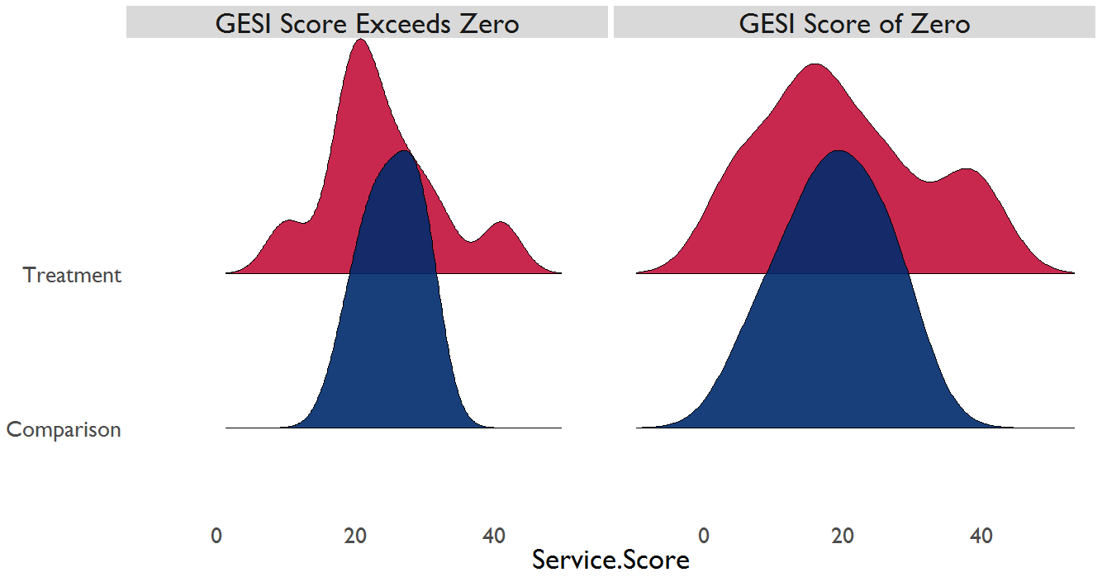
Given the low number of overall GESI observations, tracking changes in the GESI items may serve as a way to track the types of interventions municipalities receive and the use of, for example, small grants in the treatment areas. These data may also be helpful when combined with the general population survey for additional inferential analysis to see what the relationship is between GESI-related services and overall perceptions of service delivery. Given the range of service scores and limited GESI scores, it is not clear that there is strong relationship between the two based on the current MICA assessments.

There are two key conclusions from this assessment:
- At an aggregate level, the MICA services scores for the 30 matched municipalities is within a standard threshold for equivalency.
- Item level analysis is important for understanding the drivers of difference between assignment groups, but given the nature of the MICA (limited range of scores, inherent rater error, etc.) and the fact that ultimate outcome of interest is the change total MICA scores, any item-level imbalance is important to note, but not detrimental to the evaluation design.

Public Perception
To measure public perception, the evaluation team will utilize general population data to test hypotheses 2 through 7. In addition to capturing data on perception of government and service provision, the population survey examines citizen engagement indicators, such as political party/CSO membership, media consumption, and various participation measures, such as attending meetings or contacting elected officials. These measures will provide helpful disaggregates for descriptive analysis, as well as control in estimating outcomes for each hypothesis.

The use of the general population survey to test each evaluation hypothesis will involve generating a separate model that follows a similar functional form, with the various public perception themes as the dependent variable for each model. For example, to test hypothesis 2, that capacity building improves the perceived quality of public services, the dependent variable will be the perceived quality of services, with explanatory variables used to control for individual factors, such as age, citizen participation, education, and various local factors, such as municipality class and exposure to other USAID activities.

Conclusion

Evaluation Questions and Themes
This evaluation found what experienced observers know to be true: there are staffing issues, little-to-no vertical reporting between and within municipalities and governorates, and lack of own revenue and structural budgetary challenges inhibit the financial stability of municipalities.

How successful CITIES will be in addressing these issues will crucially depend on the training rolled out under Component 1 and 2. Of course, the success of training is highly contingent on the overall enabling environment. The provision of small-scale grants should make some progress of easing this environment, providing visible benefits to citizens, and demonstrate capacity to citizens in a way that no training program can. The CITIES evaluation will track each of these parts to see what succeeds and where and how this translates to MICA scores and overall citizen perception.

More time will be needed to determine the sustainability of specific CITIES interventions, but a clear theme was the lack of human resource decision making authority at the municipality-level and existing capacity constraints may affected the sustainability of intervention benefits.

Baseline data also suggests that although there has been some initial coordination between CITIES and other donor activities, there is still room for CITIES, other USAID programs, and other donors to develop synergies and determine how best to complement each other’s objectives. It is unclear how

Implementation Fidelity
Careful attention to the schedule of CITIES’s activities suggests a robust initiative that has seen some delay but has gradually achieved its intended scale. The CITIES evaluation has been carefully designed around the schedule of CITIES’s inputs and workplan. As occurs with many donor initiatives, there has been some scope creep, with stakeholders making requests outside of the original workplan or expressing a desire to spend more

Since the start of implementation, CITIES has done a rapid education initiative on decentralization, rapid improvement projects to secure dumpsters for large municipalities, a regional development plan across municipalities, and engaged on a national campaign of financial management and decentralization training. We conclude that these activities will not affect the design or implementation of the evaluation as they were either unlikely to have a measurable impact on the outcomes of interest in and of themselves or were provided across assignment groups. That said, it is important to continue to track such activities and to maintain communication with CITIES to determine whether and how these requests affect planned activities and resource allocation.

USAID set out a grand vision to promote Jordan’s decentralization agenda, one that spans citizen perception of government responsiveness, effectiveness, and confidence in leaders. This is a tall order for an activity that was designed to help municipalities build capacity to develop own revenue, handle the responsibilities of decentralization, and to improve citizen engagement and constituent outreach. In reviewing the schedule of activities and how faithfully they have been implemented, it is clear that donors should not expect a jump in citizen perception. Citizen perception of government has a complex and non-linear relationship with the actual performance of government institutions. CITIES is positioned to help municipalities realize changes institutionally and capacity-wise, but it remains to be seen how this will be perceived by constituents.

Baseline Equivalency and MICA Data
Measurements of institutional capacity have intrinsic uncertainty. Slight differences in interpretation can lead to differences in scores, and no amount of training can eliminate this if it is inherent in the recorded measures. The CITIES evaluation team has been vigilant in trying to minimize the error that comes from differences in interpretation. There are some measures, and some municipalities, where error is relatively high. This error presents risks to the impact estimates comparing individual municipalities, but in aggregate the error is tolerable and does not limit the evaluation design. This evaluation has used multiple raters, combined results between them, and incorporated the technical review of the CITIES Component 1 team lead to minimize measurement error across assignment groups.

The evaluation did find a low-to-moderate relationship between the measurement error and the baseline equivalency between assignment groups. This potentially raises questions about the ability of the evaluation to conduct robust inference. The reduction in scoring error reduced this overall measurement error, but it presents the need to be cautious in inferential analysis. To address this concern, the evaluation team concluded that sensitivity analysis of equivalency using multiple configurations across matched, partially matched, and the full CITIES sample are needed to assess the validity of estimates.

After reviewing two sets of scores across six configurations, the evaluation team found that the distribution of services scores are balanced across assignment groups for matched (15-15) and partially matched (15-23) municipalities. This implies that on average the CITIES and comparison municipalities are statistically similar. Our analysis of equivalency provides hope that any measurement of difference at endline can be attributed to CITIES rather than unobserved characteristics or is the result of selection bias.

Recommendations
- Maintain, or even build upon, the current level of coordination across the implementation and evaluation teams. The evaluation team used the CITIES’s MICA tool as a data collection instrument, which required training and trust, and supported the evaluation team to mitigate rater error. We recommend that USAID continue to support the open communication between the IE and IP stakeholders.
- We recommend that CITIES develop either a component-level or MEL-level tracking system for monitoring activities by date, type, and location. This will help improve implementation, measure scope creep, and provide inputs for further internal and external study.
- Dima to fill in decentralization and local governance recommendation.

Annexes

Annex 1: Notes on Implementation Fidelity

February 2018 Meetings

Component 1
MICA: All MICAs were completed and a final report was prepared. Overall conclusions reveal that first class municipalities perform better than municipalities in other categories indicating clear correlation between size and performance. At the same time, Ramtha scored in the early 20s although the municipality should have scored better. Irbid scored highest, followed by Zarqa then Salt. Class A municipalities usually scored in the 30s. Statistical conclusions cannot be drawn. No municipality showed any sign of activity planning.

Another important correlation was evident between geographic position and performance. Remote municipalities performed weaker than those in the center including Deir Al-Kahf and Salhiyyeh and Nayfeh. Municipalities in the South also performed weaker than those in the Center and North. According to the component lead, this is related to the financial system, and the areas from which various ministers hail.

The data did not reveal a specific task that is being performed better in class A municipalities than in other municipalities. C1 lead said he could not but conclude that all municipal departments are weak. Small municipalities do not have civil engineers or road engineers. Legal staff is also absent. Civil engineers, when they exist tend to be very weak. They are seconded to their positions. Sometimes municipalities have dedicated positions for engineers.

MICA Design: The discussion covered rubric issues. C1 lead said some indicators should have been better calibrated. Under urban planning, the presence of an urban plan and municipal ability to develop plan should have been split. A great deal of effort and time was spent training team members and bringing them into the process. The subjectivity of consultants was nevertheless acknowledged as a factor affecting results. C1 lead said the tool is not suitable for thorough assessment, and interventions cannot be based on its results.

There are performance indicators based on MICA but those can be assessed objectively. C1 lead said that some scores are expected to improve. If a “very basic system for participatory budgeting” is improved, the score will go up. According to him, CITIES will have the chance to improve a few scores.
.
Service Delivery Improvement Plans (SDIPs): On the 12th of March all SDIPs will be completed. Priorities include street maintenance, LED lighting, recycling, cleanliness and public services, sewage systems, and transportation. Priority setting for SDIPs is defined by the community not by MICA. “MICA is more technical. SDIP is about perceptions.”

There are two streams of funding for municipalities, one through the ministries and one through the governorate councils to which 220 million have been allocated for investments.

Grants: C1 lead expressed some concern that USAID’s procedures for allocating grants may cause further delays. The budget for grants is now 5 million for all governorates and 33 municipalities. This modest amount, according to C1 lead, may also negatively affect the project.

According to him also, CITIES will need to get grants out to municipalities in the next 6 months. If grants are late the success of the Project might be jeopardized. C1 lead gave the example of the Al-Husseiniyyeh’s mayor who told him that CITIES training is very beneficial but that his municipality “needs a loader.” The lack of equipment is impeding the ability of the municipalities to perform their job.

Expectations are high. C1 lead emphasized that showing up in municipalities is enough to raise expectations.

Component 2
Financial Management: A financial diagnostic has been completed in half the treatment municipalities. Thirteen areas were assessed. The scoring of financial operations system was done to gauge compliance levels and identify gaps in financial operations. Areas where corrective actions can be applied were identified including those of organizational structure, job descriptions, and fixed asset register.

The WB and the Spanish as part of their Qudra project are also working on financial management in three of the thirty-three treatment municipalities. The WB is working to upgrade IT systems. CITIES is looking into ways to collaborate. C2 is planning to work in year 3 on developing an “appropriate” financial management system.

IT Systems: Component 2 (C2) lead is keen on maintaining a strong relation with MoMA. MoMA has been working on automating various municipal systems. For one, financial units were linked to the central government. MoMA is rolling out the system in all municipalities. Some municipalities are not adopting the changes because they did not receive enough training.

Human Resources: Visits were completed to 17 municipalities and data was collected on personnel statuses. A statistical report was developed for each municipality, but the reports were not released.

C2 staff is working with LDUs to develop their structure and propose corrective actions. CITIES is planning to work on performance evaluations. C2 is also working with LDD at MoMA. The Project has inquired if municipalities’ organizational structure can be altered but the Ministry was not in favor. For now, CITIES is going with existing positions and will try to instigate changes through job descriptions. CITIES is trying to demonstrate to MoMA that new regulations require new staffing. Component Lead recognizes municipal salaries as a challenge. Current compensation packages will limit the ability of municipalities to attract qualified staff.

Capacity Building: CITIES will be providing capacity building support to MLDUs. MoMA is requesting that CITIES trains LDU staff in all 100 municipalities. CITIES was interested in targeting the 33 treatment municipalities only. Training will be focused on the preparation process for the needs manual/guide based on the requirements contained in CEP’s manual. CITIES decision to focus on LDUs is because the needs guide process is led by the units. C2 lead believes CITIES work would have been easier if the Activity started one year before the elections.

In addition to covering the needs guide preparation process, training is expected to also cover the development of annual action plans, strategic planning and local economic and investment development. MoMA is requesting that support is extended to all 100 municipalities. Municipal and local council members will be trained. Training will be in the form of orientation sessions (2700 elected members). Training will included orientation sessions related to decentralization, the preparation of the needs guide and the mandate of each council. Training will also be provided to governorate and executive council members.

Cooperation with other Donors: Through AFD, the GoJ received a 50 million loan for the municipal sector. CITIES helped MoMA to develop a financial observatory unit at MoMA. CITIES team visited three municipalities and assessed their system and developed a disclosure policy for MoMA. This support included developing a communication mechanism and the training of 100 municipal financial managers.

Component 3
The Activity has dropped the cohort system from its approach. C3 lead said the component tends to be somewhat reactive in its own approach. If the municipality is interested, staff will visit it and hold discussions.

C3 is working with the MCOGs to develop their outreach plans. The MCOGs are headed by the mayor and include the membership of the LDU head, youth and women. Local council members are not concerned that they are not all members. Sometimes, the MCOGs do not await CITIEIS teams to offer their support. They start initiatives on their own.

C3 lead said that the municipalities are accepting the component’s team and the component is on target in terms of its activities.

C3 prepared a community engagement review report for the 17 municipalities in which C3 conducted an initial assessment/review. The component is working with MCOGs to identify 3-5 tools to be included in each municipality’s Municipal Engagement Strategy. The strategy will be endorsed by the municipal council. In parallel the component will be working with municipalities to develop websites.

Component 4
Changes in Approach: C4 lead said the approach has shifted. Threats to cohesion (TTCs) are now being considered. In targeted municipalities, C4 team meets with the Mayor, LDU staff and local council members and explains CITIES approach to promoting community cohesion within the community and municipality. If buy in is secured, the team asks the municipality to hold a community meeting to discuss threats. About 25 community members representing different sectors attend and engage in a brainstorming session about the factors affecting relations in the community. From there, they ask community members to identify factors “that help the community bond, identifying in the process social and religious values, such as nakhweh that help achieve that. After threats are compiled and clustered, CIITIES team returns to the municipality and informs municipal partners of the needs that can be addressed by the Project, municipality or civil society.

C4 team also helps municipalities prioritize the needs that were identified through this process. This is done with Municipal Community Outreach Groups (MCOG). Following that, C4 lead meets internally with other component leads to understand what other components are doing and how work can be coordinated.

So far, introductory meetings have been held in 16 municipalities; TTCs exploration sessions were organized in 11 and prioritization was facilitated in 6. Interventions to address threat have not been identified yet.

Ranking Threats to Cohesion: The process has identified common “threats” in communities. These include the “lack of zoning,” which causes friction between community members that have the potential of escalation. This is sometimes due to arbitrary construction. Community members end up dragging disputes to the municipality. Component 4 will not be addressing such threats.

The second priority threat identified through this process is garbage collection including the location of bins.

The third threat is stray dogs.

The lack of parks and public spaces has surfaced as a final common threat.

Non-service related TTCs include elections and drugs which cause “agitation” in the community.

GESI (Cross-cutting component)
GESI has an advisory function not an implementation one. However, GESI lead said that her crosscutting component may end up having some implementing role. GESI lead works with all components to ensure that GESI is mainstreamed. When mainstreaming GESI, analysis and documentation will be undertaken to provide component leads with data to help them ensure GESI sensitive interventions.

A GESI analysis was not conducted. GESI lead said she was not able to conduct one. She only did a desk review and produced a short report. The thinking at that time was that a separate GESI analysis would be conducted for each municipality.

GESI Review Process: The GESI review was designed to cover four activities. In the Municipal Institutional Capacity Assessment (MICA) 18 statements were added to evaluate the status of targeted groups and assess the level of services and relation to municipalities. MICA GESI scores are now being finalized.

The second part covers the HR audits. Eight were done so far. A gender analysis of the HR audit will be conducted.

The third part is the baseline survey. GESI lead met with REACH and incorporated questions in the survey. REACH provided a short report on GESI.

The last part includes data collection from female elected councils and staff about their challenges, experiences, and aspirations. The data is analyzed and incorporated in each municipality’s profile. The generated analysis will mostly feed into Component 3 and 4 only.

In year 1 when MoI revised the organizational structure of LDD, the ministry added a unit for community outreach to ensure that all stakeholder needs are identified. The GESI lead started working with the new Unit. The staff was brought together to discuss their tasks then were trained on the decentralization needs manual.

The Unit is expected to hold sessions with community groups. Community outreach/equal opportunities representatives will meet with the community to identify needs at the governorate level. They will focus more at sector needs rather than municipal needs. Because of this engagement, the sequence of engagement and needs identification and prioritization is expected to be much easier next year.

August 2018 Meetings

Component 1
Municipal Priorities for Activity Interventions: After C1 team completed the MICAs with municipal staff and reported on results, the staff engaged in identifying about 6 intervention priorities in each municipality. The identification process yielded common issues across all treatment municipalities. The first common priority identified through this process is street maintenance which was mentioned in 30 out of the 33 targeted municipalities. This will be addressed by CITIES through training on maintenance plans, surveys, assessment of technical quality, implementation plans and other related areas. C1 lead felt that outsourcing quality could also be improved.

Street lighting was identified as the 2nd priority issue for municipalities followed by health inspections, one-stop-shop then solar energy. C1 lead discussed the assessment of solid waste management the project conducted. According to him, there is no occupational health management in any of the municipalities.

SDIPs were based on MICA results, observations during the MICA sessions and other assessments. According to C1 lead, project interventions are informed by SDIPs as well as team observations. Both in turn inform municipal plans. Some C1 findings are corroborated by C4 findings related to communal stressors.

Training offered by the Activity will be in the form of on the job training followed by coaching to monitor and support the application of knowledge. Training will start in late September. Groups will be organized geographically. Each group will include 6 municipalities with two staff members from each municipality.

Street Naming: The minister requested that street naming is included as a priority area. The tender procedure is in process.

Public parks: Public parks will be a joint activity with C4. The first 4 municipalities are currently being selected for implementation. Municipalities will be asked to identify locations. C4 will mobilize an organization to develop sites and will also provide some equipment.

Solar Energy: In terms of solar energy, C1 carried out a study to determine if the project is technically and financially feasible. C1 is proposing that municipalities contract private investors to build the solar plants to feed municipal needs consuming about 15% of budgets (around JOD 150,000.) CITIES’ role will include developing feasibility plans and implementation plans and overall facilitation.

Fleet Maintenance: C1 hired an expert to visit all municipalities and train staff on fleet maintenance. The expert will train staff on how to do first line maintenance and how to manage car parks.

Solid Waste: The assessment of solid waste that C1 conducted identified community cleanliness as a priority need. Based on the assessment, municipalities have defective route planning. Routes are not the most efficient which may lead to municipalities incurring related high costs. Support for route planning was requested by 16 municipalities and will be provided in 18. The project will support municipalities to develop solid waste management plans that will cover proposals to improve garbage collection, job descriptions, analysis of routes among other operational issues. Support may also include small equipment ($5000 per municipality). In Ma’an the municipality has already accepted the plan. Health and safety equipment will also be provided in the amount of $2000 per year per municipality.

Recycling: Several municipalities requested support for recycling initiatives but CITIES will not provide such support except in a few locations including Maadi in Salt. Support will be in the form of technical advice for sorting at source. In Sahab where the municipality was also keen on starting a recycling initiative CITIES will only help develop a SWM plan for the municipality. C1 lead emphasized the importance of supporting visible initiatives including public parks. Recycling is not considered sufficiently visible.

Health Inspections of Food Shops and Markets: GAM has a good system for inspecting professional licenses. CITIES has hired someone from GAM who is ready to undertake related training. The training will cover such issues as the current legal framework, how to maintain a database and carry out systematic inspections and when to resort to the police.

One-Stop Shop Service: C1 lead expressed some skepticism about this identified priority need and what it means for every municipality. According to him, municipalities will receive different forms of support in this area. Some municipalities simply want a sign. Some want equipment for a new building. In Zarqa, CITIES will provide equipment. In Irbid, support will be provided under C2. In Salt, CITIES is working with Mercy Corps to provide needed assistance.

Local Development Plans (LDP): Only some municipalities have expressed the need for developing LDPs. Decentralization requires municipalities to have both strategic and development plans in addition to the needs guide. The sequence of how these plans are developed is important. This year the development of the needs guides went ahead without being informed by municipal strategic plans because a few municipalities have such plans. CITIES will roll out a training program in all 33 municipalities to cover gaps in this area. The training will be piloted in Sharhabeel in Jordan Valley. All 33 municipalities will be taught how to collect data.

C1 also reported that the development of a regional development plan with two other municipalities (Muath bin Jabal and Tabaqet Fahel; both comparison municipalities) is underway.

CITIES trained MoMA staff. The project provided a 6-day ToT training on the development of LDPs. C1 also trained LDUs and executive council directors on how to develop governorate development plans. This, according to C1 lead, was a success because twelve governorates produced their own plans. Even though some of these plans will require additional effort to enhance their quality the various governorates now have plans developed independently from MoPIC. Moreover, and according to C1 lead, by the end of August 2018, all governorates would have approved their investment plans.

The new decentralization law requires governorates to develop both strategic and development plans. CITIES advocated that the two be combined and support is provided for the production of strategic development plans. These contain vision and implementation plans. The combined plans have now been approved by the executive councils and referred to the governorate councils where they are being discussed. MoI will not need to approve them.

Reporting: Mayors are required by law to submit reports to municipal councils and then to the minister of municipal affairs. CITIES will train mayors on how to report and will develop a standardized template for reporting. At MoMA, staff will be assigned to follow up on these reports. Reports could be used to inform policy.

Master Plans: MOMA requested that CITIES supports the development of master plans which CITIES will do.

Tracking Inputs: CITIES developed supplementary indicators because many of the Project’s activities are not reflected by the project’s primary indicators. Beyond indicators, Municipal Action Plans are updated on a monthly basis. Across all components, the plans capture all activities in all the treatment municipalities.

Challenges: MoMA has high expectations for the Project. The minister has made several requests for support including for street naming, master plans and regional plans. MoMA expected that the Project would provide more support in the form of in kind assistance. According to C1 lead, municipalities were also under the impression that the Project would be providing more equipment. C1 lead said the project “can achieve a decent result.” He expects MICA scores to move by 10%. He expects cancellations of support for LDPs and one stop shops.

On MICA, C1 lead said the tool is useful but “rougher and less accurate” than intended. It also does not capture qualitative changes. For example, the quality of transportation such as reliability of bus services is not captured by the tool.

Component 2
Financial Management Assessments
- The financial management assessments will be completed by September.
- Thirteen (13) areas of financial management are being assessed by CITIES.
- Assessments in 25 municipalities have already been completed.
- C2 organized 75 days of orientation sessions for local and municipal council members. The sessions covered the role of the councils and procedural aspects. C2 lead said that the 75 days orientation sessions delayed C2 core activities.
- C2 also trained all MLDUs on the procedural manual developed by CEP. CITIES tries to include MOMA staff in the 1-day training. C2 conducted trainings for 16 MLDUs and 3 GLDUs to finalize the needs list. After the needs lists were approved by the municipal councils, C2 worked with GLDUS to help them consolidate the lists.
- C2 also conducted 12 2-day trainings for governorate council members on budgeting and a Fiscal Reform Project developed manual about budget formulation.
- To assess trainings, CITIES conducts pre and post evaluations. The last training attempted to assess buy in of financial staff and commitment to adopt corrective actions. In general, municipal staff are interested and responsive. Educated young mangers tend to be less resistant to change.

Human Resources: C2 completed 19 HR audits.

There is a connection between financial scoring and C2 activities. C2 is planning to work on cash flow, revenue tracking, and budget formulation.

Challenges: C2 lead said he expects some challenges with having municipal staff adopt corrective actions without the provision of financial incentives.

Another challenge relates to MoMA’s slow process. C2 is planning to train financial managers, HR, local council members, and MLDUs. These trainee groups refer to different units at MoMA who are slow to respond and coordinate.

In terms of progress, two activities are derailed: The development of local council manual of control. C2 lead asked for the activity to be removed because there is no need for a manual. The decentralization unit will develop a manual for all councils that will cover all regulations. Another activity that will be delayed is the training activity for executive managers.

Component 3
C3 Indicators: C3 lead said that C3 is meeting its targets for indicators relating to public forums. The definition of public forum is an event attended by more than 16 community members. C3 reached 70 public forums instead of the targeted 66 because of this year’s SDIP meetings. MCOGs are also counted towards “avenues for youth” because youth are represented on the Groups.

C3 lead said that when MCOGs hold meetings with the community, events are similar to townhall meetings. In Jafer for example, one of the meetings with community members was able to attract 55 people.

The formation of the MCOGs could be counted towards indicator 1.3 on Municipality Serviced Orientation toward Individual Citizens in the MICA tool.

Challenges: These include:
- Municipalities dropping out of the project;
- Weak MCOGs that need to be more closely supported and encouraged to remain active;
- Other donors have committees in municipalities whose work will need to be coordinated and followed up on; and
- The component’s ability to capture information relating to its own activities.

Awareness sessions will be held on the subject of budgets. People need to understand the limits of municipal action and the responsibilities they bear as citizens, including the responsibility to pay taxes. Community members should also understand the municipality’s financial cycle, who approves it and how it’s approved.

Eight municipalities are already sharing their budgets with their communities. More effort is needed for full-fledged participatory budgeting.

Moving forward consultative sessions and capacity building are needed to build communication tools the MCOG already identified including townhall meetings and community members databases. Automated data with report generating capabilities is also needed.

Component 4
TTCs Identification Approach and Progress: The TTC profiles for 23 municipalities are complete. Salt and Madaba have just been finalized.

This Activity’s framework is discussed and set with the mayor and MCOG. This includes one or more meetings with the mayor or staff to explain the approach and decide on when to hold the exploration meeting with the community. About 25-30 community members attend usually in addition to municipal council or governorate council members who also invite people to join.

During communal sessions, CITIES staff ask community members to visualize a cohesive community, and then ask them to focus on their community and identify factors that would strengthen cohesion. Threats are categorized as either service related or social. Service related threats are divided to municipal services and other public services. Public services cover transportation and education, water and electricity. The social category of threats includes general threats and youth and women related subsets. Community members are also asked to identify stressors on relationships including that with the municipality.

Through their efforts, C4 staff try to construct an understanding of what the threats in the community are. In Dleil for example, community members complained they have issues with engaging youth. C4 staff try to understand if this is a mere stressor that is service related or a threat to cohesion. Sometimes service related stressors can morph into TTCs. According to C4 lead, transportation can escalate and become a threat to cohesion in a situation where a boy for example, sees his sister in a private car with a stranger.

C4’s approach follows that of CITIES in terms of first identifying and prioritizing issues within communities then deciding how to address them. Threats are compiled and reviewed through MCOGs and are then prioritized.

Results revealed common threats across all municipalities including the lack of public parks and lack of zoning. Common social issues include drugs.

Priorities however were difficult to identify. Social issues are easily ranked, but not other threats. Now C4 is working with MCOGs to decide the nature of needed interventions. In February 2018 C4 engaged the community in awareness sessions on the roles of municipal and local council members. Ninety-seven (97) sessions were held, one in each municipality with a total of 4055 attendants. C2 held awareness sessions on the roles of councils with council member while C4 held the sessions for community members. Five of these sessions targeted youth. C4 has then resumed its analysis on the threats to cohesion. To date, C4 has worked with 25 municipalities to identify threats to cohesion. In 18 municipalities the threats were ranked and in 14 appropriate interventions were identified.

Interventions will include procurement or in-kind grants for the rehabilitation of parks, soccer fields, multipurpose rooms, and youth centers. On the “softer” side of possible activities are awareness and cleanliness campaigns, the formation of youth groups and the facilitation of meetings with stakeholders such as cattle owners and municipal staff. C4 interfaces with LDUs to facilitate C4 activities.

Challenges and Changes: C4 raises awareness about the importance of accountability and role of community in decentralization. Challenges include the high level of distrust between administrative layers, and the widespread misconception about roles and responsibilities.

Some municipalities are conservative. This limits the participation of women. Jafar and Hallabat for example of such communities. Women don’t attend sessions held by the Project.

In terms of knowledge management and how information is documented and reported, the Project uses attendance sheets and pre and post evaluations. Activity tracking is documented in the Municipal Action Plans.

Conflict Management and Mitigation (CMM) was shifted to year 3.

Meeting with CoP
Challenges: The CoP reported that the project is not where it should be in terms of outcomes or impact. Assessments have not been completed yet. C2 activities have warded off relationship problems with municipalities. However, both mayors and communities are frustrated. The component leads are also frustrated because they are not able to implement activities yet. The MICA and SDIP processes are taking too long. Because grants have not been disbursed the project is negatively affected. In October, the Project can make in kind donations.

Upcoming Assistance: The grants manual is already approved. Grants will be branded as USAID CITIES grants. An issue to consider is who receives the credit for assistance and how does that affect public perception of municipalities.

The CoP reported that thirty percent of each grant will be at the discretion of mayors to spend as they see fit. Seventy thousand will be allocated for service delivery and another 70 thousand for community engagement and cohesion. 1.5 million will be granted to CSOs to help municipalities move on social cohesion.

C2 is not tied to grants but can procure services. C2 has a procurement plan (separate from grants) for organizational development. The component’s budget is 600k. Seven municipalities were selected to receive equipment, printers, and computers.

Coordination with other Donors: CITIES worked with the French to help develop a financial observatory at MoMA. Cooperation between the CITIES and AFD is strong.

Annex 2: Investigating Scorer Agreement
The Municipal Institutional Capacity Assessment (MICA) is CITIES’s primary tool for determining a municipality’s service delivery capacity. CITIES has described the tool as a way to “start a conversation” around its implementation approach in each of its municipalities. Change in the MICA scores is also the main outcome of interest for this evaluation, with the comparison of scores between CITIES treatment municipalities and the matched control municipalities serving as the main focus of the IE design. Given the importance of MICA scoring for both implementation and estimation of CITIES’s impact, assessment of the MICA scores themselves is warranted to ensure reliable, minimally biased estimates.

There is concern about measurement consistency with any data collection effort. Two reasonable people can interpret the same question in slightly different ways, which can affect the reliability of the overall measurement endeavor. In the case of the CITIES IE, the use of the MICA as a primary data source for this IE presents two main challenges: between team reliability and within team reliability.

The evaluation team’s MICA scoring in control municipalities needed to be aligned with that of CITIES’s scoring in its treatment municipalities to ensure between-team comparability. The evaluation team and CITIES needed to have a similar understanding of each MICA item and how to apply MICA scores appropriately. To this end, the evaluation team received two training sessions with members of the CITIES team. The evaluation team also shadowed CITIES staff as they applied the MICA in six Mafraq governorate municipalities. The goal of training with and shadowing CITIES staff was to minimize the variability between each group’s scores and overcome the challenge of each team implementing the MICA tool differently.

The second challenge MICA scoring presented as part of baseline data collection was within team, or inter-rater, reliability. Even though the IE team received training on how to employ the MICA tool, there could still be variability within the IE team on how to appropriately score the same municipality on the same measures. Beyond the training and guidance that the evaluation team received from CITIES, the MICA tool itself has guidance on how to apply scores for each item. For example, on MICA measurement 2.1, Technical Trainings in Service Delivery, the MICA tool provides the guidance to apply a score of 1 if, “The municipality occasionally organizes training on technical topics (e.g. maintenance infrastructure, maintenance of vehicles/equipment, SWM), at request [sic].” This seems straight forward, but there are often cases where conditions on the ground are more ambiguous, such as whether staff were actually able to provide services and their qualifications to do so. If there is a lot of variation within the IE team on what constitutes one score over another, assessment of the comparison municipalities could be biased as would comparison to CITIES’s treatment municipalities.
Although the evaluation team used the same MICA tool as CITIES, the mode of entry differed. The evaluation team collected MICA data using an electronic Open Data Kit (ODK) survey. ODK is an open-source survey platform that is compatible with most mobile devices and can save data entry progress. The scoring process involves a series of interviews, relies on extensive notes, and, in general, took place over a few hours, with follow-up calls as needed. The evaluation team developed the ODK-version of the MICA tool to ensure standardization of entry and to develop a central database for scores. Enumerators took notes during the interview and then re-entered these into the ODK form the day after data collection. By limiting room for data entry error and having data uploaded as soon as it has been entered, the evaluation team in Jordan and at MSI in the US could easily check for issues, track data collection progress, and begin analyzing the scores. In addition to using ODK for the comparison counties, the evaluation team also used the ODK MICA tool to enter MICA scores from CITIES. Through this process, the evaluation team has all of the MICA scores in a single, uniformly formatted data set. For the comparison municipalities, the ODK MICA tool allows the evaluation team to see who scored which municipalities, when the scoring was started, when it ended, and output the data an in easy to analyze file type.

Assessing Reliability
Before determining how to address inter-rater reliability, the evaluation team needed to know the magnitude of score variability. To assess how harmonized the IE team was on their MICA ratings, two or more team members scored the same municipality for the following 15 municipalities:
Table 12: Number of Ratings per Comparison Municipality
Municipality | Number of Ratings
Ain Albasha | 2
Al Seru | 2
Alauion | 2
Alsharah | 2
Alyarmook Aljadedah | 2
Bab Amman | 3
Iel Jadeda | 2
Jizah | 2
Manshiat Bane Hasan | 3
Mazar Jadeda | 2
Mo’ath Abn Jabal | 2
Shafa | 3
Tabaqat Fahl | 2
Talal Aljadedah | 3
If the evaluation team were perfectly harmonized and had interpreted local conditions in each municipality identically, we would expect all of the MICA scores to be the same. In some cases, the guidance provided is ambiguous or there were inconsistencies in the rubric. For example, for services item 3.1, related to Urban Planning, many municipalities have aspects of a 0 score, as well as a 2 score. Some municipalities have may have staff to carry out urban planning and have a plan, but the staff are not actually qualified to do this task. In other cases, there may be an urban plan that is decades old or included a large amount of land designated as “unregulated” with little explanation. Any assessment tool will encounter issues like this given that there will likely always be ambiguity on the ground that does not fit nicely into one single category. The IRR analysis can help systematically flag these issues and then allow for appropriate corrections.

The MICA tool also allows for intermediate scores, e.g. 1.5, to allow for some flexibility in the rating system. As shown in the figure below, there was general agreement between the evaluation team’s MICA enumerators, particularly on the higher end of the MICA scale (e.g. scores of 4 and 5). However, the figure also shows that Enumerator 3 utilized half scores more often than the other two team members.

Figure 24: Distribution of MICA Scores by Enumerator
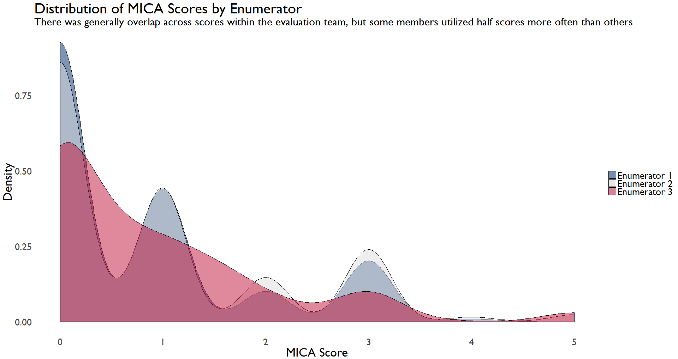
The lack of overlap suggests that more investigation is needed to analyze the level of reliability. To understand how harmonized scores were, the evaluation team looked at the MICA services scores, i.e. the main MICA items that directly relate to municipality capacity and service provision, MICA GESI scores, the scores that capture how well a municipality has addressed accessibility and gender issues, and the combined, GESI-services scores across the full MICA tool. Splitting the data across these three categories allows the evaluation team to highlight gaps in understanding within the team and assess what may be driving divergence in scores. For each of the three data sources, GESI, Services, or the full MICA, the evaluation team performed two tests to assess reliability: percent agreement and and intra-cluster correlation.

Percent Agreement
This is a basic statistic showing the percentage of agreement between two or more enumerators. For each municipality, the number of identical scores for each MICA item is counted and divided by the total number of MICA items. For example, in the table below, we see that enumerator 1 gave the municipality a score of two on item 3.4, “Building licensing and control,” while Enumerator 3 entered a score of three, but they both gave a score of zero on item 4.1.

Table 13: Select MICA items with Scoring Divergence
Item | Enumerator 1 | Enumerator 3
3.2 | 1 | 1
3.3 | 1 | 1.5
3.4 | 2 | 3
4.1 | 0 | 0
4.2 | 0 | 0.5
4.3 | 1 | 1.5
Percent agreement is a useful first step for assessing how similar ratings for each municipality are overall. One limit of this approach is that it does not account for the fact that raters may, through random chance, have the same scores on some items. If taken as the sole measure of reliability, percent agreement may lead one to conclude there was more synthesis of scores than actually occurred. The evaluation team was cautious about overstating reliability, but included percent agreement in its tests because it is an intuitive way to highlight areas of divergence.

Intra-Cluster Correlation
Intra-cluster correlation (ICC) provides an estimate of the relationship between scores within some grouping, such as municipalities. The ICC provides an estimate of how much variability in scores is a result of the variance between raters. That is, ICC provides a measure of the similarity of scores for the same municipality after taking into account the variation across all of the MICA items. A high ICC coefficient denotes stronger similarity between raters, while a lower coefficient suggests a weaker relationship. This measure is useful for understanding how similar raters were to each other while taking into account the fact that there is going to be variability across items since some categories are more likely to be within the control of municipalities and garner a higher or lower score than other MICA items.

The appropriateness of the ICC depends on whether one considers the MICA scoring options to be categorical or continuous. Although the ODK MICA tool included the option for scores that were between integer item values, e.g. 1.5, and the CITIES team provided guidance that enumerators should score outside of the integer categories for municipalities on the margin of one score or another, the tool is set up with clear categorical item scores. For example, not all MICA items run from zero to five, some MICA items go from 0 to 1 to 5 and only have associated guidance for those integer items. Regardless, the MICA scores are numeric and ICC coefficients were calculated based on the level of agreement.

Full MICA Score Reliability
The evaluation team assessed the overall inter-rater reliability across MICA scores. The MICA tool is constructed to allow for more ambiguity on service-related scores and less on GESI-related scores. By seeing how harmonized enumerator scoring was across all items, the evaluation team was able to understand where there may have been general misunderstanding about certain municipality conditions. This broader reliability analysis was the first step in a more detailed investigation of enumerator harmonization.

As shown in the table below, when both GESI and Services scores are included together, the agreement statistics tend to be higher. One reason for this is the low variance for GESI scoring—the evaluation team raters were generally synthesized in their scoring for these items as shown in the high percent agreement in Table 16. The ICC levels are also high given this low variation between and across items and raters when GESI scores are included. The high ICCs are driven by the variance across clusters. For example, Alsharah’s rater were not identical, but the magnitude of their scoring was very similar, resulting in an ICC of 0.99.

Table 14: Overall MICA Score Reliability Statistics

Municipality | Percent Agreement | ICC
Alsharah | 86.05 | 0.99
Al Seru | 83.72 | 0.87
Ain Albasha | 79.07 | 0.96
Alauion | 76.74 | 0.85
Bab Amman | 76.74 | 0.97
Talal Aljadedah | 76.74 | 0.99
Mo'ath Abn Jabal | 71.43 | 0.94
Shafa | 69.77 | 0.99
Alyarmook Aljadedah | 69.23 | 0.94
Tabaqat Fahl | 69.23 | 0.98
Iel Jadeda | 67.44 | 0.93
Manshiat Bane Hasan | 66.67 | 0.97
Mazar Jadeda | 65.12 | 0.99
Jizah | 62.79 | 0.89

Service Score Reliability
The MICA Service items cover 23 of the municipal responsibilities outlined in Municipalities Law 41, as well as other relevant services such as public utilities, transportation, or disaster management where the municipality plays some coordinating role in conjunction with the relevant ministry or public authority. For each service, quality levels are assigned scores from zero to five. The evaluation team met with CITIES as part of the MICA training to discuss these items as well as during the evaluability assessment and design stages to understand the service aspect of the MICA tool. The evaluation team also had external subject matter experts review the MICA and provide additional input and research to help the team further understand the service-related MICA items.

Table 15: MICA Service Score Reliability Statistics
Municipality | Percent Agreement | ICC
Al Seru | 73.91 | 0.84
Alsharah | 73.91 | 0.83
Ain Albasha | 60.87 | 0.88
Alauion | 60.87 | 0.69
Talal Aljadedah | 60.87 | 0.75
Alyarmook Aljadedah | 56.52 | 0.87
Bab Amman | 56.52 | 0.84
Manshiat Bane Hasan | 56.52 | 0.73
Shafa | 52.17 | 0.78
Mo'ath Abn Jabal | 47.83 | 0.7
Tabaqat Fahl | 47.62 | 0.64
Iel Jadeda | 43.48 | 0.75
Jizah | 43.48 | 0.30
Mazar Jadeda | 43.48 | 0.80

As shown in the table above, there was limited initial agreement between enumerators on the MICA services scores. The average percent agreement was about 56 percent. Taken together, the reliability statistics above suggest that the enumerators were consistently in disagreement on the appropriate services scores. The services reliability tests prompted the evaluation team to revisit divergent scores and determine a final score for each municipality. This process involved a thorough review of the enumerator notes and discussion of each item to see if there may have been details that an enumerator missed. As noted in the evaluation design proposal, there are certain limits to the MICA tool. The MICA scoring process is not only sensitive to enumerator bias, but also to the availability of local officials and their willingness to share information. Some variation in scores is expected, but the results of the evaluation team’s initial analysis prompted additional follow-up as discussed below.

GESI Score Reliability
The 17 GESI items are scored on a binary, yes-no scale. The guidance on the GESI items is generally clear, so more similarity in scores was expected. Given the binary scale, ICC is not generally recommended as the most appropriate measure of inter-rater reliability. The inclusion of ICC can still provide an edifying comparison for understanding how this statistic varies in relation to percent agreement and how related scores are between and across clusters, or municipalities. The GESI scores were on average about 93 percent in agreement, suggesting strong reliability. Jizah had a relatively low percent agreement, at about 84 percent, which prompted more investigation into where enumerators may have seen different GESI-related municipality infrastructure or interpreted the availability of some service differently. The high ICC presented in the table below is largely a function of the binary nature of GESI scores; that is, scores will be inherently related to each other based on the set-up of the measure.

Table 16: MICA GESI Score Reliability Statistics
Municipality | Percent Agreement | ICC
Ain Albasha | 100.00 | 1.00
Alsharah | 100.00 | 1.00
Bab Amman | 100.00 | 1.00
Mo'ath Abn Jabal | 100.00 | 1.00
Al Seru | 94.74 | 0.89
Alauion | 94.74 | 0.95
Iel Jadeda | 94.74 | 0.99
Talal Aljadedah | 94.74 | 1.00
Tabaqat Fahl | 94.12 | 1.00
Ma'an | 89.47 | 0.99
Mazar Jadeda | 89.47 | 0.99
Shafa | 89.47 | 1.00
Alyarmook Aljadedah | 86.67 | 0.96
Jizah | 84.21 | 0.98

Synthesizing IE MICA Scores
Based on the above analysis, and as part of overall quality assurance, the evaluation team undertook a MICA synthesis process to align scores across raters. The end goal of this was to develop a final dataset of comparison municipality MICA scores. The evaluation team went through each item-by-item disagreement for each municipality, compared scores, notes, and then reviewed the MICA guidance to develop a final score. As previously mentioned, in some cases, the guidance was ambiguous or inconsistent. In other cases, the enumerators simply went over their notes, discussed what they observed, and determined whether to maintain or change the final score. The table below shows the same items for the same municipality from the start of this IRR section. The last column shows the resolved scores. For services item 3.3, which covers the participation of the citizens and the business community in identifying citizens’ needs, the enumerators resolved that the frequency of such activities did not warrant a score above a 1, denoting occasional activities.

Table 17: Select MICA items with Scoring Divergence and Final Scoring
Item | Enumerator 1 | Enumerator 3 | Final
3.2 | 1 | 1.0 | 1.0
3.3 | 1 | 1.5 | 1.0
3.4 | 2 | 3.0 | 3.0
4.1 | 0 | 0.0 | 0.0
4.2 | 0 | 0.5 | 0.5
4.3 | 1 | 1.5 | 1.5

Each municipality had an average of 3.8 points change across all MICA services items. Jizah municipality saw the most changes between the lead enumerator and the final score, with a total of seven score updates. Despite around four points changing in each municipality, the average change in the lead enumerator’s score was only 0.03 points. In eight cases, scores changed by one point, scores changed by 1.5 points in three cases, and in two cases the MICA services scores changed by 2.5 points. The two largest changes in the final scores were in Shafa and Jizah. In Shafa, 2.5 points were removed for item 4.2, which covers maintenance of assets, while in Jizah 2.5 points were added to item 4.7, which covers public transportation. The Jizah score was changed as the team learned that the municipality is connected to a bus line, but that this line does not consistently run within the municipality. For Shafa, the team noted that while there is local maintenance, it is almost entirely outsourced and not provided through municipality. Despite these changes, the final MICA scores generally preserved the lead enumerator’s initial assessment. The figure below shows the initial distribution of scores and the final MICA score set, which has the same general distribution as the lead enumerator’s scores.

Figure 25: Distribution of Initial and Final MICA Scores
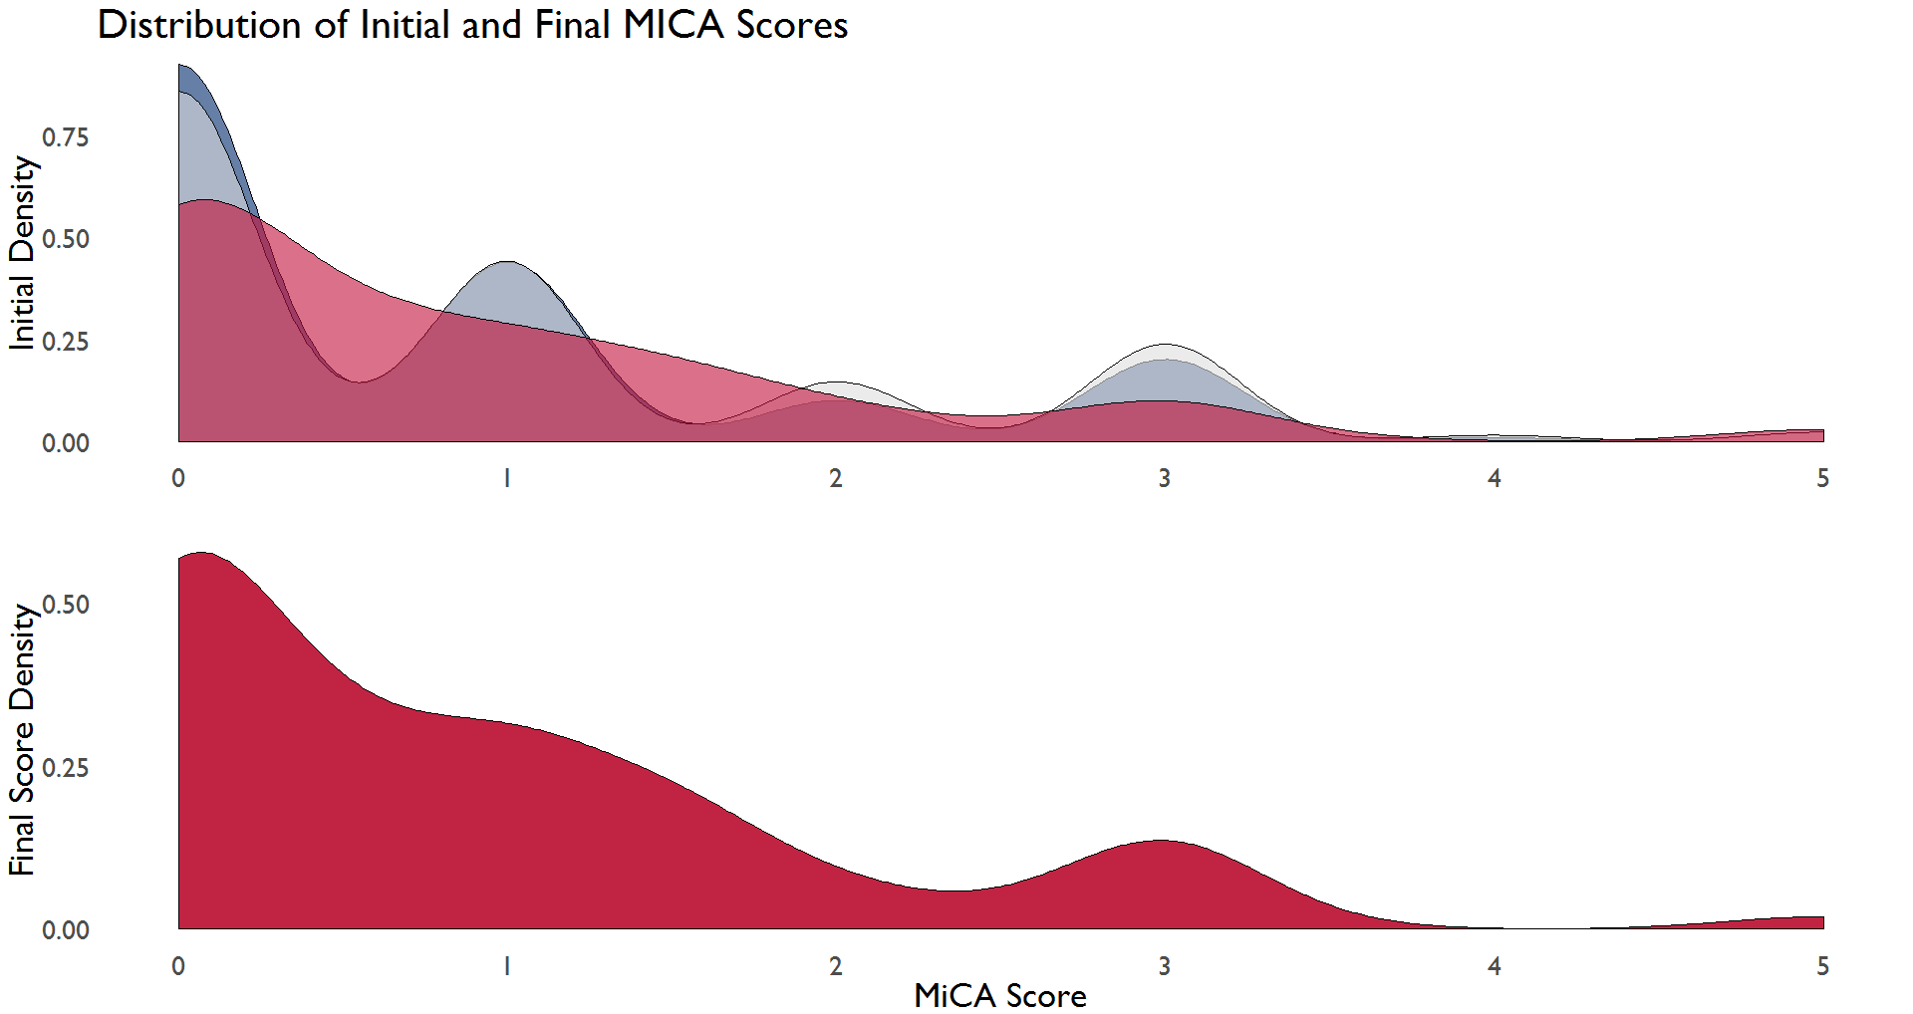
At the municipality level, the evaluation team generated the numeric error between raters and ranked each municipality to see how internally consistent the scoring was across enumerators. The evaluation team found that the average error across the 15 municipalities was around 0.3 points.
The graph below shows the example of Jizah, which had seven items for which there was disagreement between enumerators. Although this municipality had one of the largest point disagreements for a single MICA item, the graph below highlights the fact that, on many of the items, the disagreement was the difference of 0.5 points, and there was no disagreement in a nine cases.
Figure 26: Change in MICA Services Scores for Jizah
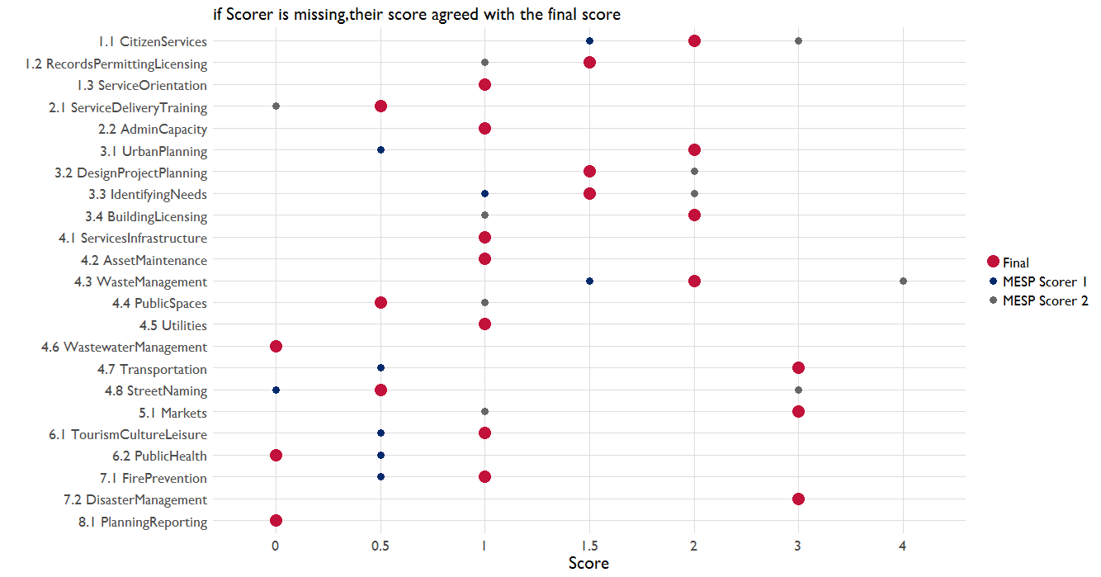
Results for the GESI items were similar, although with fewer changes overall given the low number of GESI observations. There were seven changes to GESI scores across the 15 comparison municipalities. The reason for these changes was similar to that of the services scores: the tool itself allows for subjective judgment. This is particularly true for the binary GESI items. The figure below illustrates the limited number of GESI scores and subsequent changes.

Figure 27: Changes in MICA GESI Scores for Mazar Jadeda
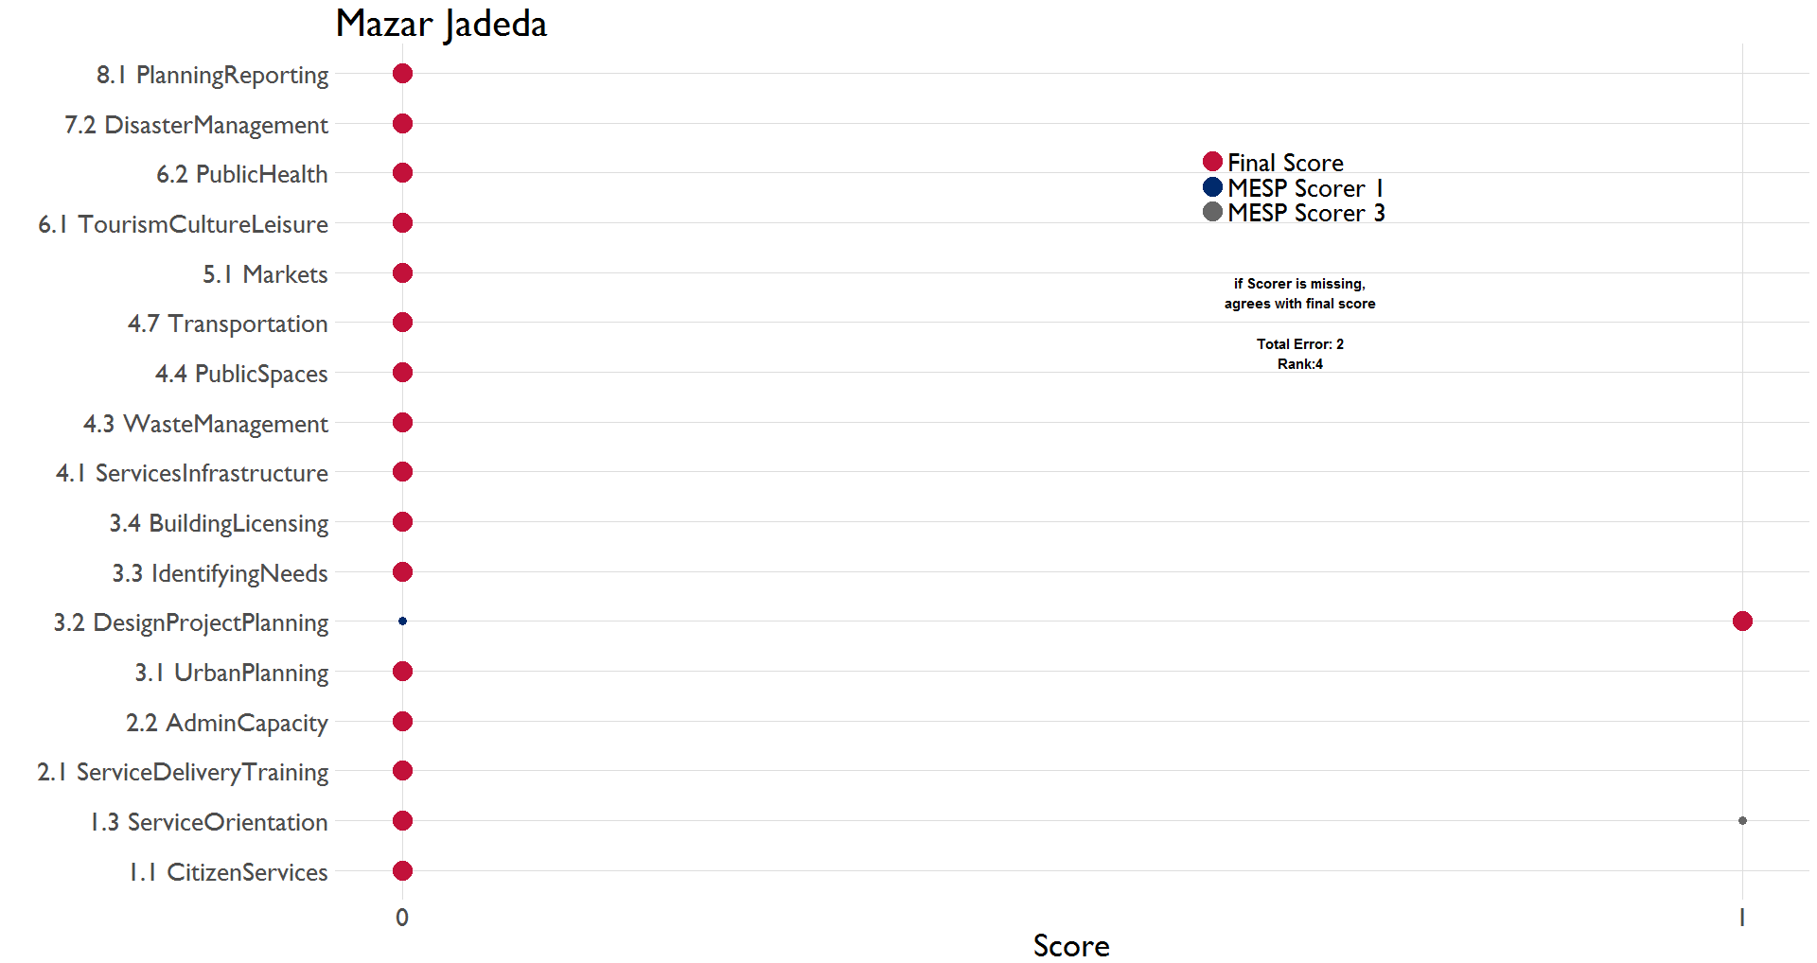
From this review, the evaluation team was able to create a final dataset of MICA scores to use for descriptive analysis and to test balance between assignment groups.

Annex 3: MESP Rater Agreement, by Municipality

Figure 28 Agreement Error by Item - Ain Albasha
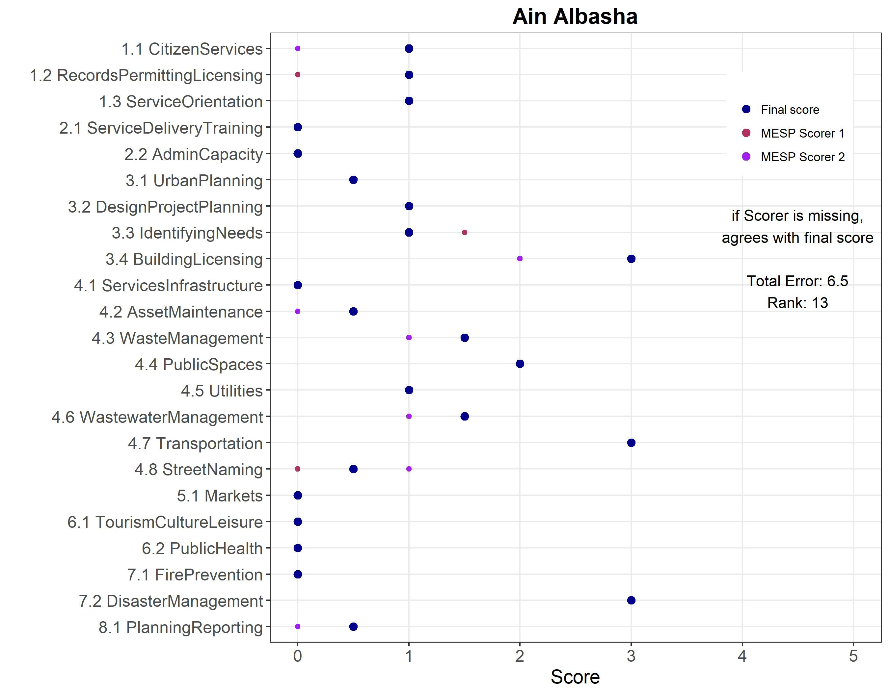

Figure 29 Agreement Error by Item - Al Seru
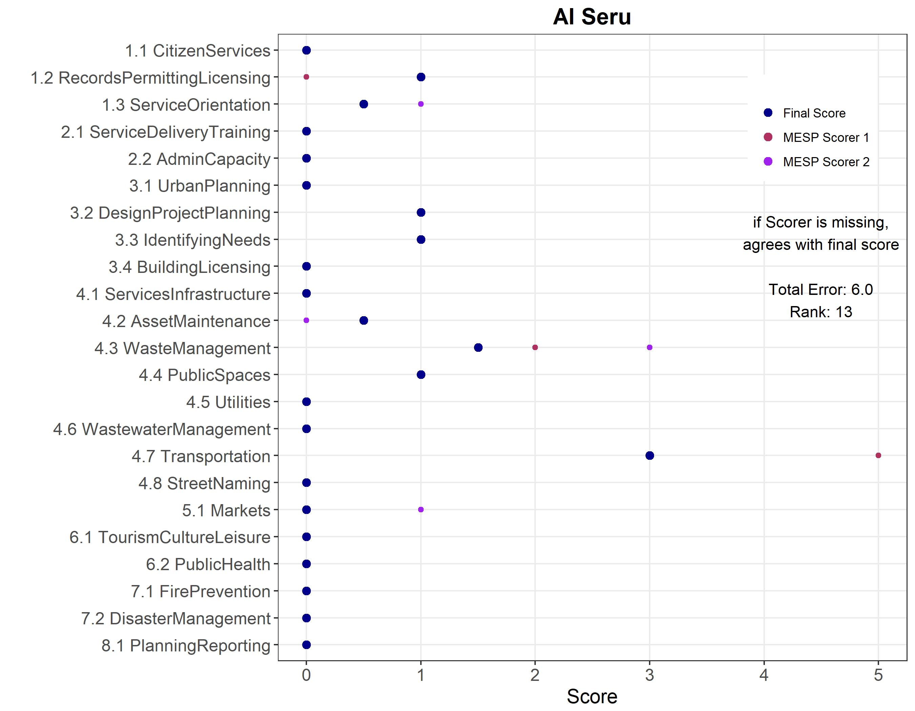

Figure 30 Agreement Error by Item - Alauion
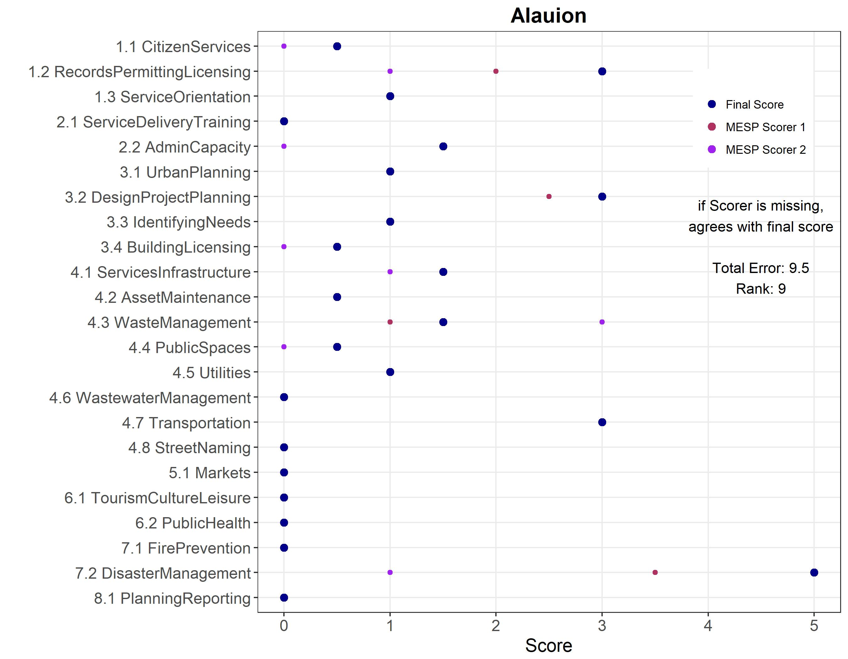

Figure 31 Agreement Error by Item - Alsharah
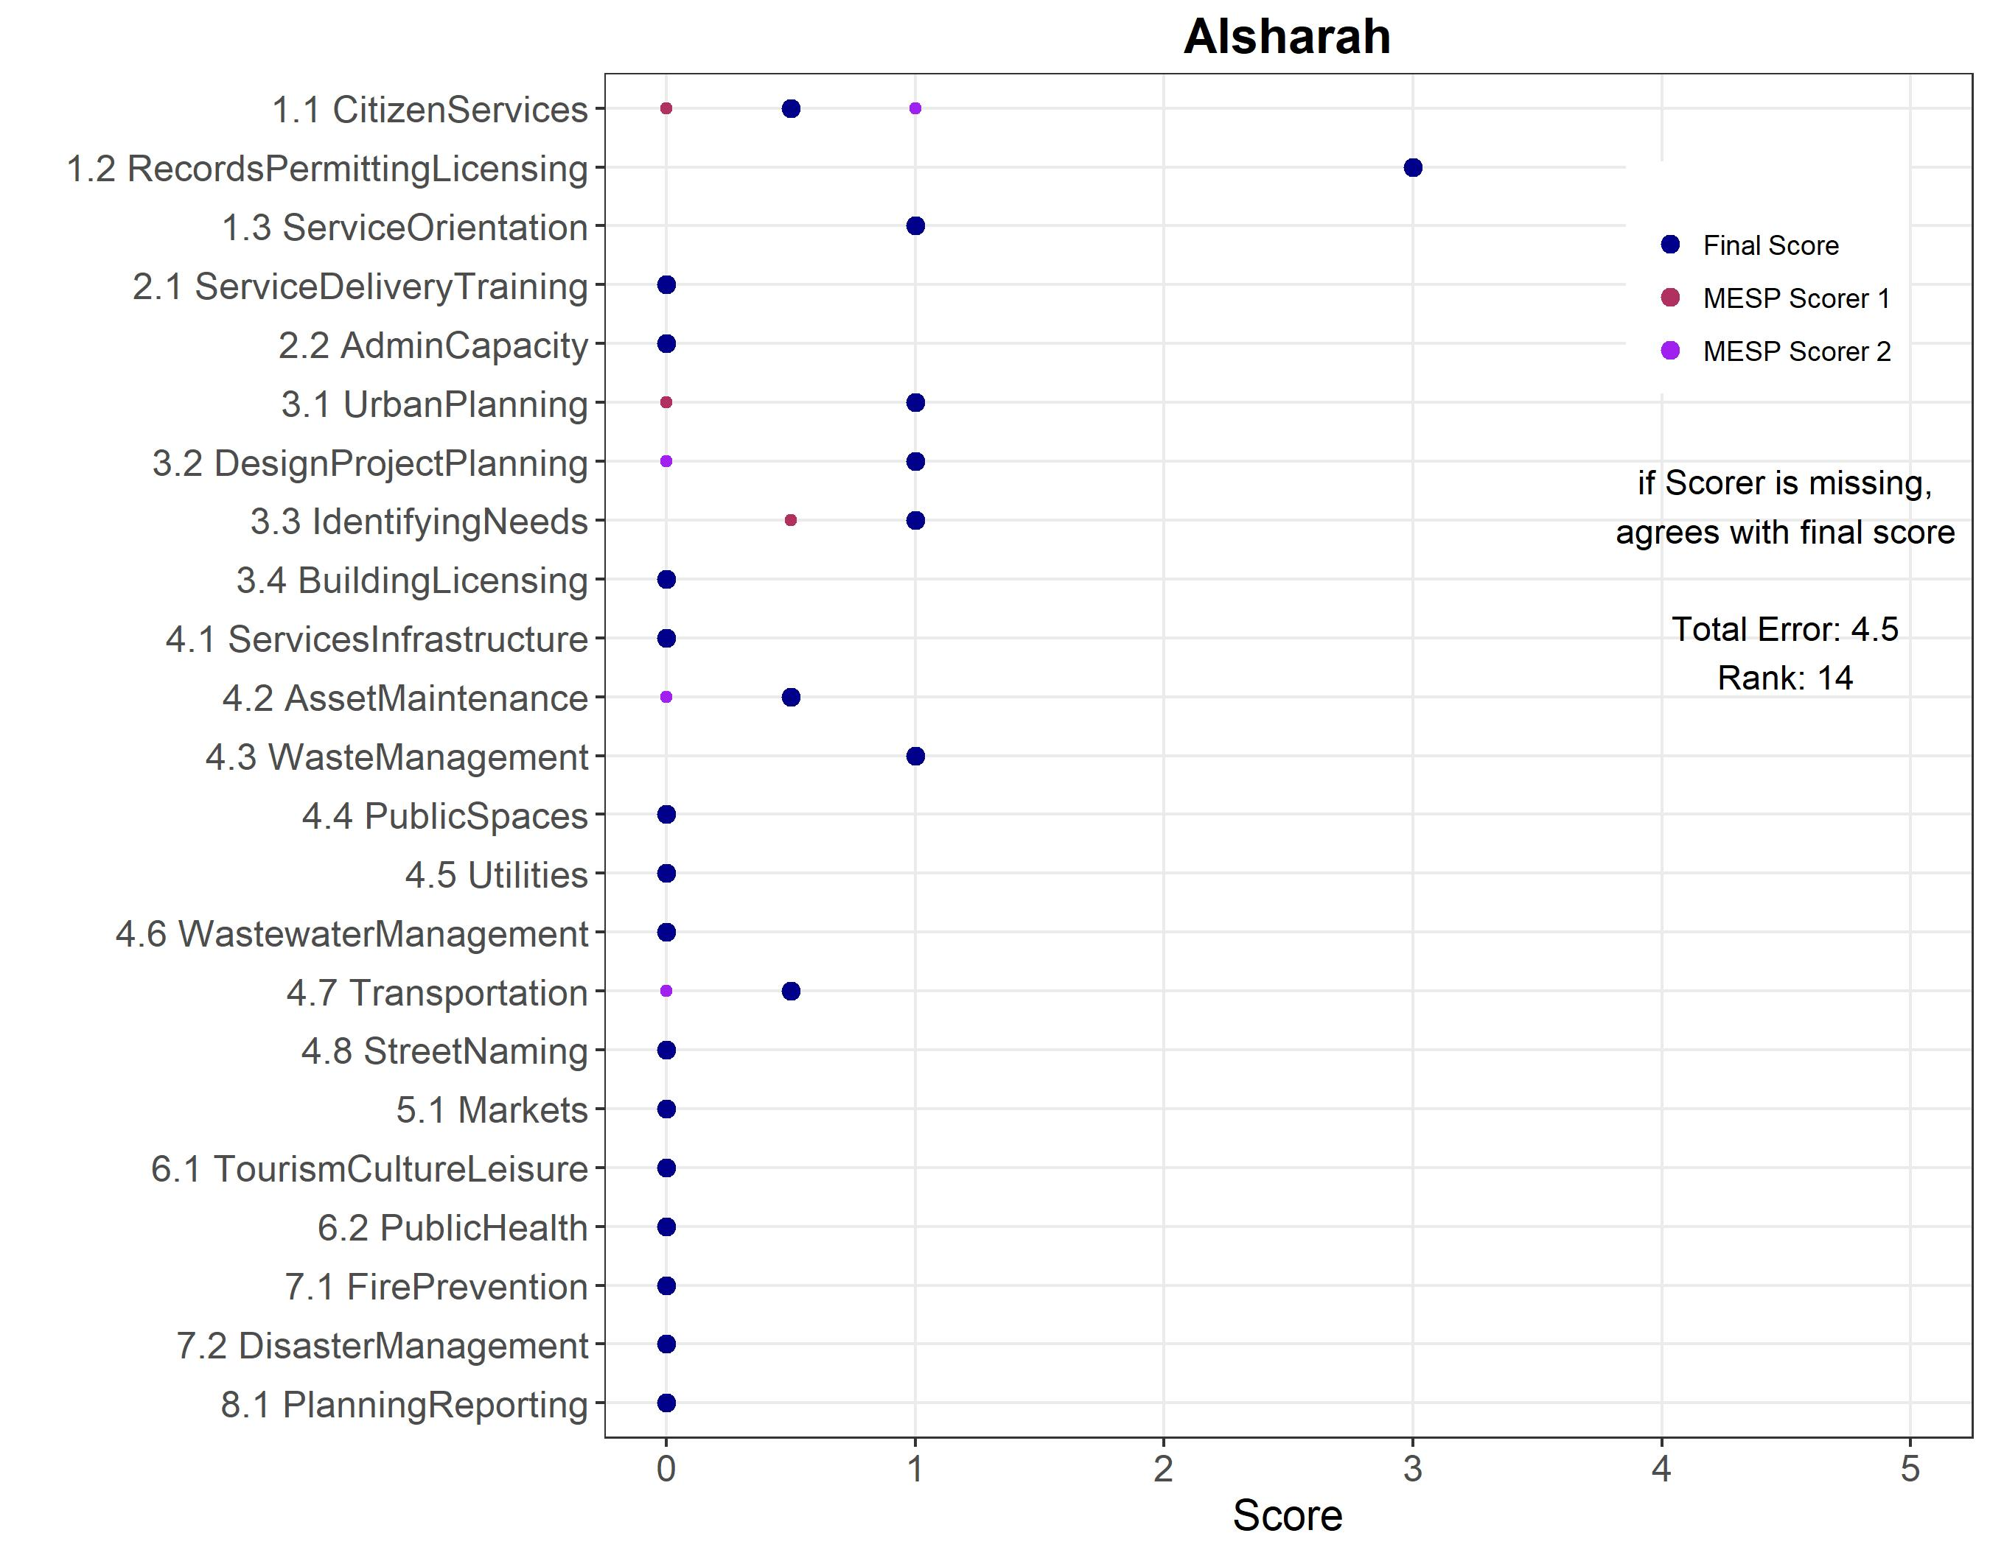

Figure 32 Agreement Error by Item - Alyarmook Aljadedah
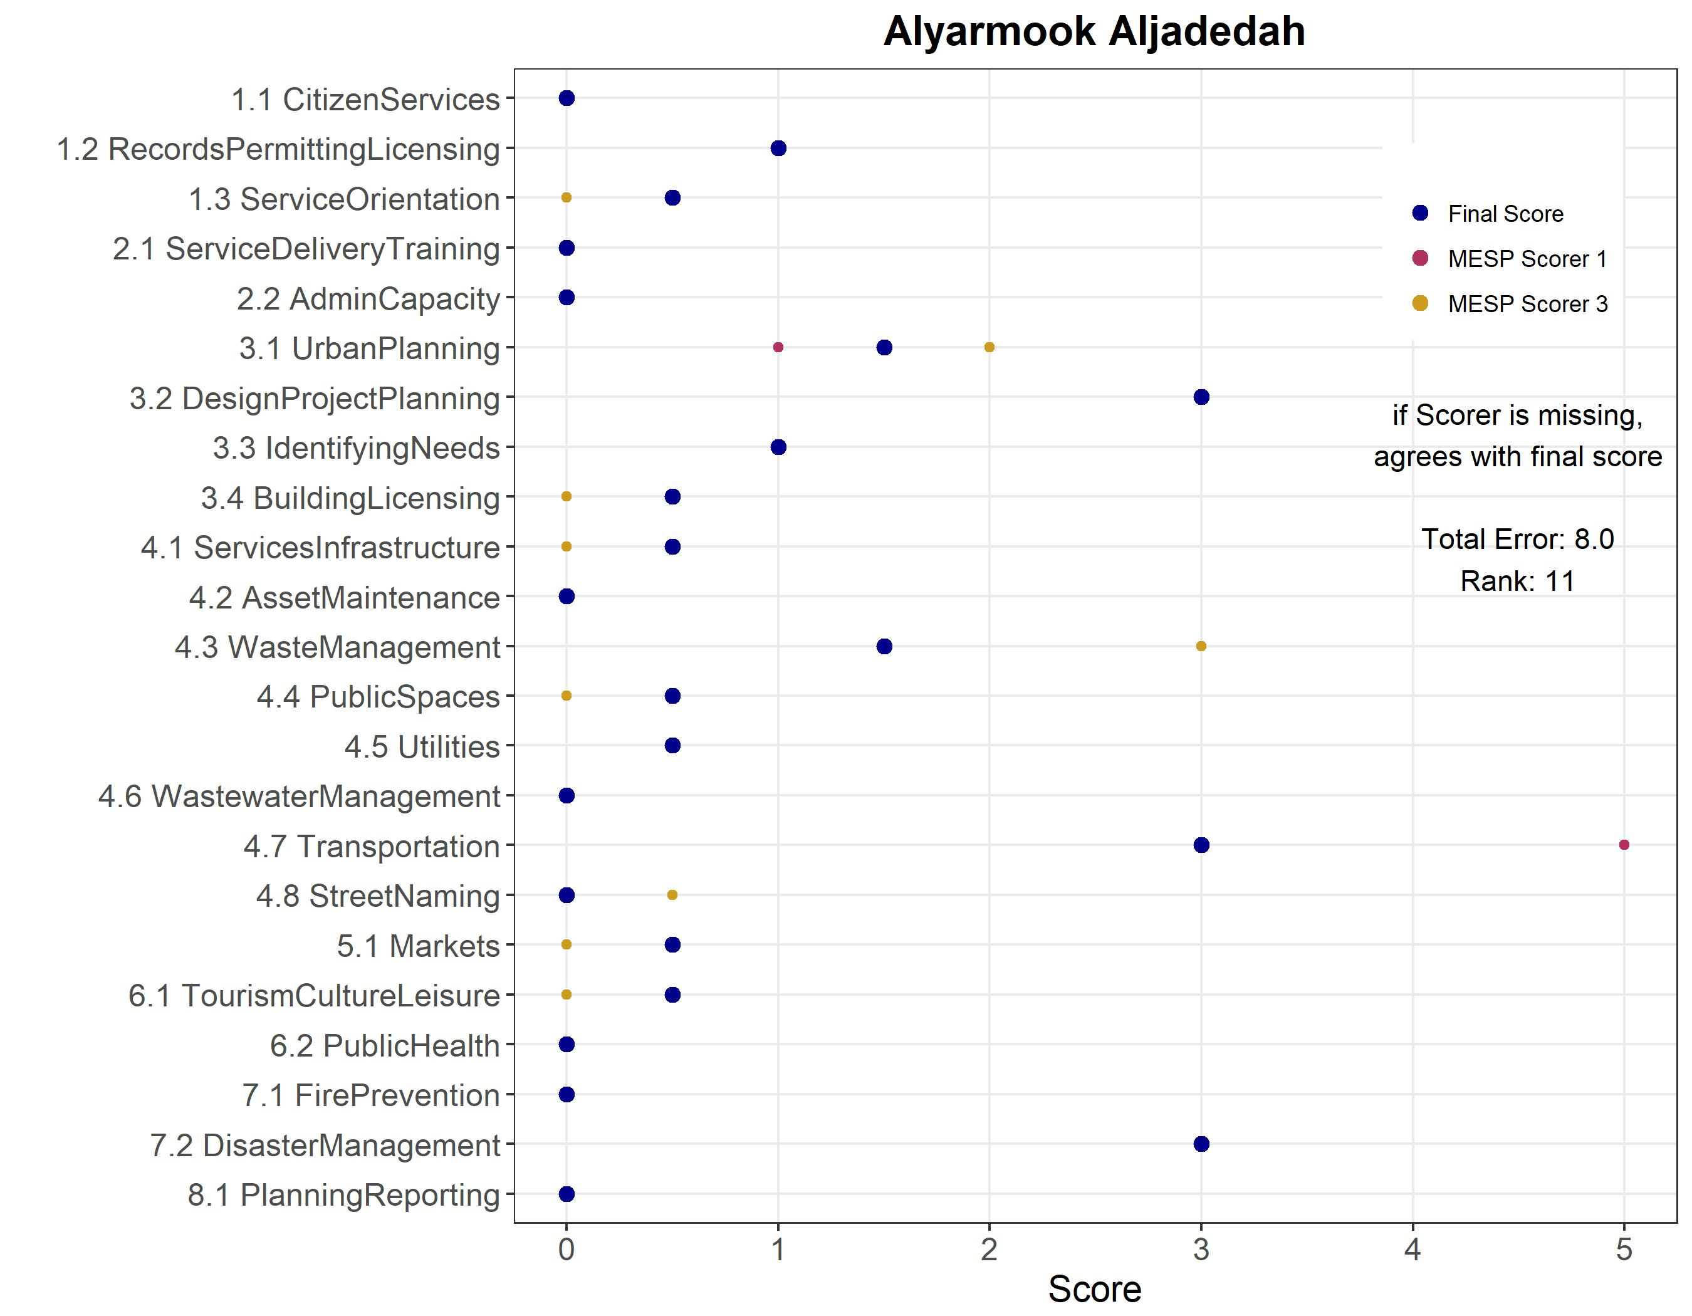

Figure 33 Agreement Error by Item - Bab Amman
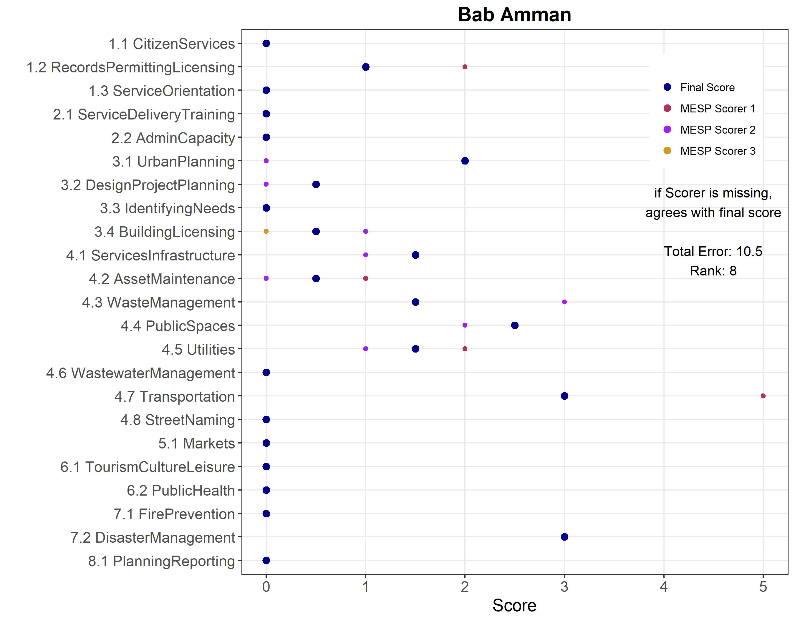

Figure 34 Agreement Error by Item - Iel Jadedah
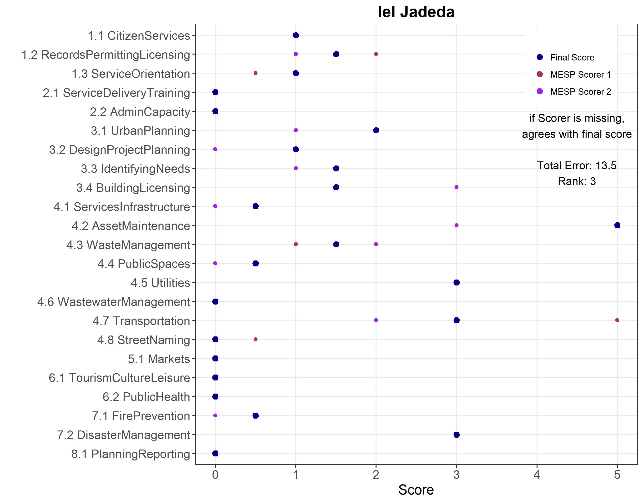

Figure 35 Agreement Error by Item - Jizah
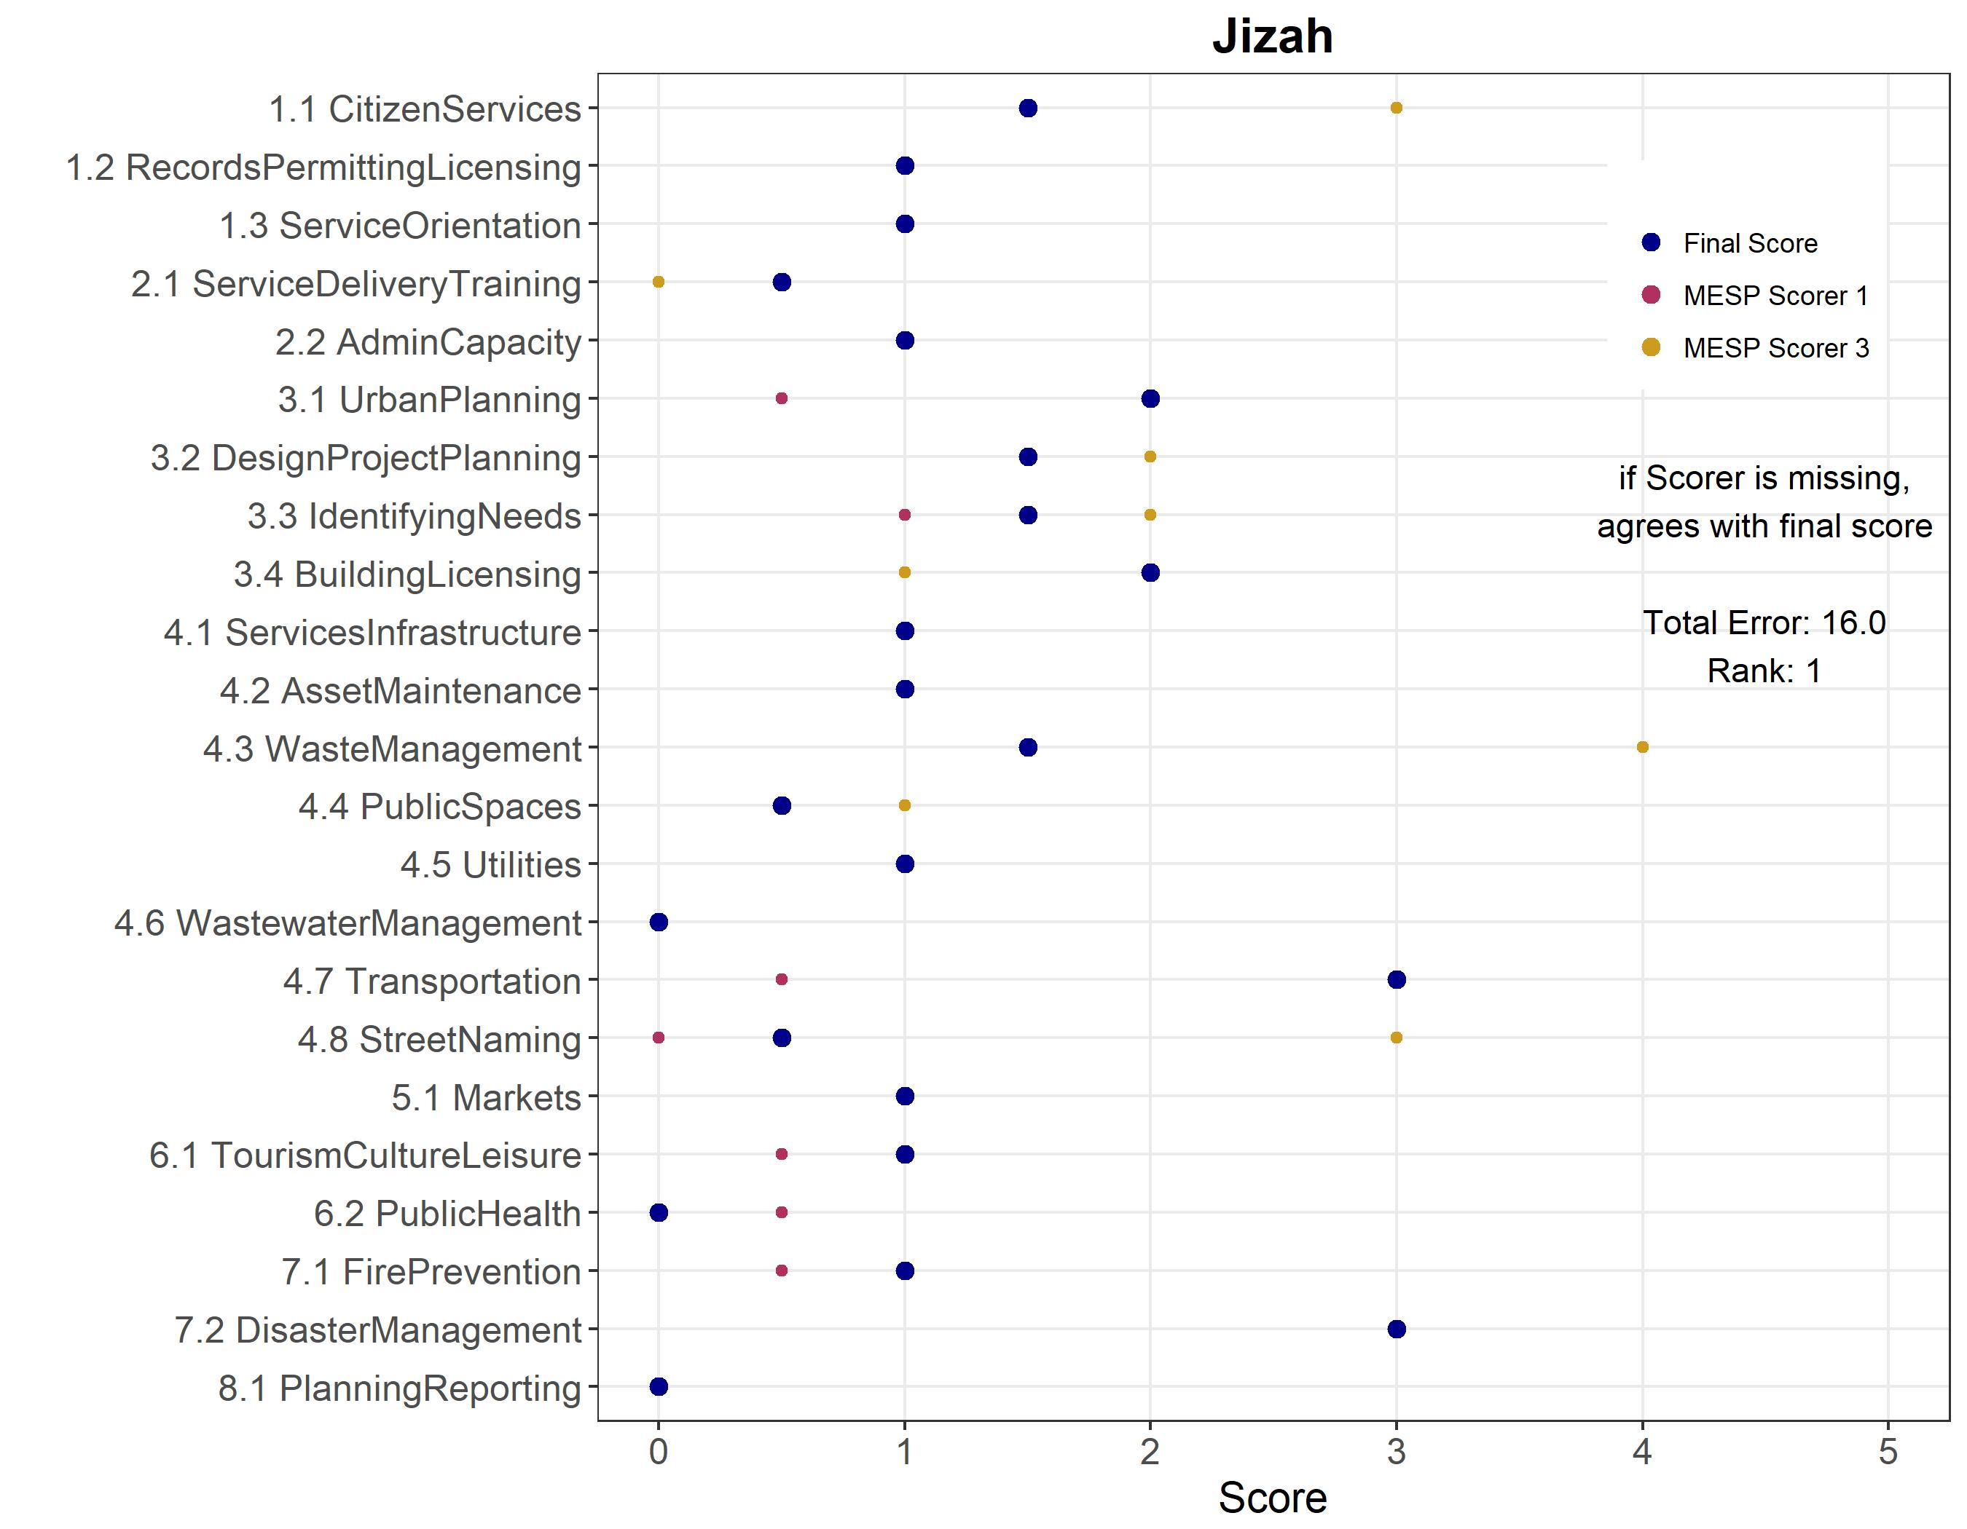

Figure 36 Agreement Error by Item - Manshiat Bane
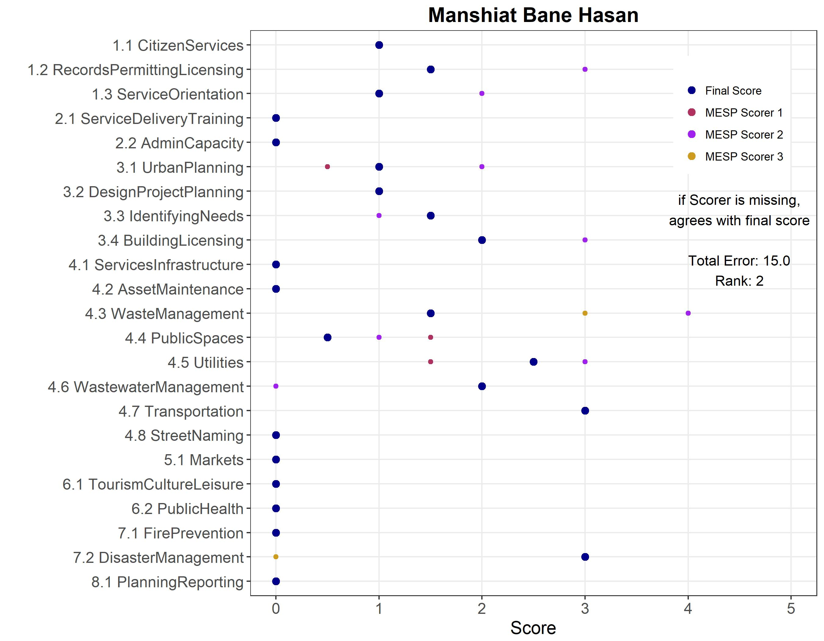

Figure 37 Agreement Error by Item - Mazar Jadeda
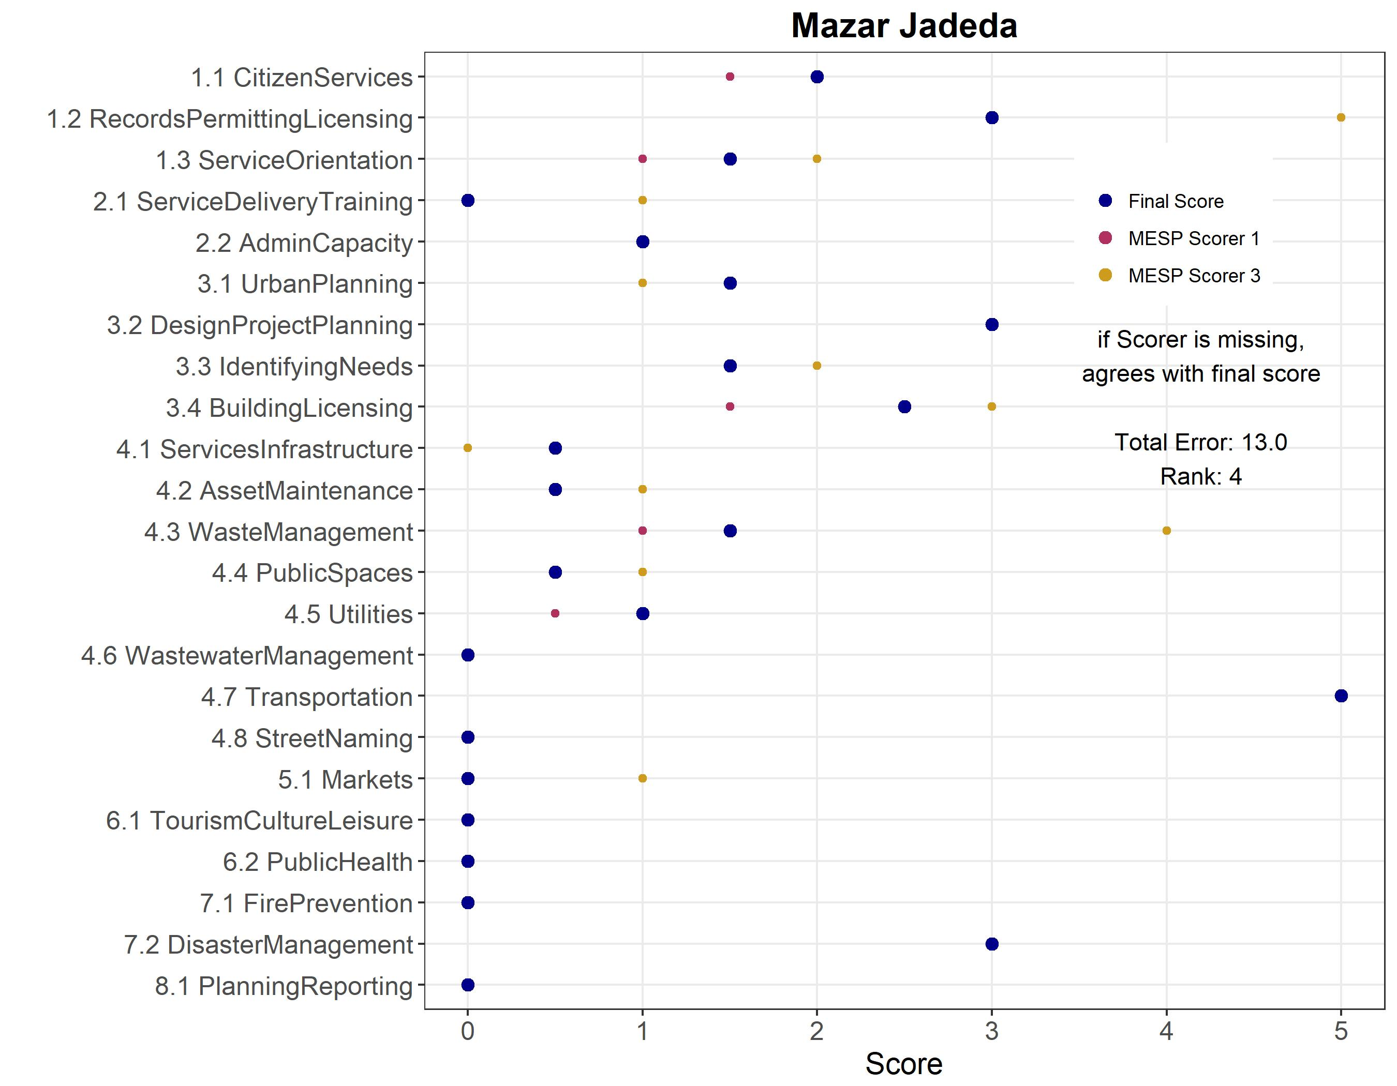

Figure 38 Agreement Error by Item - Mo'ath Abn Jabal
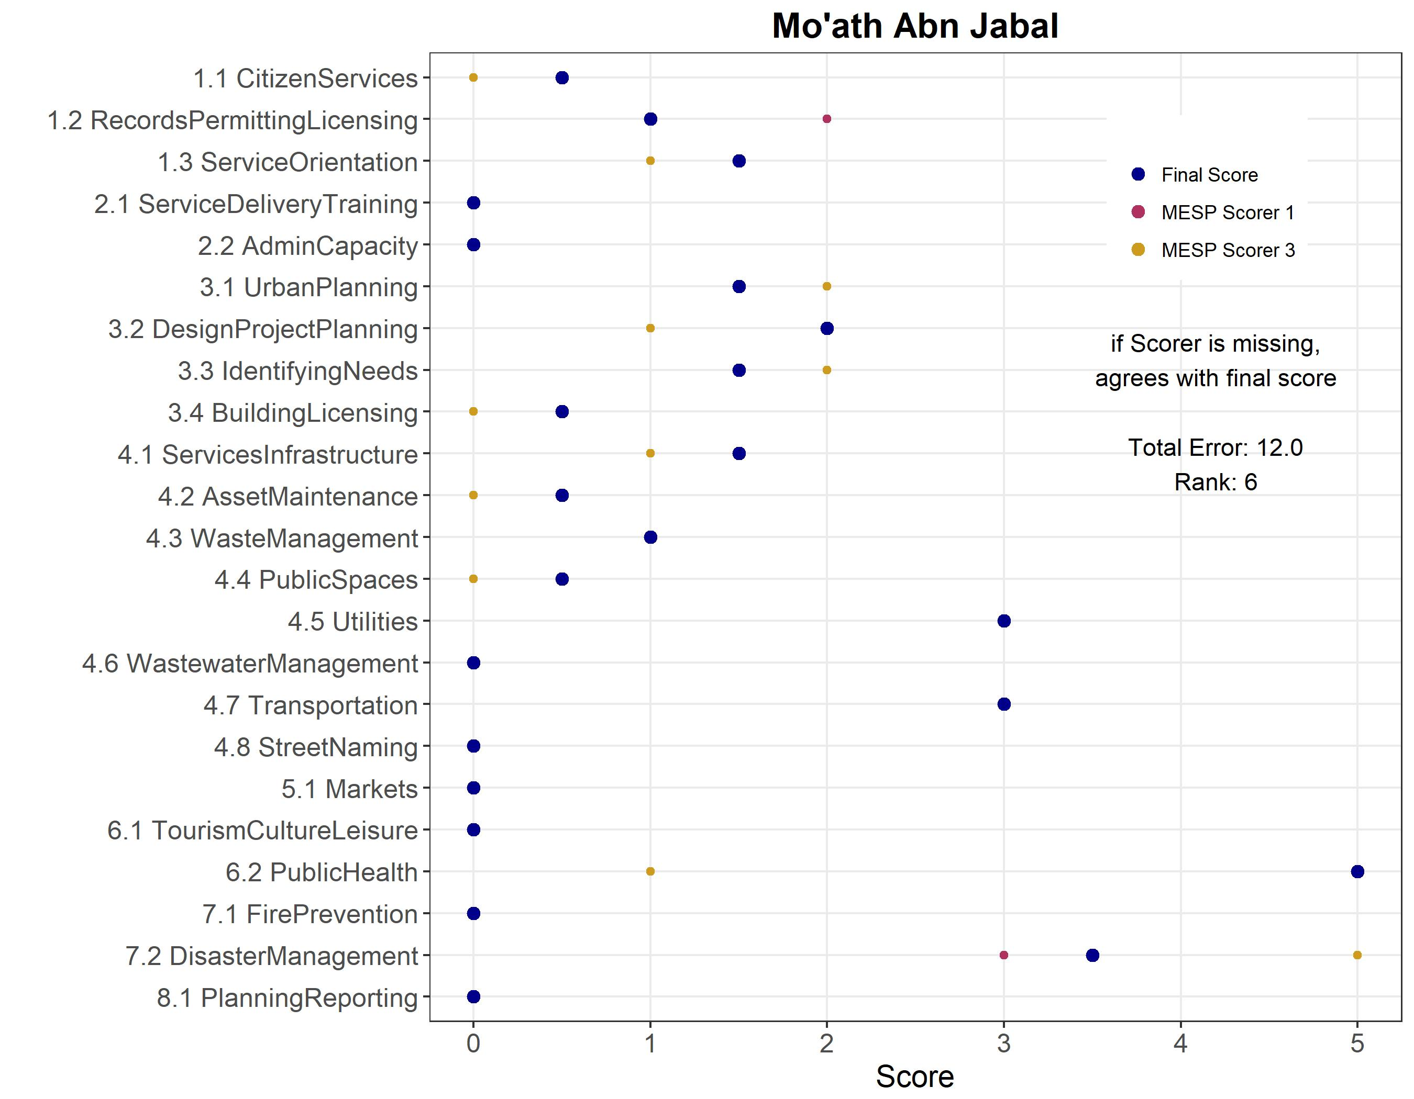

Figure 39 Agreement Error by Item - Shafa
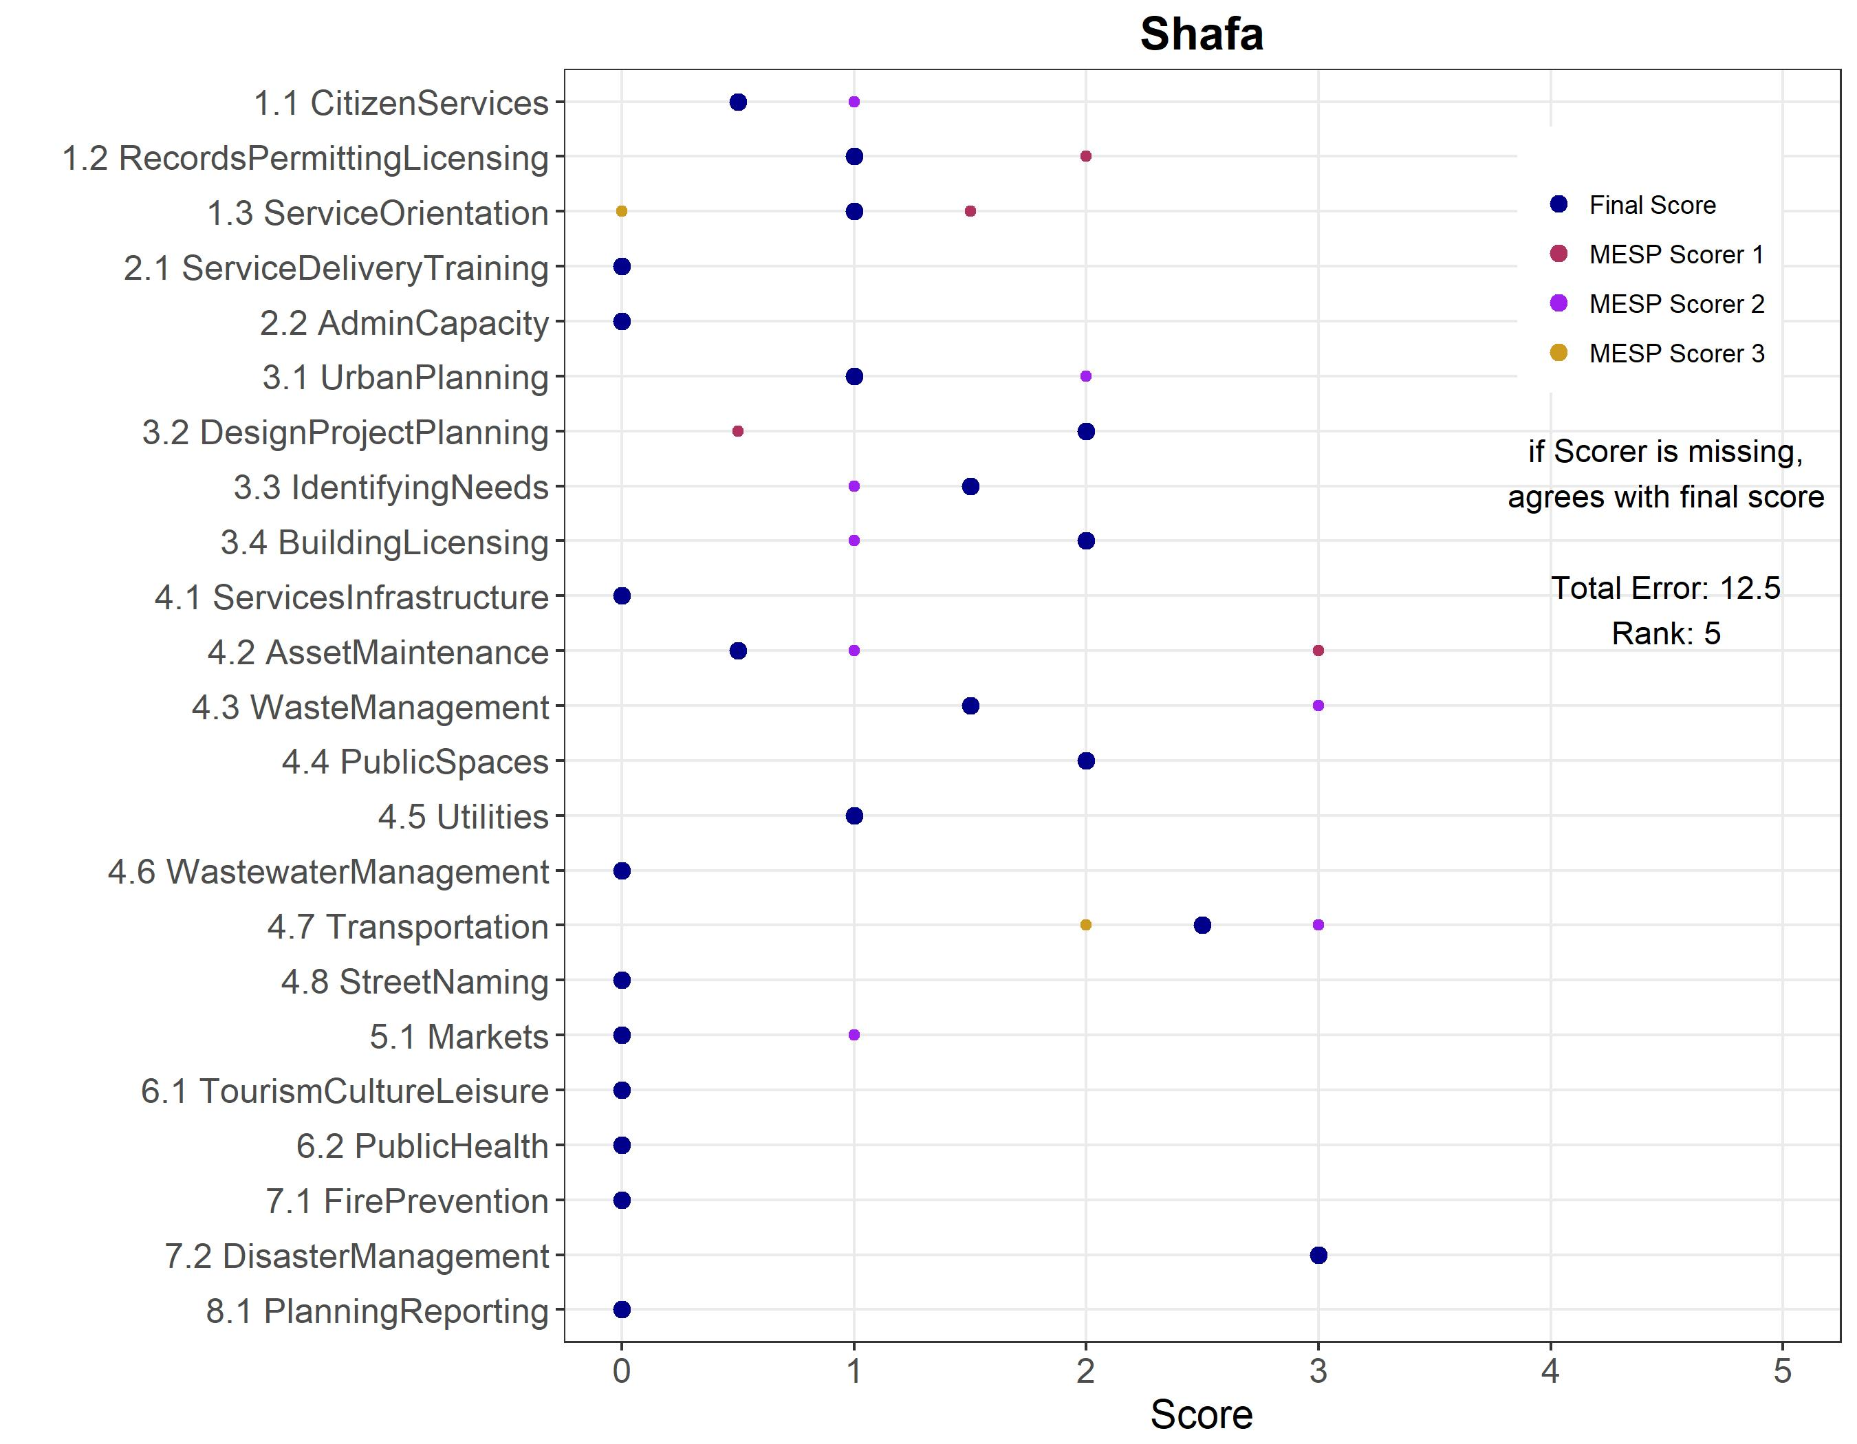

Figure 40 Agreement Error by Item - Tabaqat Fahl
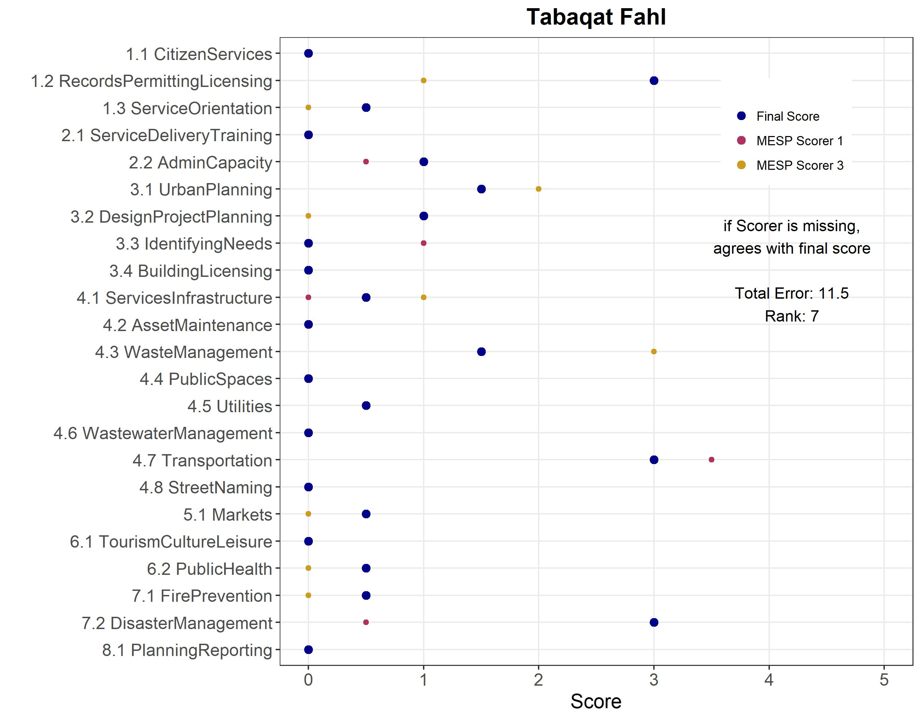

Figure 41 Agreement Error by Item - Talal Aljadedah

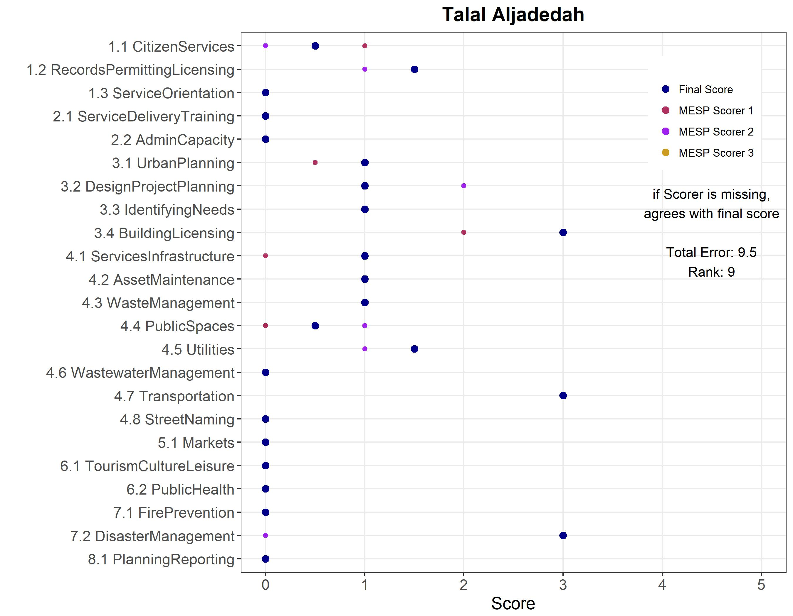

Annex 4: Investigating Baseline Equivalence

The tables below show the full MICA services and GESI items and the balance statistics for each of the following configurations:
- Full configuration: All 33 CITIES municipalities and 15 evaluation municipalities
- Partial Configuration: 23 Class B and C CITIES municipalities and the evaluation municipalities
- Matched Configuration:15 matched CITIES municipalities and the evaluation municipalities.
As mentioned in the body of the report, mean differences at or below an absolute value of 0.25 generally suggest strong balance. The upper and lower confidence intervals used the normalized mean value and a 95 percent confidence level.
Table 18: Detailed MICA Services Items Balance Statistics, full configuration
Measure | Treatment Mean | Comparison Mean | Difference | Standardized Mean Difference
1.1 | 1.45 | 0.80 | 0.65 | -0.66
1.2 | 1.14 | 1.70 | -0.56 | 0.65
1.3 | 1.11 | 0.80 | 0.31 | -0.50
2.1 | 0.39 | 0.10 | 0.29 | -0.59
2.2 | 0.68 | 0.33 | 0.35 | -0.63
3.1 | 1.42 | 1.27 | 0.16 | -0.21
3.2 | 1.67 | 1.77 | -0.10 | 0.10
3.3 | 1.27 | 1.17 | 0.11 | -0.16
3.4 | 1.70 | 1.40 | 0.30 | -0.25
4.1 | 0.95 | 0.60 | 0.35 | -0.50
4.2 | 1.36 | 0.77 | 0.60 | -0.50
4.3 | 2.11 | 1.80 | 0.31 | -0.34
4.4 | 1.58 | 0.80 | 0.78 | -0.89
4.5 | 1.83 | 1.23 | 0.60 | -0.56
4.6 | 0.59 | 0.23 | 0.36 | -0.49
4.7 | 2.58 | 2.93 | -0.36 | 0.33
4.8 | 0.58 | 0.07 | 0.51 | -0.83
5.1 | 1.91 | 2.40 | -0.49 | 0.33
6.1 | 0.79 | 0.13 | 0.65 | -0.71
6.2 | 1.29 | 0.50 | 0.79 | -0.54
7.1 | 0.06 | 0.20 | -0.14 | 0.44
7.2 | 0.70 | 1.57 | -0.87 | 0.86
8.1 | 0.47 | 0.03 | 0.44 | -0.70

Table 18: Detailed MICA Services Items Balance Statistics, partial configuration
Measure | Treatment Mean | Comparison Mean | Difference | Standardized Mean Difference
1.1 | 1.22 | 0.8 | 0.42 | -0.45
1.2 | 0.85 | 1.7 | -0.85 | 1.20
1.3 | 0.85 | 0.8 | 0.05 | -0.10
2.1 | 0.13 | 0.1 | 0.03 | -0.10
2.2 | 0.46 | 0.33 | 0.12 | -0.24
3.1 | 1.09 | 1.27 | -0.18 | 0.31
3.2 | 1.52 | 1.77 | -0.24 | 0.25
3.3 | 1.17 | 1.17 | 0.01 | -0.01
3.4 | 1.46 | 1.4 | 0.06 | -0.05
4.1 | 0.72 | 0.6 | 0.12 | -0.20
4.2 | 0.89 | 0.77 | 0.12 | -0.11
4.3 | 1.54 | 1.8 | -0.26 | 0.41
4.4 | 1.24 | 0.8 | 0.44 | -0.58
4.5 | 1.46 | 1.23 | 0.22 | -0.21
4.6 | 0.13 | 0.23 | -0.1 | 0.19
4.7 | 2.13 | 2.93 | -0.8 | 0.77
4.8 | 0.35 | 0.07 | 0.28 | -0.59
5.1 | 1.3 | 2.4 | -1.1 | 0.84
6.1 | 0.48 | 0.13 | 0.34 | -0.44
6.2 | 0.98 | 0.5 | 0.48 | -0.34
7.1 | 0.04 | 0.2 | -0.16 | 0.51
7.2 | 0.52 | 1.57 | -1.04 | 1.10
8.1 | 0.59 | 0.03 | 0.55 | -0.83

Table 19: Detailed MICA Services Items Balance Statistics, matched configuration
Measure | Treatment Mean | Comparison Mean | Difference | Standardized Mean Difference
1.1 | 1.23 | 0.8 | 0.43 | -0.45
1.2 | 0.83 | 1.7 | -0.87 | 1.24
1.3 | 0.93 | 0.8 | 0.13 | -0.29
2.1 | 0.13 | 0.1 | 0.03 | -0.10
2.2 | 0.43 | 0.33 | 0.1 | -0.2
3.1 | 1.03 | 1.27 | -0.23 | 0.38
3.2 | 1.53 | 1.77 | -0.23 | 0.22
3.3 | 1.07 | 1.17 | -0.1 | 0.15
3.4 | 1.63 | 1.4 | 0.23 | -0.22
4.1 | 0.73 | 0.6 | 0.13 | -0.22
4.2 | 0.93 | 0.77 | 0.17 | -0.14
4.3 | 1.5 | 1.8 | -0.3 | 0.43
4.4 | 1.37 | 0.8 | 0.57 | -0.75
4.5 | 1.47 | 1.23 | 0.23 | -0.23
4.6 | 0.13 | 0.23 | -0.1 | 0.17
4.7 | 2.33 | 2.93 | -0.6 | 0.63
4.8 | 0.37 | 0.07 | 0.3 | -0.52
5.1 | 1.6 | 2.4 | -0.8 | 0.59
6.1 | 0.6 | 0.13 | 0.47 | -0.48
6.2 | 1.3 | 0.5 | 0.8 | -0.53
7.1 | 0 | 0.2 | -0.2 | 0.77
7.2 | 0.67 | 1.57 | -0.9 | 0.93
8.1 | 0.73 | 0.03 | 0.7 | -0.89

Table 20: Detailed MICA GESI Items Balance Statistics, full configuration
Measure | Treatment Mean | Comparison Mean | Difference | Standardized Mean Difference
1.1 | 0.18 | 0.00 | 0.18 | 1.72
1.2 | 0.18 | 0.20 | -0.02 | 0.11
1.3 | 0.06 | 0.00 | 0.06 | 1.50
2.1 | 0.09 | 0.00 | 0.09 | 1.55
2.2 | 0.03 | 0.00 | 0.03 | 1.45
3.1 | 0.33 | 0.13 | 0.20 | 1.02
3.2 | 0.36 | 0.20 | 0.16 | 0.75
3.3 | 0.06 | 0.00 | 0.06 | 1.50
3.4 | 0.12 | 0.00 | 0.12 | 1.61
4.1 | 0.00 | 0.00 | 0.00 | 0.00
4.2 | 0.00 | 0.00 | 0.00 | 0.00
4.3 | 0.21 | 0.00 | 0.21 | 1.79
4.4 | 0.00 | 0.20 | -0.20 | 1.07
4.5 | 0.12 | 0.00 | 0.12 | 1.61
4.6 | 0.00 | 0.00 | 0.00 | 0.00
4.7 | 0.00 | 0.00 | 0.00 | 0.00
4.8 | 0.03 | 0.00 | 0.03 | 1.45
5.1 | 0.18 | 0.00 | 0.18 | 1.72
6.1 | 0.18 | 0.20 | -0.02 | 0.11
6.2 | 0.06 | 0.00 | 0.06 | 1.50
7.1 | 0.09 | 0.00 | 0.09 | 1.55
7.2 | 0.03 | 0.00 | 0.03 | 1.45
8.1 | 0.33 | 0.13 | 0.20 | 1.02

Table 21: Detailed MICA GESI Items Balance Statistics, partial configuration
Measure | Treatment Mean | Comparison Mean | Difference | Standardized Mean Difference
1.1 | 0.09 | 0.00 | 0.09 | 1.73
1.2 | 0.13 | 0.20 | -0.07 | 0.50
1.3 | 0.04 | 0.00 | 0.04 | 1.65
2.1 | 0.09 | 0.00 | 0.09 | 1.73
2.2 | 0.00 | 0.00 | 0.00 | 0.00
3.1 | 0.35 | 0.13 | 0.21 | 1.11
3.2 | 0.30 | 0.20 | 0.10 | 0.52
3.3 | 0.00 | 0.00 | 0.00 | 0.00
3.4 | 0.17 | 0.00 | 0.17 | 1.91
4.1 | 0.00 | 0.00 | 0.00 | 0.00
4.2 | 0.00 | 0.00 | 0.00 | 0.00
4.3 | 0.22 | 0.00 | 0.22 | 2.02
4.4 | 0.00 | 0.20 | -0.20 | 0.84
4.5 | 0.09 | 0.00 | 0.09 | 1.73
4.6 | 0.00 | 0.00 | 0.00 | 0.00
4.7 | 0.00 | 0.00 | 0.00 | 0.00
4.8 | 0.04 | 0.00 | 0.04 | 1.65
5.1 | 0.09 | 0.00 | 0.09 | 1.73
6.1 | 0.13 | 0.20 | -0.07 | 0.50
6.2 | 0.04 | 0.00 | 0.04 | 1.65
7.1 | 0.09 | 0.00 | 0.09 | 1.73
7.2 | 0.00 | 0.00 | 0.00 | 0.00
8.1 | 0.35 | 0.13 | 0.21 | 1.11

Table 22: Detailed MICA GESI Items Balance Statistics, matched configuration
Measure | Treatment Mean | Comparison Mean | Difference | Standardized Mean Difference
1.1 | 0.07 | 0.00 | 0.07 | 2.00
1.2 | 0.07 | 0.20 | -0.13 | 1.12
1.3 | 0.00 | 0.00 | 0.00 | 0.00
2.1 | 0.13 | 0.00 | 0.13 | 2.15
2.2 | 0.00 | 0.00 | 0.00 | 0.00
3.1 | 0.40 | 0.13 | 0.27 | 1.40
3.2 | 0.27 | 0.20 | 0.07 | 0.35
3.3 | 0.00 | 0.00 | 0.00 | 0.00
3.4 | 0.20 | 0.00 | 0.20 | 2.33
4.1 | 0.00 | 0.00 | 0.00 | 0.00
4.2 | 0.00 | 0.00 | 0.00 | 0.00
4.3 | 0.27 | 0.00 | 0.27 | 2.55
4.4 | 0.00 | 0.20 | -0.20 | 0.67
4.5 | 0.07 | 0.00 | 0.07 | 2.00
4.6 | 0.00 | 0.00 | 0.00 | 0.00
4.7 | 0.00 | 0.00 | 0.00 | 0.00
4.8 | 0.07 | 0.00 | 0.07 | 2.00
5.1 | 0.07 | 0.00 | 0.07 | 2.00
6.1 | 0.07 | 0.20 | -0.13 | 1.12
6.2 | 0.00 | 0.00 | 0.00 | 0.00
7.1 | 0.13 | 0.00 | 0.13 | 2.15
7.2 | 0.00 | 0.00 | 0.00 | 0.00
8.1 | 0.40 | 0.13 | 0.27 | 1.40

Annex 5:

Annex 6: Analyzing Institutional Capacity
One of the key outcome measures for the CITIES IE is municipality MICA score. In developing this evaluation design, the evaluation team met with the CITIES Component One lead several times to learn about the background and implementation of the MICA tool. It is critical to understand how CITIES is using the MICA tool, what it can and cannot capture, and the potential for bias or omission based on the tool’s design.

Originally created as part of a Chemonic’s activity in Afghanistan, the MICA tool that CITIES is using has been adjusted for the Jordanian context. The Component One lead described it as a vehicle for, “entering into a first conversation with Municipalities. It gives the program [i.e. CITIES] - despite the admitted methodological flaws of the tool - a picture of where the municipalities are in terms of service delivery.”

CITIES is in the process of applying the MICA tool in 33 Municipalities. The tool is applied over the course of two to three days and is used as an interview template with relevant stakeholders. Enumerators do not directly ask about each MICA metric, but rather pose open-ended questions related to each metric and then attempt to substantiate these through follow-up questions and requests to observe documents, certificates, or other relevant materials and fixed assets. After the scoring process in the Municipality is finalized, the MICA enumerators discuss the findings with the Component One lead to collaboratively review and determine a final score for the Municipality.

After a municipality has been scored, CITIES staff develop a service delivery improvement plan. CITIES also identifies which of the four activity tools (grants, technical assistance, training programs, or private public partnerships (PPP)) could be used for implementing the service delivery improvement plan (SDIP). From here, CITIES meets with the mayor, councilors, and community members to prioritize the identified needs. For example, based on the MICA scoring, CITIES may identify solid waste management, urban planning, and fire prevention management as the main areas of need. The municipality stakeholders rank the identified needs that emerge from the MICA based on local priorities. In a final step, the prioritized needs are sent to the Municipal council for approval. In parallel to this, the SDIP may also identify needs through community outreach and to capture priorities that may not be addressed in the MICA.

MICA Challenges
Measuring BEYOND MUNICIPALITY FUNCTIONS
The analysis of which functions are under the full control of municipalities is based on the land law and the evaluation team’s research and interviews. However, in many cases, it is possible that CITIES activities may have an influence on MICA items that are not under the control of municipalities, as detailed in the table below, due to citizen engagement efforts. For example, if local leaders respond to complaints related to areas outside municipal control, they may make an effort to contact the relevant authority higher in the governance structure. The MICA tool may in fact pick up this change should it occur.
Article 5A of the 2015 Municipality Law states that councils shall assume 29 functions, authorities and powers within the boundaries of the municipality. Only 18 of the 29 functions fall under the full control of the municipalities, while the other eleven occur “in coordination” with other entities, such as the sector ministries, although there is no guidance in the law regarding this coordination.

Of the 23 MICA scoring metrics, six are not under the locus of control for municipalities, as shown in the table below. To complicate matters further, review of the MICA tool, municipal law, and other documentation reveals that not all of the MICA indicators that fall under the direct control of the municipalities are anchored in existing legal, regulatory, and policy frameworks (e.g. citizen service desk is not a legal obligation of the municipalities). There are 14 MICA metrics that both fall under the direct span of control of municipalities and are anchored in the law and regulatory framework. These items are highlighted in blue in Table 10.

Table 19: MICA Items Under Municipal Control
MICA No | Service | Under Municipal Control
1.1 | Citizen services | Yes
1.2 | Manual records & systems for Permit & licensing system | Yes
1.3 | Municipality service orientation toward individual citizens | Yes
2.1 | Technical trainings in service delivery | Yes
2.2 | Municipal Staff capacity for basic administrative and management skills | Yes
3.1 | Urban planning | Yes
3.2 | Capacity to design local development plans and manage design and execution of capital projects | Yes
3.3 | Participation of citizens & business community in identifying citizens’ needs | Yes
3.4 | Building licensing and control | Yes
4.1 | Services r.t infrastructure | Yes
4.2 | Maintenance of assets | Yes
4.3 | Solid waste management | Yes
4.4 | Cleanliness of public spaces and infrastructure | Yes
4.5 | Public utilities | No
4.6 | Wastewater management | No
4.7 | Public transport | No
4.8 | Street naming & building numbering | Yes
5.1 | Markets | Yes
6.1 | Tourism, cultural, and leisure time services | No
6.2 | Public health related services | Yes
7.1 | Fire prevention | No
7.2 | Calamity management | No
8.1 | Planning and reporting | Yes

The MICA tool is likely sufficient for CITIES purposes of “starting a conversation” around municipality service needs. However, to fill the gap left by the current MICA items that are neither under municipal control nor supported through regulatory guidance, the evaluation team will consider employing additional MICA items that capture changes in municipality services, processes, and management. An augmented MICA will allow the evaluation team to better measure outcomes that have the potential to change in both treatment and comparison municipalities and are related to CITIES interventions.

Annex 7: Listing of Selected Treatment and Comparison Municipalities
Region | Governorate | Municipality | Treatment | Class | Log population | Refugee population | Poverty rate
Central | Amman | Sahab | 1 | B | 11.767 | 0.195 | 0.202
Central | Balqa | Dair Alla | 1 | B | 10.841 | 0.017 | 0.299
Central | Balqa | M'addi | 1 | B | 10.018 | 0.049 | 0.299
Central | Zarqa | El-Hallabat | 1 | C | 10.265 | 0.602 | 0.138
North | Irbid | Sahel Horan | 1 | B | 11.184 | 0.242 | 0.251
North | Mafraq | Bal'ama Aljadedah | 1 | B | 10.419 | 0.099 | 0.144
North | Mafraq | Dair Alkahf Aljadedah | 1 | C | 9.298 | 0.046 | 0.428
North | Mafraq | Khaldiyah | 1 | C | 10.581 | 0.169 | 0.195
North | Mafraq | Prince Alhusain Ben Abdollah | 1 | C | 9.750 | 0.165 | 0.061
North | Mafraq | Salhiah & Naifeh | 1 | C | 9.939 | 0.163 | 0.447
North | Mafraq | Serhan | 1 | B | 10.178 | 0.239 | 0.202
North | Mafraq | Um aljmal Aljadedah | 1 | B | 10.289 | 0.193 | 0.176
South | Aqaba | Hud Aldisah | 1 | C | 8.719 | 0.017 | 0.475
South | Maan | Al Jafer | 1 | C | 8.962 | 0.004 | 0.338
South | Maan | Husanieh Aljadedah | 1 | B | 9.814 | 0.008 | 0.525
Central | Amman | Jizah | 0 | B | 11.274 | 0.086 | 0.222
Central | Balqa | Ain Albasha | 0 | B | 11.589 | 0.075 | 0.295
North | Ajlun | Alauion | 0 | B | 10.002 | 0.057 | 0.339
North | Ajlun | Shafa | 0 | B | 10.128 | 0.062 | 0.278
North | Irbid | Al Seru | 0 | B | 10.042 | 0.119 | 0.132
North | Irbid | Alyarmook Aljadedah | 0 | C | 10.109 | 0.157 | 0.132
North | Irbid | Mazar Jadeda | 0 | B | 10.037 | 0.148 | 0.170
North | Irbid | Mo'ath Abn Jabal | 0 | B | 10.849 | 0.147 | 0.360
North | Irbid | Tabaqat Fahl | 0 | B | 10.558 | 0.180 | 0.360
North | Jarash | Bab Amman | 0 | C | 9.735 | 0.026 | 0.203
North | Mafraq | Husha Aljadedah | 0 | C | 10.131 | 0.264 | 0.061
North | Mafraq | Manshiat Bane Hasan | 0 | C | 9.382 | 0.236 | 0.150
South | Karak | Talal Aljadedah | 0 | C | 8.970 | 0.021 | 0.286
South | Maan | Alsharah | 0 | C | 9.619 | 0.008 | 0.505
South | Maan | Iel Jadeda | 0 | C | 9.625 | 0.018 | 0.483

Annex 8: Qualitative Data Collection Guides

General Introduction for KIIs/Group Interviews
Thank you very much for meeting with us today and for being willing to answer our questions. Before we start, let me provide some context for this meeting and explain briefly what we would like to discuss with you and why. As you know, USAID is supporting a wide range of projects and activities carried out by various organizations in Jordan. With the knowledge and consent of the Government, and as part of its ongoing commitment to adapt and learn from its interventions, USAID has asked us, the USAID Jordan Monitoring and Evaluation Support Project, to conduct a study of municipal public services in Jordan. The purpose of this study is to collect information about municipalities in Jordan at different points in time to understand and measure changes in municipal institutional capacity and public service delivery. Part of the study will cover contextual variables affecting local governance.

The findings from this evaluation will help USAID, the Government of Jordan, and the broader donor community better understand the status of municipal services and improve the effectiveness of their respective interventions.

Your answers will be kept confidential; the report that will develop out of this study will not attribute any particular comment to any particular individual, or for that matter to any particular group of respondents. All we are trying to do is merely understand how municipalities are functioning. We will then review everything we have heard, and summarize it in a report that will be shared with USAID.

Again, we are very grateful for your willingness to help us as we conduct this study. If you are comfortable with this approach, I am planning to ask you X questions, a few of which entail follow-up questions. You may end the interview at any time. Before we proceed, do you have any questions for us?

KII Discussion Guide for Executive/Governorate Council Members
- What do you think of the new decentralized system and how has your experience as a new executive/governorate council member been so far?
- Executive council members only: How has your role changed under the new system?
- Governorate council members only: What is your role and how are you performing it?
- How frequent are the meetings of the executive/governorate council?
- How does the executive council communicate with the governorate council? How many times did the two councils meet before they endorsed this year’s budget?
- Can you please describe the process by which municipal needs are processed at the governorate level? How do the executive/governorate councils prioritize the development needs/projects they receive from the various municipalities? Can you walk me through the sequence of preparation and approval, number and type of participants involved and reference resources used in the process?
- Are there information bottlenecks that impact this process?
- How often is the governorate council briefed on budget disbursements for governorates or municipalities?
- Do you think this new decentralized system will improve the quality of public services delivered at the municipal level? Why/Why not?
- What challenges/opportunities do you foresee in the implementation of the new decentralized system?
- Is there any negative or positive impact for the implementation of the new system?

KII Discussion Guide for Mayors
- What do you think of the new decentralized system and have you seen any changes so far?
- For treatment municipalities only: Can you brief us about CITIES support to your municipality so far? How do you evaluate this support?
- Have you been approached by your governorate council members yet? If yes, please describe the process and what resulted from it?
- Do you think the new decentralized system will improve the quality of public services delivered at the municipal level? Why/Why not?
- What challenges/opportunities do you foresee in the implementation of the new decentralized system?
- What are the three most important priorities for improving municipal service provision capacities overall?
- What specific challenges do you encounter while performing your job ((financial management challenges, general management challenges, working environment challenges, logistical support challenges, other)?
- Can you suggest management practices that are important for the municipality to adopt, to enhance its internal capacity and facilitate its workflow?
- Can you walk us through the sequence of budget preparation and approval, number and type of participants involved and reference resources used in the process?
- Will all capital spending decisions be made at the governorate level while operating expenditures are included in your budget approved by MOMA?
- Do you think the new position of Executive Manager will streamline municipal workflow? How/why not?
- Has the Executive Manager attended any of the Executive Council meetings so far? How did that go/ Why not?
- Does tribalism affect your ability to perform your job? If yes, how?

KII/GI Discussion Guide for Municipal Council Members
- Can you please describe your role for me?
  - What specific functions does the municipal council perform?
  - Is your role effective? How about the role of the local council? Why/Why not?
  - Do you feel your role overlaps with/complements that of the local council? What about with certain units within the municipality?
  - What challenges specific to your role have you encountered since you started?
- What do you think of the new decentralized system and have you seen any changes yet?
- How do local councils engage/consult with the community and then communicate public input/feedback to the municipality?
- How often do municipal councils meet? Do members get compensated for these meetings? Do you generate meeting minutes? Are they publicly available?
- How can citizens be sure that the municipality is incorporating the input/feedback they provide? Does engagement result in projects the community has collectively agreed on? How does the municipality report back to the community?
- Do you think this new decentralized system will improve the quality of public services delivered at the municipal level? Why/Why not?
- What challenges/opportunities do you foresee in the implementation of the new decentralized system?
- Is there any positive/negative impact for the implementation of the new system?
- For treatment municipalities only: Are you aware of the CITIES project? Can you brief us about CITIES support to your municipality so far? How do you evaluate this support?

KII/GI Discussion Guide for Local Council Members
- What do you think of the new decentralized system and have you seen any changes yet?
- Can you please describe your role for me? What specific functions does the local council perform?
- Do you feel your role overlaps with/complements that of the municipal council? What about with certain units within the municipality?
- What challenges specific to your role have you encountered since you started?
- How do local councils engage/consult with the community and then communicate public input/feedback to the municipality?
- Is your role effective? How about the role of the municipal council? Why/Why not?
- How often do local councils meet? Do members get compensated for these meetings? Do you generate meeting minutes? Are they publicly available?
- How frequently are you briefed on the proceedings of municipal council meetings?
- How can citizens be sure that the municipality is incorporating the input/feedback they provide? Does engagement result in projects the community has collectively agreed on? How does the municipality report back to the community?
- Do you think this new decentralized system will improve the quality of public services delivered at the municipal level? Why/Why not?
- What challenges/opportunities do you foresee in the implementation of the new decentralized system?
- Is there any negative/positive impact for the implementation of the new system?
- For treatment municipalities only: Are you aware of the CITIES project? Can you brief us about CITIES support to your municipality so far? How do you evaluate this support?

KII/GD Discussion Guide for Civil Society Organizations
- What do you think of the new decentralized system and have you seen any changes so far?
- The new municipalities law mandates that the municipality should engage civil society. Is the municipality engaging CSOs? Are local councils reaching out to you? How/why not?
- In your opinion, how effective are the municipality’s community engagement mechanisms? Are they sufficiently inclusive? Does engagement result in projects the community has agreed on?
- Is the role of the local councils effective? Why/Why not?
- How do you monitor the performance of your municipality?
- Do you think the new decentralized system will improve the quality of public services delivered at the municipal level? Why/Why not?
- Does the municipality engage civil society in the budgetary process?
- What challenges/opportunities do you foresee in the implementation of the new decentralized system?
- Is there any negative/positive impact for the implementation of the new decentralized system?
- For treatment municipalities only: Are you aware of the CITIES project? Can you brief us about CITIES support to the municipality so far? How do you evaluate this support?

KII Discussion Guide for Government Officials
- What is your role?
- There are a number of donor-led projects supporting decentralization and municipal capacity building. Can you speak a little about the coordination effort and structure?
- Are you aware of the CITIES project?
  - Can you brief us about CITIES support to municipalities so far?
  - How effective has this support been?
- What do you think of the new decentralized system?
  - Is there any negative/positive impact for the implementation of the new decentralized system?
  - What regulations are still needed to streamline the new decentralized process?
  - What challenges/opportunities do you foresee in the implementation of the new decentralized system?
- In your opinion, what sequence of interventions would best support decentralization today given current limitations and political economy realities? What should donors focus on?
- What interventions would best support public service delivery and municipal capacity building?
- Because of the current economic situation, fiscal decentralization will be a decentralization of expenditures but not revenue collection. This means municipalities will continue to depend on the central government. Do you agree with this statement? Please elaborate.
- What is the formula for deciding governorate budgetary allocations?
- I am aware that there are different interventions that aim to build the capacity of the various councils through training. How sustainable will this learning be if/when councilors change in the next election? Do you think it is better to focus capacity building efforts on municipal staff? Please elaborate.
- Will the new Local Governance Institute be training council members and municipal staff? What skills will you be focusing on? If training is meant to cover the roles of the various councils, will it also tackle technical competencies to perform these roles?

KII Discussion Guide for Donors/USAID IPs
- Can you tell me about your project and how it relates to municipal capacity building, public service delivery, and/or decentralization?
- Has the CITIES program coordinated or collaborated with you in anyway? Please explain.
- What do you think of the new decentralized system and have you seen any changes so far?
  - Do you think the new decentralized system will improve the quality of public services delivered at the municipal level? Why/Why not?
  - Is there any negative/positive impact for the implementation of the new decentralized system?
- What challenges/opportunities do you foresee in the implementation of the new decentralized system?
  - What regulations are still needed to streamline the new decentralized process?
- In your opinion, who will be the emerging power holders in the new system, and what is the nature of their respective power?
- In your opinion, what sequence of interventions would best support decentralization today given current limitations and political economy realities?
- In your opinion, what sequence of interventions would best support municipal service delivery and capacity building today, given current limitations and political economy realities?

KII Discussion Guide for CITIES
- Can you please update us about any progress in your component/generally?
- Have there been any changes on the ground affecting the implementation of the project?
- Is the planned sequence of interventions proving to be sufficiently suited to the context? Please elaborate.
- What challenges/opportunities, if any, have your component/project encountered?
- Are there any outliers in the treatment municipalities? If yes, what factors contribute to this designation?
- How do you evaluate the implementation of the new decentralized system? Is there any negative/positive impact so far?
- What regulations are still needed to streamline the new decentralized process and support the work you are doing?
- Are the municipalities and/or the GoJ sufficiently cooperative?
- What is your current mechanism for coordination with other donors and/or the GoJ?
  - With whom do you coordinate within these organizations/institutions?
- Do you think planned capacity building support to various council members and municipal staff will be able to bridge current technical gaps? Please elaborate.
- Do you think the decision to house the local governance institute at the Amman municipality will contribute to the sustainability of the project’s capacity building efforts? If yes, how? If no, why not?

KII Discussion Guide for USAID
- CITIES has been rolling out various activities at the municipal level. What do you think of the progress the project is achieving so far?
  - Which interventions do you view are more effective? Less effective? Why?
  - Are there already any outliers in the treatment municipalities? If yes, what factors contribute to this designation?
  - Is the planned sequence of interventions proving to be sufficiently suited to the context? Please elaborate.
- What challenges/opportunities if any has the project encountered so far?
  - Have there been any changes on the ground affecting the implementation of CITIES?
  - Have any lessons learned emerged thus far?
- What types of collaboration or coordination are you aware of between CITIES and other USAID IPs or other donors?
- Are the municipalities and/or the GoJ sufficiently cooperative?
- Do you think planned capacity building support to various council members and municipal staff will be able to bridge current technical gaps? Please elaborate.
- Do you think the decision to house the local governance institute at the Amman municipality will contribute to the sustainability of the project’s capacity building efforts? If yes, how? If no, why not?
- How do you evaluate the implementation of the new decentralized system? Is there any negative/positive impact so far?
  - In your opinion, what regulations are still needed to streamline the new decentralized process and support the work CITIES is doing?

Annex 8: Selected Bibliography

Imbens, Guido, and Donald B. Rubin. Causal Inference for Statistics, Social, and Biomedical Sciences: An Introduction. Cambridge: Cambridge University Press, 2015.

Computing IRR for observational data

Guideline for selecting and reporting icc for reliability

U.S. Agency for International Development
1300 Pennsylvania Avenue, NW
Washington, DC 20523

The evaluation design currently does not offer specific detail on small-scale beneficiary surveys. Detailed planning for such surveys will develop alongside the specific disbursement of CITIES grant funding or other service delivery initiatives induced by CITIES activities.
For an excellent backgrounder on the historical context of decentralization in Jordan, see Jordan - Third Tourism Development Project: Annex B.
See Bergh, 2016, page 81. Also, MOPIC (Ministry of Planning and International Cooperation), 2006, Municipal Joint Service Councils Assessment Study, ERM, 154 p. as quoted in Ababsa 2013.
See Bergh 2016. Also, Jordanian Embassy, About Local Government.
See OECD, 2017.
Ibid
Chemonics leads a consortium of implementing partners consisting of VNG International, Planet Partnerships, ConsultUs, and Interdisciplinary Research Consultants.
Municipal responsiveness can be defined as municipality governance listening to and addressing peoples’ needs in an open and efficient manner.
Municipal effectiveness can be defined by perceptions of the degree to which municipal leaders and administrators can formulate and implement policies that address citizen needs, the perceived quality and maintenance of existing and requested public services, and the perceived credibility of the government to follow through on citizen needs.
The ability to address common problems refers to the perception of how political, tribal, gender, religious, or other affiliations influence a municipality’s response to citizen needs and requests, as well as the ability of municipality leadership to coordinate without inequitable concession to these affiliations.
Other measures, such as citizen perception of local government responsiveness and effectiveness, are more impactful. However, improvement in MICA scores are seen as directly within CITIES’ manageable interests to achieve, while changes in citizen perception are subject to multiple factors outside of CITIES’ control and are also difficult to measure with the necessary precision to attribute to the CITIES activity.
Mapping of Development Partners Interventions in Supporting Local Governance: Local Development in Jordan, 2018, p.6.
Ibid.
After removing the ten class A municipalities, class B-D municipalities were matched on the criteria of overall and refugee populations, poverty rate, and presence of either CEP or ESSRP. A set of 15 comparison municipalities were selected that, in aggregate, were most closely balanced against the set of 23 treatment municipalities – again in aggregate. From this initial specification, the matching process was re-run to select 15 out of the 23 treatment municipalities that represented the closest aggregate match to the 15 comparison municipalities.
In the event that the evaluation finds a CITIES treatment effect among class B-D municipalities, the chief interest in the first configuration will be to observe the extent to which such an effect may replicate among class A municipalities.
Ideally, any CITIES treatment effect will persist across each of these two configurations.
There is a 0.57 Pearson correlation coefficient between employees and total MICA score (p <0.01), but this is likely not robust to multivariate analysis given the many other confounders for municipality performance. Budget expenditure and own revenue have negative correlation coefficients -0.27 and -0.12, respectively, but these are not significant.
Other measures, such as citizen perception of local government responsiveness and effectiveness, are more impactful. However, improvement in MICA scores are seen as directly within CITIES’ manageable interests to achieve, while changes in citizen perception are subject to multiple factors outside of CITIES’ control and are also difficult to measure with the necessary precision to attribute to the CITIES activity.
The evaluation team thanks George Hartman, CITIES team lead for Component 1 Service Delivery, for his generous donation of time to support the effort, and to allow evaluation team scorers to accompany his own staff.
The introduction will be tailored to the various types of respondents targeted for data collection.

